
Gwangju Institute of Science and Technology

Official Press Release (https://www.gist.ac.kr/)

Section of Mi-Yeon Kim Nayeong Lee
Public Affairs Section Chief Senior Administrator
(+82) 62-715-2020 (+82) 62-715-2024

Contact Person Professor Joon Ha Kim
for this Article School of Earth Sciences and
Environmental Engineering
(+82) 62-715-3277

Release Date 2018.07.24

Professor Joon Ha Kim fosters environmental
leaders by volunteering his time and effort

□ GIST (President Seung Hyeon Moon) – Professor Joon Ha Kim of the School of Earth Sciences and Environmental Engineering has been volunteering his time and energy to conduct a four-week "Environmental Statistics and Data Analysis Expert Education" training course for environmental experts. This training was held at Oryong Hall on every Monday since July 2, 2018, and the commencement ceremony for the course on held on July 23, 2018.

∘ E-DAP (Environmental Statistics and Data Analysis Expert Education) was launched in July 2014 by the International Environmental Research Institute (IERI, Director In Seop Chang) to help educate environmental workers, public officials, and businessmen. About 50 students participate in the course every year on a first-come first-served basis.

□ This training program is based on the environmental statistics and data analysis self-directed study book using R and SPSS, which was prepared by Professor Joon Ha Kim during the last 10 years, and the students apply the methods of analyzing the data obtained through experiments and field research related to environmental engineering and by applying a logical interpretation.

□ In addition, E-DAP 5, which was held this year, will provide students with data analysis exercises using EDISON * simulation software and R **. The data analysis exercise was utilized to make it easier for students to apply their learning in class.

* EDISON (Education-research Integration through Simulation on the Net) is a national project to develop a research and learning platform with software for national simulation based on the computing infrastructure of Korea Institute of Science and Technology Information (KISTI) and provides a real-time environment for education, research, and industry in eight areas.

** R is a programming language and software environment for statistical calculations and graphical operations. It can be used in low-end computers, and is specialized in large-volume data processing, making it ideal for big data analysis.

□ Dr. Jong-seok Lee, a postdoctoral researcher (Ajou University) who completed the course, said, "I tended to see only trees when writing a paper or when working with data, and it was nice to see the big picture and the forest through Professor Joon Ha Kim's lecture."

∘ Another E-DAP 5 graduate, Kyung-hwa Kang (International Climate & Environment Center), said, "We were able to learn how to accurately express the results of the analysis as well as gathering a lot of data from the results of environmental projects and research. I would like to strongly recommend GIST's educational programs, which is focused on practical training."

□ Professor Joon Ha Kim said, "The environmental industry in the era of the 4th Industrial Revolution requires experts with big data analysis and practical research ability using the latest science and technology. With the GIST International Environmental Research Institute, I will continue to contribute to the development of next-generation environmental leaders with the ability to handle environmental data from acquisition to application."

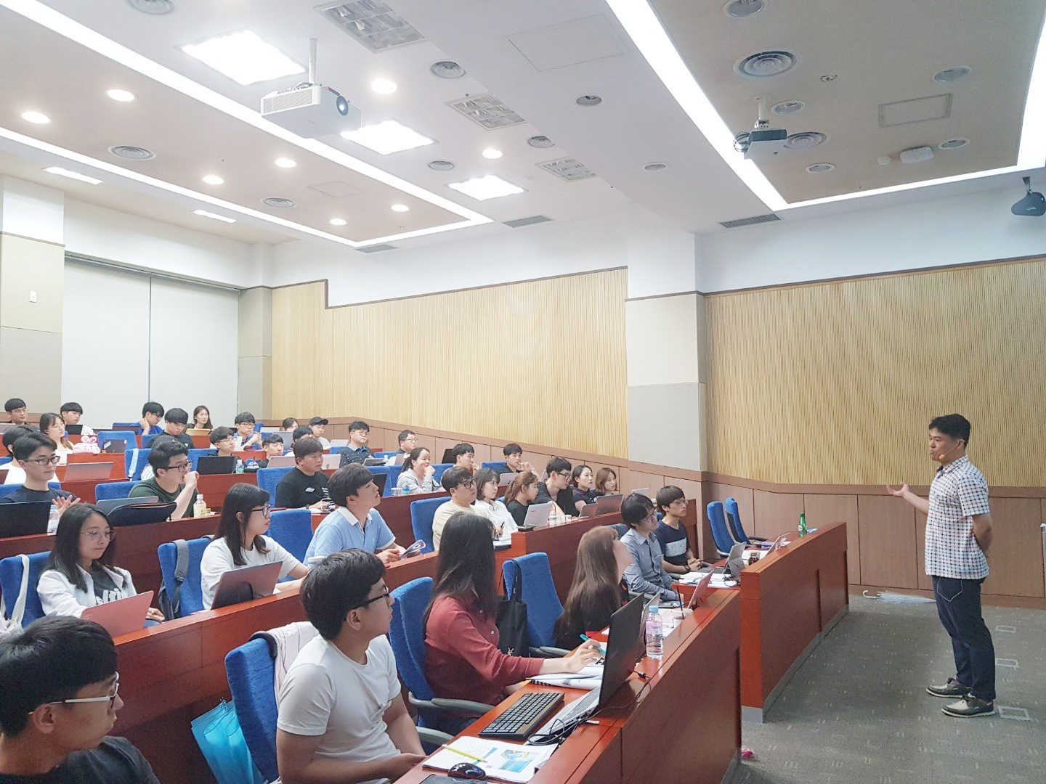
▲ Professor Joon Ha Kim conducting the "Environmental
Statistics and Data Analysis Expert Education" at GIST

