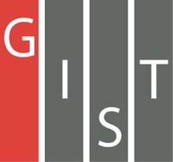
Gwangju Institute of Science and Technology

Official Press Release (https://www.gist.ac.kr/)

Section of Hyo Jung Kim Nayeong Lee
Public Affairs Section Chief Senior Administrator
(+82) 62-715-2061 (+82) 62-715-2062

Contact Person Professor Jae-Il Kim
for this Article School of Life Sciences
(+82) 62-715-2494

Release Date 2020.01.09

Professor Jae-Il Kim's company 'ANYGEN' selected for the "Materials, Parts, and Equipments Small and Medium Enterprises 100 Project"

□ Gwangju Institute of Science and Technology (GIST, President Kiseon Kim) School of Life Sciences Professor Jae-Il Kim founded the company ANYGEN, * which has been selected as the 55 companies for the "Materials, Parts, and Equipments Small and Medium Enterprises 100 Project."

* ANYGEN (CEO Jae-Il Kim): Founded in 2000 by GIST School of Life Sciences Professor Jae-Il Kim, it is the first start-up company started at GIST and is a bio venture company develops globally innovative new drugs such as peptide biomaterials (industrial and pharmaceutical) and amino acid-peptide-based anticancer, anti-diabetic, and analgesics. It is developing new drugs for global innovation such as anti-diabetes.

∘ The Ministry of SMEs and Startups (Minister Young-sun Park) announced the final selection of the "Materials, Parts, and Equipments Small and Medium Enterprises 100 Project" * on December 9, 2019, in order to increase the level of self-reliance in technologies in the materials, parts and equipment sector and contribute to the creation of new industries in the future.

* "Materials, Parts, and Equipments Small and Medium Enterprises 100 Project" is one of the roadmaps for the development of specialized materials, parts, and equipment, which is being promoted by the government.

□ With 1,064 companies applying, the final 55 companies were selected through on-site evaluation, technology evaluation, and public evaluation. The 55 companies selected this time have increased fairness and transparency through open evaluation and the participation of the public.

∘ Basic chemistry (6 companies), automobiles (7 companies), machinery (8 companies), displays (8 companies), and electronics (16 companies) are the only companies selected for "Materials, Parts, and Equipments Small and Medium Enterprises 100 Project." Among the selected companies, ANYGEN is the only pharmaceutical and bio-related company.

□ ANYGEN is located in Jangseong Nanobio Center and produces peptide (API) for medical, research, and cosmetics based on its own peptide synthesis technology and is commissioned to develop new drugs by international pharmaceutical companies and bio venture companies.

∘ As a result of their efforts to manufacture peptide drugs and develop new drugs, it had lower prices for its six products and was listed on the KOSDAQ market in 2016 based on its own technology to develop peptide bio materials and new drugs. In July 2018, the company expanded its business with the "ANYGEN Peptide Farm Osong," a non-cancer drug production line, in Osong Science Complex, Chungbuk.

∘ In addition, the company recently underwent an on-site survey to obtain recognition as a good manufacturing facility (GMP) from the Ministry of Food and Drug Safety (MFDS). The results are expected early this year. Once the plant is certified as an excellent manufacturing facility, it is expected that the company will expand its manufacturing/production line and see significant sales growth in peptide raw materials and clinical peptides for new drug development.

□ ANYGEN CEO Professor Jae-Il Kim said, "This year, we will focus on the production of peptide raw materials, clinical trial production of new drugs, and the development of innovative new drugs. ANYGEN will move from being the only GMP certified peptide specialized company in Korea to become a global peptide specialized company that develops new drugs for mass production as well ass innovative peptides for drug development and clinical trials."

□ Companies selected for the "Materials, Parts, and Equipments Small and Medium Enterprises 100 Project" will receive up to 18.2 billion won for five years over the life cycle of R&D, venture investment, commercialization funds, research personnel, exports, and marketing.

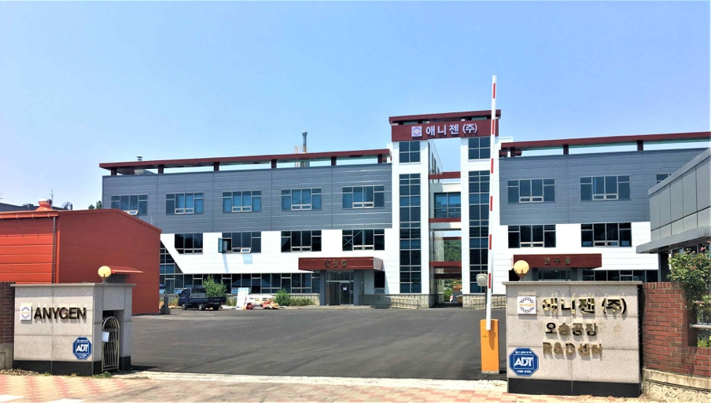
▲ [Picture 1] ANYGEN Osong Plant

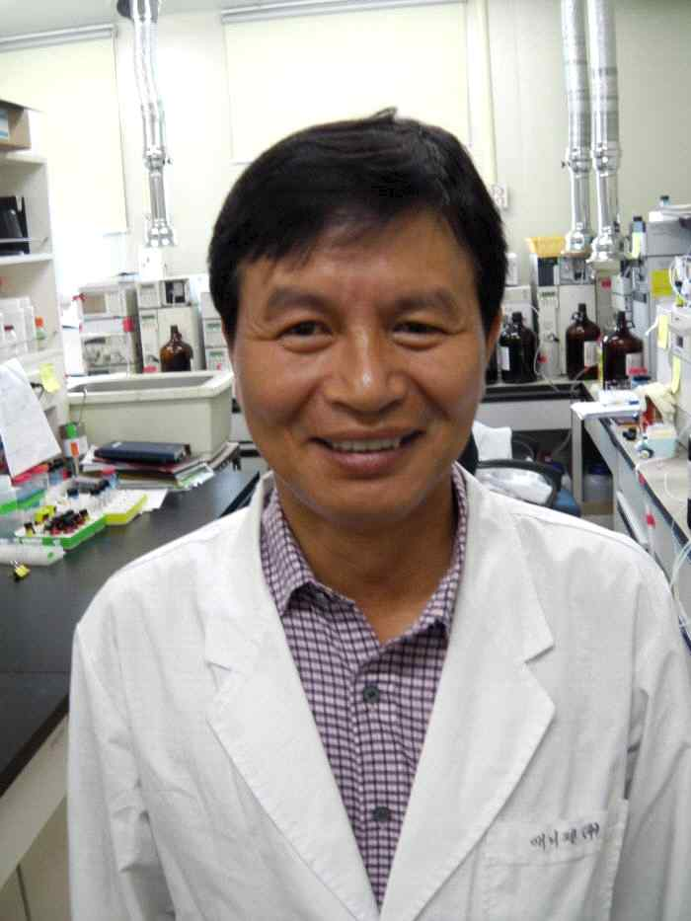
▲ [Photo 2] School of Life Sciences Professor Jae-Il Kim

