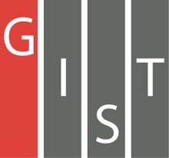
Gwangju Institute of Science and Technology

Official Press Release (https://www.gist.ac.kr/)

Section of Hyo Jung Kim Nayeong Lee
Public Affairs Section Chief Senior Administrator
(+82) 62-715-2061 (+82) 62-715-2062

Contact Person Professor Sung-Gyoo Park
for this Article School of Life Sciences
(+82) 62-715-2511

Release Date 2019.12.10

Professor Sung-Gyoo Park receives the 2019 "Minister of Health and Welfare Award" at the Government Award for the Promotion of Health
and Medical Technology

□ GIST (President Kiseon Kim) School of Life Sciences Professor Sung-Gyoo Park received the 2019 "Minister of Health and Welfare Award" at the Government Award for the Promotion of Health and Medical Technology.

∘ The main award ceremony was held at the Marigold Hall of El Tower on December 10, and 41 government awards were given to 36 professors, including Professor Sung-Gyoo Park who was awarded the Minister of Health and Welfare Award in the category of outstanding research.

□ The 2019 government award ceremony, which marks its 18th anniversary this year, is aimed at spreading the importance and consensus of the nation's health industry and to honor the hard work of researchers who have made outstanding achievements in health care research in Korea.

∘ To honor the hard work of researchers in the health industry, the award ceremony has become more prominent with the Minister of Health and Welfare Award in 2002, the Korea Health Industry Development Institute Award, the Prime Minister's Award in 2005, the President's Award in 2006, the President's Award in 2010, and the President's Medal in 2016.

□ Professor Sung-Gyoo Park has been working for many years to develop treatments using immune cells and to develop drugs to contain the hepatitis viruses. As a result, he was credited with laying the foundation for practical use of research as well as academic research results, including the publication of his papers in many of the world's most prestigious academic journals.

∘ Professor Sung-Gyoo Park is currently conducting non-clinical research in collaboration with Seoul National University Hospital (Professor Yoon-jun Kim), Cha Hospital (Professor Yu-ri Cho), and Samil Pharmaceutical (President Seung-beom Hur) to enter the clinical trials for hepatitis virus suppressing drugs. Phase 1 clinical trial is in preparation.

∘ Professor Sung-Gyoo Park's collaborative research team is working on research to develop a hepatitis virus therapeutic drug for GLP (Non-Clinical Trial Control) toxicity test and to be approved as a new clinical drug within one year.

□ Professor Sung-Gyoo Park said, "We are grateful for the generous support of the Ministry of Health and Welfare for these developmental studies. With this award, we will continue to focus on researching the application of diseases that are in high demand for various therapeutic candidate technologies currently under development."

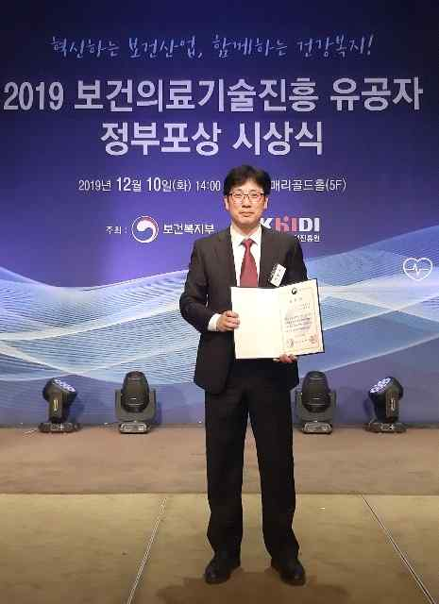
[Photo] Professor Sung-Gyoo Park receives the 2019 "Minister of Health and Welfare Award"
at the Government Award for the Promotion of Health and Medical Technology

