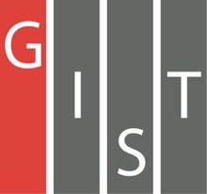

**Gwangju Institute of Science and Technology**

**Official Press Release (https://www.gist.ac.kr/)**

**Section of** Mi-Yeon Kim Nayeong Lee

**Public Affairs** Section Chief Senior Administrator

(+82) 62-715-2020 (+82) 62-715-2024

**Contact Person** Dong-ju Park, Master's student

**for this Article** School of Electrical Engineering

and Computer Science

(+82) 62-715-2664

**Release Date** 2019.01.08

**School of Electrical Engineering and Computer Science student Dong-ju Park receives the grand prize in Naver's NLP Challenge Named Entity Recognition**

□ GIST (President Seung Hyeon Moon) – Dong-ju Park with the State_Of_The_Art team from the School of Electrical Engineering and Computer Science participated in the Natural Language Processing (NLP) Challenge organized by Naver and won the grand prize in the Named Entity Recognition (NER) category.

□ The 'NLP Challenge' * is an online competition for Korean language processing, hosted by Naver and Changwon University (Computer Engineering and Adaptive Intelligence Laboratory). The talented teams participating in the contest benefited from support from Naver employmees.

* NLP Challenge is a contest that uses Naver Smart Machine Learning (NSML) as its own cloud platform to solve Korean language processing problems through various machine learning and deep learning algorithms.

∘ This competition involved two important tasks: 1). named-entity recognition (NER) that recognizes, extracts, and classifies entity names corresponding to people, places, and times in the document and 2). semantic role labeling (SRL) to determines what role the words and expressions have in a sentence.

□ The NLP Challenge was held online last year from November 16th to December 14th, and a workshop was held on December 28th at Naver Green Factory to reward outstanding participants. At the workshop, one team was selected for the grand prize, two teams for the second prize, and three teams for the third prize.

□ Dong-ju Park participated in the competition by organizing the State_Of_The_Art team as a student in the Meta-Evolutionary Machine Intelligence lab of Professor Chang Wook Ahn. The State_Of_The_Art team combined long short-term memory and conditional random field algorithms and applied various methodologies to win the grand prize in the Named Entity Recording (NER) category.

□ Graduate student Dong-ju Park said, "Tuning the hyperparameters by applying knowledge gained through experience to the underlying network seems to have played a big part. It is a meaningful honor to have won the contest based on Korean data."

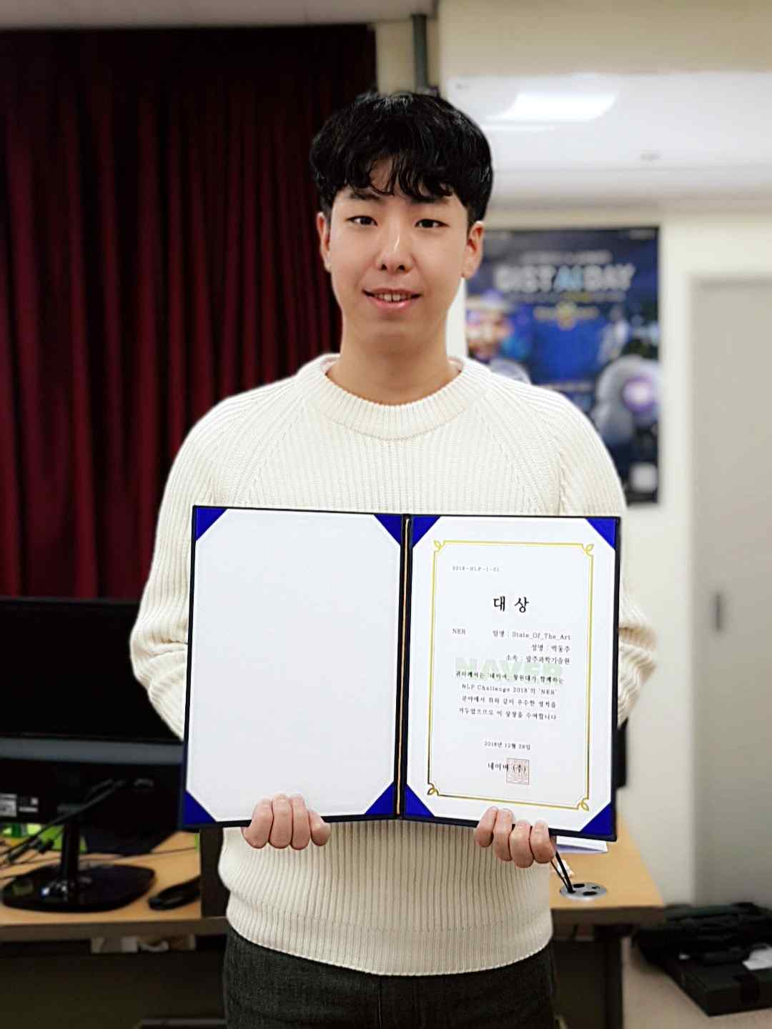

▲ Dong-ju Park of the State_Of_The_Art team won the Naver NLP Challenge