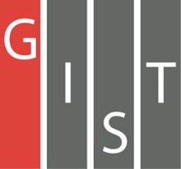

**Gwangju Institute of Science and Technology**

**Official Press Release (https://www.gist.ac.kr/)**

**Section of** Hyo Jung Kim Nayeong Lee

**Public Affairs** Section Chief Senior Administrator

(+82) 62-715-2061 (+82) 62-715-2062

**Contact Person** Professor Hong Kook Kim

**for this Article** School of Electrical Engineering

and Computer Science

(+82) 62-715-2228

**Release Date** 2019.12.04

**Professor Hong Kook Kim's research team wins AI Grand Challenge Award for audio recognition**

□ GIST (President Kiseon Kim) School of Electrical Engineering and Computer Science Audio Intelligence Technology & Research Lab (advisor: Professor Hong Kook Kim) participated in the '2019 AI Grand Challenge' * , which was held in Seoul, Korea, and hosted by the Ministry of Science and ICT, and won on second place in the audio recognition track.

* The '2019 AI R&D Grand Challenge' is based on the theme of 'saving lives quickly within the golden time in complex disaster situations using artificial intelligence and robotics,' which will be achieved in four stages by 2022 after the government presents a final goal that is difficult to currently achieve.

∘ Four tracks this year to focus on selecting teams that can use AI skills in specific areas to best solve specific problems: ▲ Track 1 situation: find specific people, objects, and buildings with video ▲ Track 2 character recognition: identify people at different angles and heights ▲ Track 3 audio recognition: estimate the direction of origin by listening to a person's call for help ▲ Track 4 control: navigate obstacles autonomously.

□ GIST formed the ‘WisenetAI_GIST’ (Nam-kyun Kim, Kwang-myung Jeon, Jung-min Moon, In-young Park, Kun-woo Lee, Joon-ho Kim, Jung-hyun Yang, Jung-eun Lim, Jin-soo Park, Ji-hyun Park, and advisor Professor Hong Kook Kim) with Hanwha Techwin to participate in 'Track 3 audio recognition' and was selected as the final 2nd among 33 participating teams. The participants from the Korea Institute of Construction and Technology, which occupied the first place, were also GIST graduates (advisor: Hong Kook Kim), who were honored to receive their awards.

∘ Professor Hong Kook Kim said, "I am very happy to be recognized for my achievements in AI technology development in the field of auditory intelligence. I will continue training students who can contribute to national AI development and create excellent research results that can contribute to establishing a social safety net."

□ Outstanding teams (ranked 1st to 3rd in each track) selected in the first stage of this year's competition received 6 billion won in annual research funds to continue their R&D activities along with the prize money. The second-place WisenetAI-GIST team plans to carry on two years of follow-up research with a fund of KRW 2 million and annual R & D support funding of KRW 500 million.

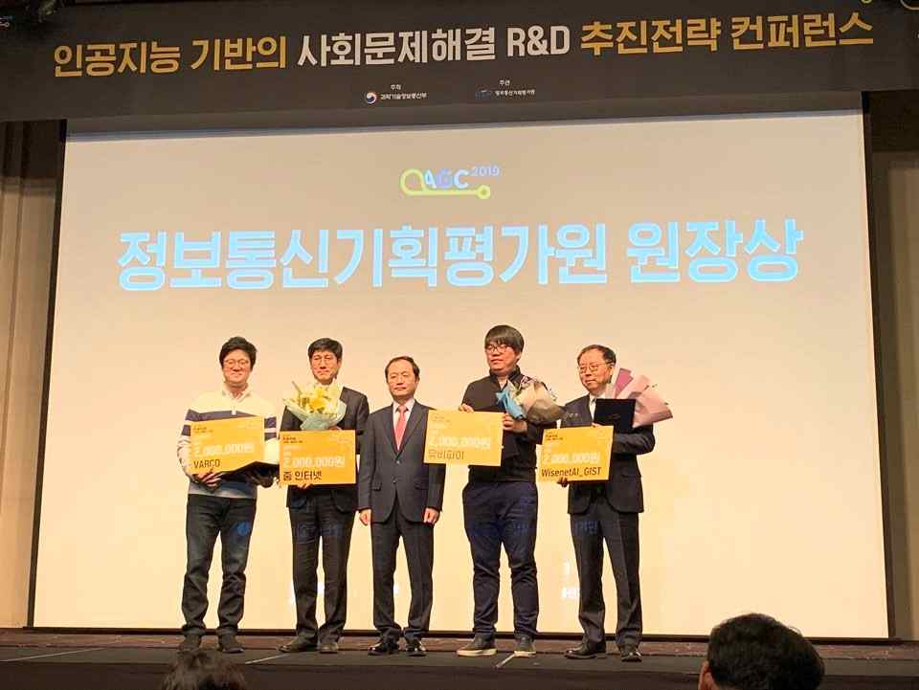

▲ Photo 1: 2019 AI Grand Challenge Contest (Professor Hong Kook Kim on the far right)

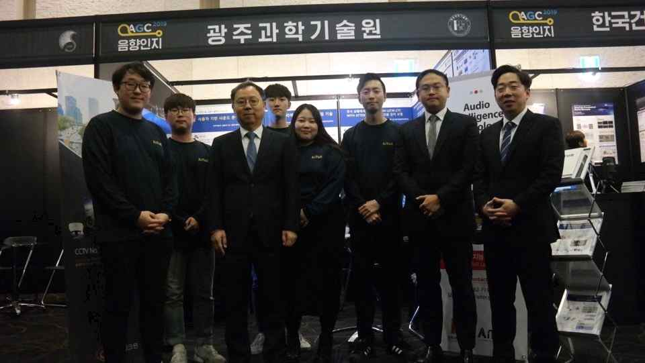

▲ Photo 2: Audio Intelligence Technology & Research Lab (from left) Nam-kyun Kim, Jung-min Moon, Professor Hong Kook Kim, Joon-ho Kim, In-young Park, Kun-woo Lee, Kwang-myung Jeon, and Chan-joon Jeon