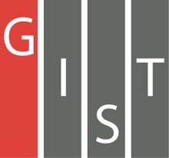

**Gwangju Institute of Science and Technology**

**Official Press Release (https://www.gist.ac.kr/)**

**Section of** Mi-Yeon Kim Nayeong Lee

**Public Affairs** Section Chief Senior Administrator

(+82) 62-715-2020 (+82) 62-715-2024

**Contact Person** Hee-min Kwak, Ph.D. student

**for this Article** School of Electrical Engineering

and Computer Science

(+82) 62-715-2286

**Release Date** 2019.06.03

**School of Electrical Engineering and Computer Science students Hee-min Kwak and Mun-do Park won the Outstanding Youth Startup Idea**

**Competition in 2019**

□ GIST (President Kiseon Kim) School of Electrical Engineering and Computer Science students Hee-min Kwak and Mun-do Park under Professor Dong-Seon Lee won the Outstanding Youth Startup Idea Competition, which was sponsored by GIST, Gwangju University, and the Ministry of SMEs and Startups.

∘ The competition was held from 10 a.m. to 7 p.m. on May 24, 2019, at GIST's Oryong Hall. After mentoring 50 teams out of 85 teams that applied for the competition, 10 teams were selected as finalists. The winning team and three runner-ups were selected through the finals.

□ Students Hee-min Kwak and Mun-do Park proposed the "LED module (fluorescent lamp type)" which aims to supply LED lights for easy use at home by supplementing the limitations and disadvantages of the existing LED modules.

∘ Recent LED modules can be replaced only if consumers have basic knowledge of electricity, while the LED modules proposed by Hee-min Kwak and Mun-do Park received high praise from the judges for their convenience in attaching them in the same way as existing fluorescent lights, and their replacement method due to a single element failure were also highly competitive in reducing replacement costs.

□ Student Hee-min Kwak said, "We wanted to develop LEDs that have been studied in our laboratory for a long time, not just for research but for easy use by many people. First of all, I would like to thank Professor Dong-Seon Lee and his colleagues who worked with me everyday to encourage us to do interesting and exciting research and actively supported our outside activities."

∘ The winners of the Outstanding Youth Startup Idea Competition in 2019 were awarded one million won.

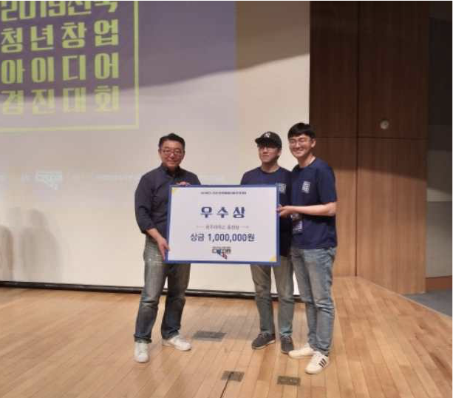

▲ [From left]: Chairman Sang-yong Ha of the Startup Support Network and School of Electrical Engineering and Computer Science Ph.D. students Mun-do Park and Hee-min Kwak