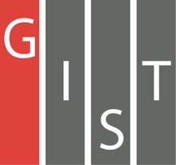

**Gwangju Institute of Science and Technology**

**Official Press Release (https://www.gist.ac.kr/)**

**Section of** Hyo Jung Kim Nayeong Lee

**Public Affairs** Section Chief Senior Administrator

(+82) 62-715-2061 (+82) 62-715-2062

**Contact Person** Professor Euiseok Hwang

**for this Article** School of Mechanical Engineering

(+82) 62-715-2785

**Release Date** 2020.02.14

**Professor Euiseok Hwang's research team wins the excellence award in a data science contest**

**by using big data for energy**

□ Gwangju Institute of Science and Technology (GIST, President Kiseon Kim) School of Mechanical Engineering Professor Euiseok Hwang's research team received the excellence award in the 'Energy Big Data Utilization Data Contest' organized by the Electronics and Telecommunications Research Institute (ETRI) and the Energy Valley Institute of Technology and hosted by the Data Competition Platform (DACON).

∘ The 'Big Data Energy Utilization Contest' is a competition that uses electrical and meteorological data to predict hourly, daily, and monthly power consumption for each household and company.

□ Professor Euiseok Hwang's research team was composed of Ph.D. students Ji-seok Yoon, Jun-ho Song, Seung-wook Yoon and predicted the electrical usage of 200 apartments and stores with a high degree of accuracy by using a selective learning-based prediction model.

∘ Selective learning-based forecasting model uses machine learning to analyze characteristic patterns of power usage based on statistical techniques to selectively learn and predict electrical usage and load on the power grid.

∘ Professor Euiseok Hwang research team competed against a total of 111 teams to win the excellence award by earning second place, and the award ceremony was recently held at GIST's Oryong Hall.

□ Professor Euiseok Hwang was the research team's advisor and said, "The proposed prediction model uses artificial intelligence to improve the prediction accuracy for power usage loads under different situations and is expected to be applied to various smart grid application technologies that require power usage prediction, such as responding to demand."

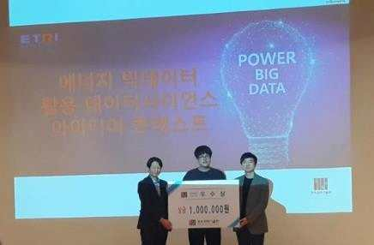

[Photo] Winning the excellence award in the 'Big Data Energy Utilization Contest'