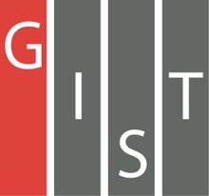

**Gwangju Institute of Science and Technology**

**Official Press Release (https://www.gist.ac.kr/)**

**Section of** Hyo Jung Kim Nayeong Lee

**Public Affairs** Section Chief Senior Administrator

(+82) 62-715-2061 (+82) 62-715-2062

**Contact Person** Gun-woo Lee, Ph.D. Student

**for this Article** School of Electrical Engineering

and Computer Science

(+82) 62-715-3121

**Release Date** 2019.08.26

**Professor Hong Kook Kim's research team wins the best paper award at the 2019 United States-Korea Conference (UKC)**

□ GIST (President Kiseon Kim) School of Electrical Engineering and Computer Science Professor Hong Kook Kim's research team wins the best paper award at the 2019 United States-Korea Conference (UKC).

∘ The 32nd annual UKC was held in Chicago, United States, from August 14 to 17, 2019, and is the largest science and technology conference among Korean and American scientists and was co-hosted by the Korean-American Scientists and Engineers Association (KSEA, President Jun-seok Oh), the Korean Federation of Science and Technology Societies (KOFST, President Myung-ja Kim), and the Korea-US Science Cooperation Center (KUSCO, Chairperson Jung-hye Noh).

□ The event was attended by presidents and researchers from Korean and American universities, including GIST, University of Chicago, University of Illinois, and Seoul National University. A symposium of 13 sub-departmental experts, joined by more than 40 sponsoring agencies, was also held, with 17 thematic forums on advanced scientific technology research and trends.

∘ This year 365 excellent papers, including oral presentations and posters, were published under the theme of smart science, engineering, and health for a better society. The paper "Speech denoising based on U-shaped neural network" led by GIST Professor Hong Kook Kim (corresponding author) and carried out by Ph.D. student Gun-woo Lee (first-author) was honored with the best paper award by describing an effective method to eliminate noise by applying deep learning mixed with speech.

□ Professor Hong Kook Kim said, "In-depth discussion and research on signal processing applied deep learning in the era of the 4th Industrial Revolution is more important than ever. The improvement of sound quality in a harsh noise environment is very likely to be used for voice recognition systems for industrial and disaster applications in the future."

∘ Gun-woo Lee, the first-author of the paper, said, "The recent application of deep learning structure, which has been actively researched, regarding sound noise abatement, seems to have resulted in the award due to being in line with the interest of the UKC. The award in this competition is very meaningful, and I feel honored and will be more sincere with my research in the future."

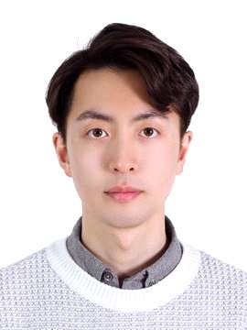

▲ Gun-woo Lee, recipient of the UKC Best Paper Award