

**Gwangju Institute of Science and Technology**

**Official Press Release (https://www.gist.ac.kr/)**

**Section of** Hyo Jung Kim Nayeong Lee

**Public Relations** Section Chief Senior Administrator

(+82) 62-715-2061 (+82) 62-715-2062

**Release Date** 2020.10.27

**School of Earth Sciences and Environmental Engineering master's student Jung Goo Choi won the Electrochemical Society's excellent poster award**

□ GIST (Gwangju Institute of Science and Technology, President Kiseon Kim) School of Earth Sciences and Environmental Engineering master's student Jung Goo Choi (advisor: Professor Jaeyoung Lee) was selected as the recipient of the "PEFC&E20 2nd Place Best Poster Winner, selected in the field of high molecular electrolyte fuel cells and electrolyzers by the 2020 Electrochemical Society (ECS PRiME 2020)."

∘ The Electrochemical Society (ECS) is the most prestigious international academic conference in the field of electrochemistry and was established in Philadelphia, United States, in 1902. In particular, the PRiME (Pacific Lim Meeting) is a very large conference that is held every four years and is co-hosted by Korean and Japanese electrochemical societies.

∘ This year's Electrochemical Society (ECS PRiME 2020) was conducted online from October 4 to 9 and received more than 3,300 abstracts with 75 online symposiums being held.

□ Professor Jaeyoung Lee's research team synthesized phosphorus in a carbon layer and produced a Pt/C-P type catalyst doped with phosphorus on the carbon support of the platinum catalyst. As a result of analyzing the properties of the synthesized catalyst, the reactivity to methanol was lower than that of the existing platinum-based catalysts. In particular, even when a small amount of methanol was present, the reactivity to oxygen was maintained, and the methanol permeation phenomenon was overcome and high performance was confirmed.

∘ This research makes it possible to overcome the methanol permeation phenomenon and improve the performance of the methanol fuel cell, and this is expected to contribute significantly to the development of catalyst synthesis using the doping of heterogeneous elements.

□ Master's student Jung Goo Choi said, "I am very honored to receive an award from a prestigious academic society, and I would like to further develop and communicate good research results to the world. Because renewable energy has recently been drawing attention, I want to become a researcher who helps fuel cells play a central role."

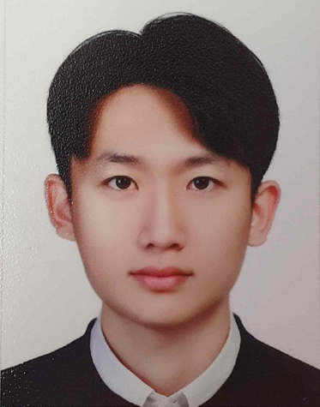

▲ Electrochemical Society's excellent poster award recipient Jung Goo Choi