

**Gwangju Institute of Science and Technology**

**Official Press Release (https://www.gist.ac.kr/)**

**Section of** Hyo Jung Kim Nayeong Lee

**Public Relations** Section Chief Senior Administrator

(+82) 62-715-2061 (+82) 62-715-2062

**Contact Person** Professor Jang-Soo Chun

**for this Article** School of Life Sciences

(+82) 62-715-2497

**Release Date** 2020.04.17

**Professor Jang-Soo Chun won the**

**3rd LINA 50+ Awards Respect for Life**

□ GIST (Gwangju Institute of Science and Technology, President Kiseon Kim) School of Life Sciences Professor Jang-Soo Chun was selected as the winner of the third 'LINA 50+ Awards' Respect for Life category hosted by the LINA Genetic Foundation, a social contribution foundation for LINA Life Insurance.

∘ Due to the COVID-19, no awards ceremony will be held, but officials from the foundation, including Mun-cheol Han, executive director of the Raina Foundation, visited GIST on April 16 and delivered the award to Professor Jang-Soo Chun on the first floor of the GIST administration building.

□ The 'LINA 50+ Awards' is the first award in Korea for the 50+ generation to mark the 30th anniversary of the founding of RINA Life Insurance and marks its third anniversary this year. It is given to individuals or organizations that have realized the value of 50+ generations' health, improving the quality of life, and respect for life in various specialized areas such as academic research, technology, and industry.

∘ The award categories include Respect for Life, Social Contribution, and Creative Innovation with a first prize award of 100 million won for each.

□ Professor Jang-Soo Chun, who was selected as the winner of the Respect for Life category, was the first in the world to show a correlation between degenerative arthritis and joint cartilage cholesterol, which is common in 50+ generations, and published his research results in the international journal Nature.

∘ Degenerative arthritis is a typical degenerative disease that reduces quality of life, but fundamental prevention and treatment methods have not been developed because no clear causes of the disease have been identified until now. Professor Jang-Soo Chun's research team found that cholesterol abnormally increased from degenerative cartilage compared to normal cartilage and that increased cholesterol metabolites caused degenerative arthritis through a series of processes, suggesting a clue to the development of fundamental prevention and treatment for arthritis.

□ Professor Jang-Soo Chun said, "It is all the more meaningful to be awarded at the 'Lina 50+ Awards' for the 50+ generation, which was first offered in Korea by the LINA Foundation. In the era of centenarians, I would like to continue to carry out research on health and well-being, not just to live longer, but to contribute to improving the quality of life and realizing the value of human life."

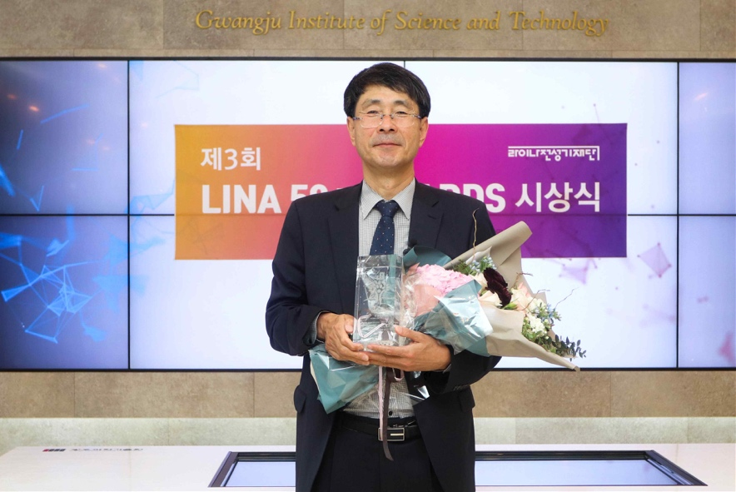

[Photo] Professor Jang-Soo Chun won the 3rd LINA 50+ Awards