Gwangju Institute of Science and Technology

Official Press Release (https://www.gist.ac.kr/)

Section of Hyo Jung Kim Nayeong Lee
Public Affairs Section Chief Senior Administrator
(+82) 62-715-2061 (+82) 62-715-2062

Contact Person Section of Public Affairs
for this Article (+82) 62-715-2061~2063

Release Date 2019.12.03

Professor Yong-Chul Kim and Professor Chanho Pak appointed as members of the National Research Foundation of Korea

□ GIST (President Kiseon Kim) Professor Yong-Chul Kim School of Life Sciences and Professor Chanho Pak of the School of Integrated Technology have been appointed as members of the National Research Foundation of Korea.

∘ The National Research Foundation of Korea operates a research project management system by experts in academic and R&D fields to effectively manage academic and R&D support projects and to maintain professionalism and fairness in project management.

∘ The expert committee will play a role in recommending candidates for the evaluation of research projects in the relevant fields of academic and R&D support projects, reviewing the results of online evaluations, establishing plans for planning and budget allocation, and evaluating new research projects.

□ Professor Yong-Chul Kim is an expert in the field of new drug discovery and Professor Chanho Pak is an expert in energy and fuel cells; both appointments are for one year and eight months until June 2021.

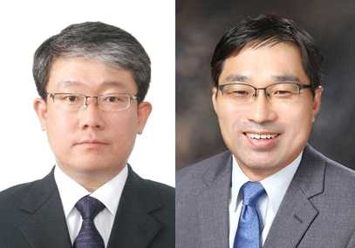
▲ School of Life Sciences Professor Yong-Chul Kim and
School of Integrated Technology Professor Chanho Pak

