

**Gwangju Institute of Science and Technology**

**Official Press Release (https://www.gist.ac.kr/)**

**Section of** Hyo Jung Kim Nayeong Lee

**Public Affairs** Section Chief Senior Administrator

(+82) 62-715-2061 (+82) 62-715-2062

**Contact Person** Professor Hong Kook Kim

**for this Article** School of Electrical Engineering

and Computer Science

(+82) 62-715-2228

**Release Date** 2020.02.05

**Professor Hong Kook Kim's research team wins the Excellence Award in the 2019 Human Plus Convergence R&D Challenge Program**

□ Gwangju Institute of Science and Technology (GIST, President Kiseon Kim) School of Electrical Engineering and Computer Science Audio Intelligence Technology & Research Lab (Professor Hong Kook Kim) received the 2019 National R&D Real Challenge Program Excellence Award that was hosted by KIRD (Director Sung-chan Cho).

∘ As part of the Human Plus Convergence R&D Challenge Program of the Ministry of Science and ICT, the program was aimed at strengthening graduate students' research capabilities centered on practical experience, and the research topic was open to any idea focused on overcoming human limitations through science and technology.

□ The Audio Intelligence Technology & Research Lab formed a team with 'Inflow' (Research Director: Dr. Nam-kyun Kim, Ph.D. student Gun-woo Lee, Inflow CEO Kwang-myng Jeon, Professor Hong Kook Kim, and Seoul National University of Science and Technology Mentor Professor Seung-ho Choi) participated in the competition under a theme to 'develop technologies to enhance basic human capabilities,' with particular emphasis on technologies to enhance human hearing among the basic five senses. The 'Inflow' team competed against 15 other teams to receive the excellence award. The award ceremony was held at Daejeon Tech Biz Center on January 29, 2019.

∘ Under the theme of 'AI device-based hearing enhancement technologies,' the research team proposed and announced technologies to overcome limitations of human hearing in complex and difficult environments (long distances, high-noise, etc.) with wearable (bluetooth handsets) and non-wearable (drones, unmanned vehicles) AI-based devices as hearing enhancement technologies for cognitive improvement over normal human hearing.

□ Professor Hong Kook Kim of the 'Inflow' team said, "The Audio Intelligence Technology & Research Lab has been continuously studying AI-based audio enhancement technologies, and we hope that this technology will be an opportunity to lay the groundwork for the development of the AR/VR industry."

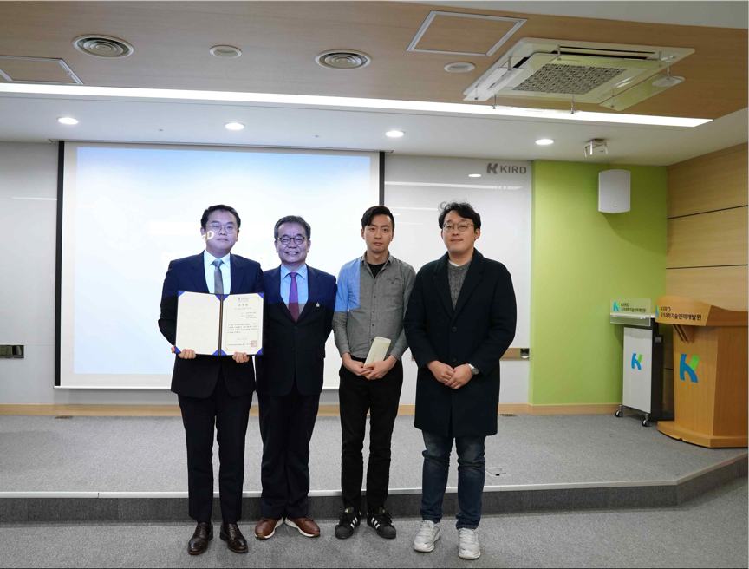

▲ Award photo with KIRD Director Sung-chan Cho