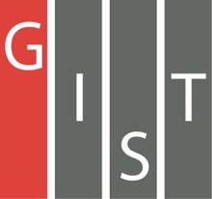

**Gwangju Institute of Science and Technology**

**Official Press Release (https://www.gist.ac.kr/)**

**Section of** Hyo Jung Kim Nayeong Lee

**Public Relations** Section Chief Senior Administrator

(+82) 62-715-2061 (+82) 62-715-2062

**Contact Person** Yoon-kwan Lee, Student

**for this Article** School of Electrical Engineering

and Computer Science

062-715-3254

**Release Date** 2020.11.23

**Professor Moongu Jeon's team won the best student thesis award from the Intelligent Vehicles Symposium**

□ GIST (Gwangju Institute of Science and Technology, President Kiseon Kim) School of Electrical Engineering and Computer Science Professor Moongu Jeon's (adjunct to the Artificial Intelligence Graduate School) research team won the Best Student Paper Award for recognizing driving conditions of autonomous vehicles at the Intelligent Vehicles Symposium 2020 (IV2020), a renowned international academic conference on autonomous vehicles.

∘ The 31st Intelligent Vehicles Symposium to be held this year is hosted by the American Institute of Electrical and Electronic Engineers (IEEE) Intelligent Transportation System Society (ITSS) and is considered one of the most prestigious international academic conferences in the field of intelligent automobiles to compare the level of core technologies related to intelligent cars being developed in countries around the world.

□ This year's international Intelligent Vehicles Symposium was held online from October 19th to November 13th. About 600 experts in the field of intelligent automobiles participated in the conference, which received more than 500 papers from 40 countries around the world, including Germany, Japan and the United States, as well as China and France, which are the three most advanced countries in automobile technology.

∘ In particular, at this conference, not only global automobile manufacturers such as BMW, Volkswagen, Benz, Audi, General Motors, Toyota, Honda, and Hyundai Motor, but also the world's leading auto-driving intelligent technology labs from Stanford University, MIT, Carnegie Mellon University in the U.S., Munich University in Germany, Oxford University in the U.K., Cambridge University, Tokyo University, Paris Institute of Technology, and Seoul National University in Korea, and Hanyang University participated and presented their latest research results.

∘ This year, a total of 275 papers were presented at the main conference and 21 workshops, of which three were selected for the Best Student Paper Award: the research team of Karlsruhe Institute of Technology in Germany, the joint research team of Chalmers University of Technology and Volvo in Sweden, and the research team of GIST Professor Moongu Jeon.

□ "Context-Aware Multi-Task Learning for Traffic Scene Recognition in Autonomous Vehicles" was led by Professor Moongu Jeon (corresponding author) and conducted by Yoon-kwan Lee (first author) who is in the integrated master's and doctoral program and presented a methodology based on computer vision and artificial intelligence that can solve the problems that arise when recognizing driving situations for autonomous vehicles.

∘ The context-aware artificial intelligence technology that utilizes Context-Aware developed by Professor Moongu Jeon's research team is a way to effectively exclude misinformation and capture only the essential features of data. Even in situations where tasks with multiple predictive difficulties are mixed, the AI model only extracts the features that are appropriately relevant and derives more accurate situational driving recognition results.

∘ Through this research, it is expected that in the short term, it can be applied to advanced driver assistance systems (ADAS) at level 3 for autonomous driving as well as a source technology for fully autonomous driving at level 4.

□ The student winner Yoon-kwan Lee said, "I am very honored to receive a big award from a prestigious international conference, and I will continue the research to realize fully autonomous driving amid the fierce competition for autonomous driving technology development in the global market."

□ Professor Moongu Jeon's research team is planning to introduce fully autonomous driving in real-world cities based on the original self-driving technology that has been independently developed.

▲ [Photo 1] GIST School of Electrical Engineering and Computer Science Professor

Moongu Jeon and integrated master's and doctoral student Yoon-kwan Lee

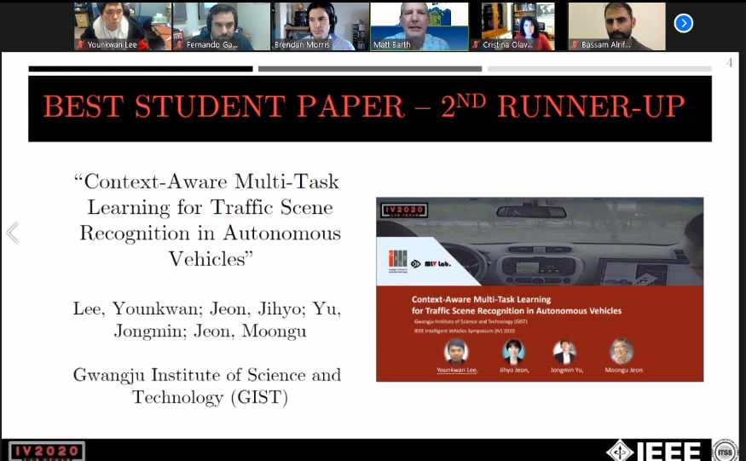

▲ [Photo 2] Online-award for the Intelligent Vehicles Symposium