

**Gwangju Institute of Science and Technology**

**Official Press Release (https://www.gist.ac.kr/)**

**Section of** Hyo Jung Kim Nayeong Lee

**Public Affairs** Section Chief Senior Administrator

(+82) 62-715-2061 (+82) 62-715-2062

**Contact Person**

**for this Article**

**Release Date**

**GIST Professor Young Min Song and Senior Researcher Sang-hwa Lee were selected as '30 Star Researchers to Shine the Future' in commemoration of the 30th anniversary of the Optical**

**Society of Korea**

□ GIST (President Kiseon Kim) School of Electrical Engineering and Computer Science Professor Young Min Song and Advanced Photonics Research Institute (APRI) Senior Researcher Sang-hwa Lee were selected as '30 Star Researchers to Shine the Future' in commemoration of the 30th anniversary of the Optical Society of Korea.

∘ To celebrate the 30th anniversary of its founding and to revitalize the field of optics, the Optical Society of Korea has named 30 people who will brighten the future of Korea's optics industry under the theme of '30 Star Researchers to Shine the Future.'

∘ The winners were selected from researchers under the age of 40 who have demonstrated excellent research and contributions to the field of optics in Korea.

□ Professor Young Min Song was selected as a winner in recognition of his contribution in the field of flexible devices based on photonics technology, including passive radiation cooling for flexible devices, ultra-thin color filters and transparent electrodes.

∘ Dr. Sang-hwa Lee was selected as a winner for his work on bio-optical technologies such as single-molecule fluorescence imaging in the field of life sciences to identify mechanisms of major biomolecules, including CRISPR gene editing.

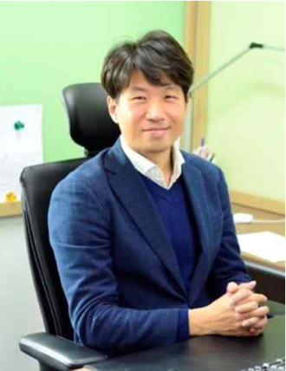 

▲ [From left] GIST School of Electrical Engineering and Computer Science

Professor Young Min Song and APRI Senior Researcher Sang-hwa Lee