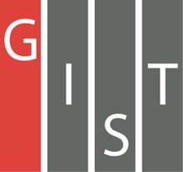
Gwangju Institute of Science and Technology

Official Press Release (https://www.gist.ac.kr/)

Section of Hyo Jung Kim Nayeong Lee
Public Relations Section Chief Senior Administrator
(+82) 62-715-2061 (+82) 62-715-2062

Contact Person Professor Joon Ha Kim
for this Article School of Earth Sciences
and Environmental Engineering
(+82) 62-715-3277

Release Date 2020.04.21

Professor Joon Ha Kim appointed as a member of the Presidential Committee on Policy Planning

□ GIST (Gwangju Institute of Science and Technology, President Kiseon Kim) School of Earth Sciences and Environmental Engineering Professor Joon Ha Kim was appointed a member of the Presidential Committee on Policy Planning.

∘ Professor Joon Ha Kim is a member of the National Growth Division, and will participate in coordination of science and technology national affairs, policy planning, and consulting.

□ The Committee on Policy Planning was established under the leadership of the president in December 2017 and has served as a 'think tank' for coordinating 100 national government coordination tasks and policy issues, researching policy issues, and planning national development strategies and policy directions.

∘ This year, the second committee will be formed to operate four new divisions: national sovereignty (policy, administrative, judicial), national growth (economy, science and technology), inclusive society (welfare, labor, environment, autonomous decentralization, balanced development), and peaceful prosperity (diplomacy, security).

□ Professor Kim said, "Based on practical experiences from the field, the bridge between the new science and technology and the implementation policy shall be faithfully performed. In particular, we will actively participate in the current administration's search for future new industries, job economy, and innovative growth."

□ Professor Joon Ha Kim has been actively participating in research projects such as the Ministry of Science and ICT, the Ministry of Environment, and the Ministry of Land, Infrastructure and Transport since he was appointed as a professor at GIST in 2004, and he has been building expertise in environmental big data research for decades. Recently, he participated as a strategic planner in the project of creating an integrated artificial intelligence industrial complex in Gwangju, contributing to the establishment of the current government's national affairs. Currently, he is an expert in environmental supercomputing at the Ministry of Science & ICT and is the head of the Urban Environment Center and actively participates in fostering new technologies for artificial intelligence and big data.

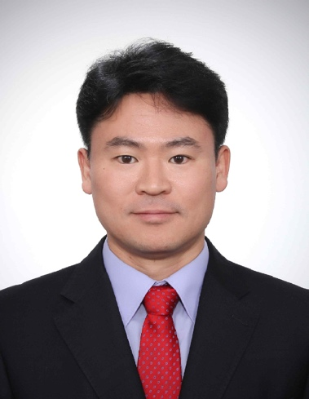
▲ GIST Professor Joon Ha Kim

