Ko Yong-seok, Doctoral Student in the School of Earth Sciences and Environmental Engineering,
Receives the Outstanding Student Poster Award from the American Society for Microbiology

- Microorganisms isolated from contaminated soil, producing large amounts of hydrogen peroxide... Utilized for plastic decomposition.

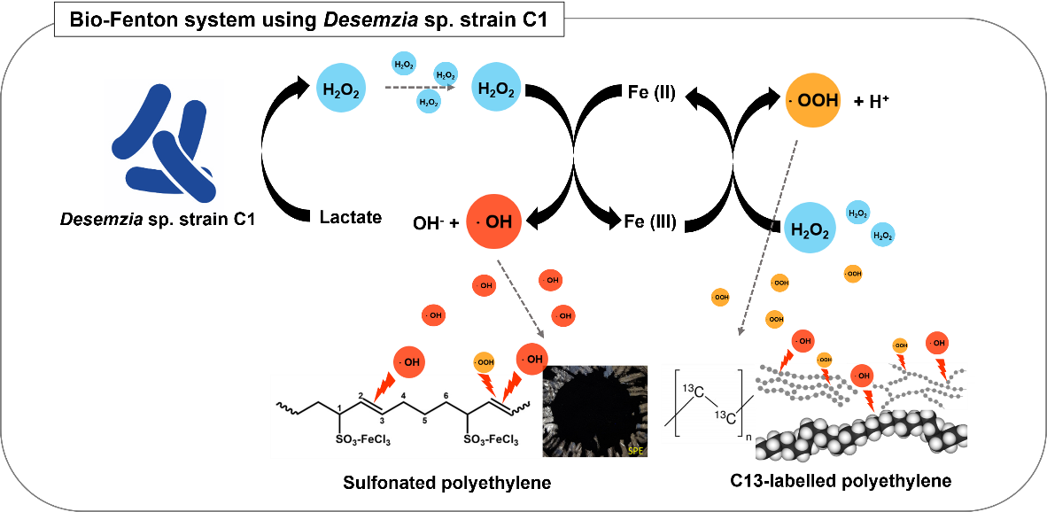
▲ Schematic diagram of decomposition technology for non-degradable organic pollutants using a large amount of hydrogen peroxide-producing microorganisms.

GIST (Gwangju Institute of Science and Technology, Park Rae-gil, Acting President) doctoral student Ko Yong-seok (advisor: Heo Ho-gil) in the School ofEarth Sciences and Environmental Engineering received the Outstanding Student Poster Award at the 2023 American Society for Microbiology (ASM) conference held in Houston, Texas.

Ko Yong-Seok discovered that microorganisms isolated from oil-contaminated environments produce large amounts of hydrogen peroxide, and he identified the optimal hydrogen peroxide production condition and genes contributing to the hydrogen peroxide production. (Dissertation title: Characterization of H2O2-Producing Bacteria, Desemzia sp. Strain C1 Isolated from Oil Contaminated Soil)

This research is expected to be used in the future to effectively decompose various organic substances, including plastics, in a non-specific manner by generating the hydroxyl radical through the Bio-Fenton reaction using this microorganism.

Ko expressed his feelings, saying, "I am grateful to my advisor and lab colleagues who have always devoted themselves to my research.” He added, "I want to contribute to solving the problem of environmental pollution by further devoting myself to research.”

Ko’s adviser, Prof. Heo Ho-gil, stated, “It is quite meaningful that the excellence of this research has been recognized at a world-class conference.” He added, “I hope that he will continue to grow as a renowned researcher in his field.”

The American Society for Microbiology, founded in 1899, is an academic organization representing microbiology around the world and has about 30,000 researchers as members. More than 5,000 members participated in this conference and more than 2,500 academic posters were presented.

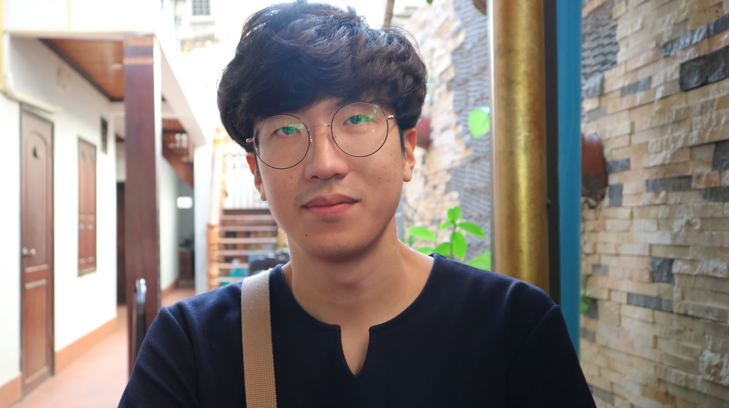
▲ Ko Yong-seok receives award from the American Society for Microbiology.

