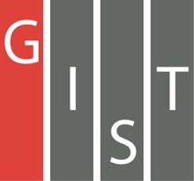

**Gwangju Institute of Science and Technology**

**Official Press Release (https://www.gist.ac.kr/)**

**Section of** Mi-Yeon Kim Nayeong Lee

**Public Affairs** Section Chief Senior Administrator

(+82) 62-715-2020 (+82) 62-715-2024

**Contact Person** Heewon Jung, Ph.D. student

**for this Article** School of Earth Sciences and

Environmental Engineering

(+82) 62-715-2461

**Release Date** 2019.01.30

**GIST students win the Grand Prize and**

**Excellence Award in EDISON SW competition**

□ GIST (President Seung Hyeon Moon) – Students from the School of Earth Sciences and Environmental Engineering won the Grand Prize in the Urban Environment and the Excellent Award at the 8th Advanced Science and Technology (EDISON) Software Contest.

∘ EDISON * is a contest to develop science and engineering undergraduate and graduate students by having them solve various scientific problems and to have them publish papers and present simulation SW developed by EDISON six specialized centers.

* EDISON is an educational and research service for the 4th Industrial Revolution tat is built to be used anytime and anywhere by incorporating computational science engineering SW into a supercomputer-linked web-based platform. EDISON has built a web portal for seven computational science engineering fields including structural dynamics, computational design, computational medicine, and urban environment.

□ The winner of the Grand Prize was the Non-normal team, which was comprised of students from the School of Earth Sciences and Environmental Engineering: Ji-soo Son (college senior), Dong-joo Seo (master's), and Da-sol Choil (integrated). The winner of the Excellence Award was the TeamFive team, which was comprised of students from the School of Earth Sciences and Environmental Engineering: Hye-won Kim (master's), Nguyen Thi Ha (Ph.D.), and Ji-hoon Ryu (master's).

∘ The Non-normal team analyzed whether Ulsan's SO2 was statistically influencing other cities, and the TeamFive team evaluated heavy metal contamination of rice and rice fields surrounding the Vietnamese mines.

□ All six students who received prizes participated in the competition by forming teams to conduct statistical analysis projects were conducted by Professor Joon Ha Kim for his School of Earth Sciences and Environmental Engineering statistics course.

∘ In particular, even though graduate students were the main participants in this competition, college student Ji-soo Son showed outstanding abilities, including her research as a team leader and her presentation with graduate students.

□ College student Ji-soo Son said, "I appreciated this valuable opportunity to experience the research process provided by the competition and to present my paper, and I have become more interested in applying various statistical testing techniques to data closely related to real life through EDISON SW. In the future, I hope that my research will contribute to the identification of the causes of air pollution."

□ Professor Joon Ha Kim, who directed the students, said, "In the era of the 4th Industrial Revolution, the environmental industry needs environmental engineers with practical research skills who are also familiar with big data processing. Based on the experience gained from participating in the competition, I hope that the students will be able to handle environmental data from basics to applications."

□ The '8th EDISON SW Development Competition' was held at Daejeon KT Human Resource Development Center on January 24 and 25, 2019, and 300 students in 165 teams participated in six specialties: environment, nano-physics, computational chemistry, structural dynamics, computational design, and computational medicine. In addition, the participation of Hee-kyung Song, a member of the National Assembly's Industrial Revolution Committee, attracted attention. In the keynote lecture entitled "Future for SW Movement," the message of "challenge your heart" was also inspiring.

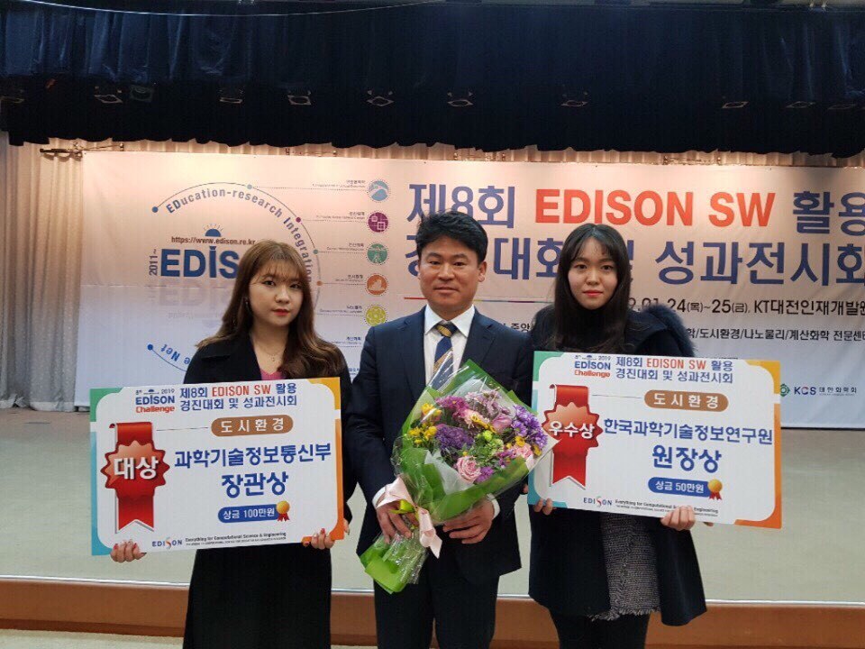

▲ EDISON competition awards ceremony photo

From left: Ji-soo Son, Professor Joon Ha Kim, and Hye-won Kim