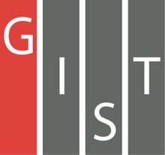
Gwangju Institute of Science and Technology

Official Press Release (https://www.gist.ac.kr/)

Section of Hyo Jung Kim Nayeong Lee
Public Relations Section Chief Senior Administrator
(+82) 62-715-2061 (+82) 62-715-2062

Contact Person Section of Public Relations
for this Article +(82) 62-715-2061~2063

Release Date 2020.06.29

GIST Professor In S. Kim is appointed as a member of the National Science and Technology Advisory Council

□ GIST (Gwangju Institute of Science and Technology, President Kiseon Kim) Vice President for R&DB and School of Earth Sciences and Environmental Engineering Progessor In S. Kim was newly appointed on June 27, 2020, as a member of the President's 3rd National Science and Technology Advisory Council.

∘ New members of the committee include GIST Professor In S. Kim △ KAIST Computer Science Professor Soo-bok Moon △ Materials Research Institute Director Hee-sook Yoon △ Science and Technology Policy Institute Research Fellow Jung-won Lee △ SK Biopharmaceuticals CEO Jung-woo Cno. The newly appointed committee members will serve for one year until June 26, 2021.

∘ The newly appointed members were selected in consideration of various factors such as expertise and research achievements in science and technology, policy experience, industry-academic-related experience, outstanding researchers in universities and research institutes, and those with professional knowledge and experience in economic and industrial fields.

□ The National Science and Technology Advisory Council is a constitutional organization directly under the President established for innovation in national science and technology, and is composed of advisory and deliberative meetings.

∘ In particular, the deliberation council is the highest review body in the field of science and technology based on the National Science and Technology Advisory Council Act and has nine civilian members, including the chairman (President), vice speakers, and professors related to science and technology, and five ministers and assistant secretaries of science and technology (executive secretaries), who will make a final review of policies and budgets in the field of science and technology.

□ Professor Kim said, "Based on my professional knowledge and long research experience as a scientist, I will faithfully fulfill the role as a bridge between new science and technology and the implementation of policies. In particular, I will emphasize human-centeredness in science and technology research and actively participate in national development through innovation and human resources development leading the 4th Industrial Revolution."

□ Since he became the first professor of GIST in 1994, Professor In S. Kim has contributed greatly to the nation's growth engine through fostering scientific talent and excellent research and development. He is currently serving as GIST Vice President for R&DB, including research planning and strategy.

∘ In addition, he has served various ministries, including the Ministry of Science and ICT, the Ministry of Environment, and the Ministry of Land, Infrastructure and Transport, and has carried out large-scale national projects in the areas of national territory environmental protection, water resources, and sustainable renewable energy. In particular, he served as the chairman of the Water Environment Division of the Central Environmental Policy Committee of the Ministry of Environment and is regarded as a researcher who has achieved outstanding results in the renewable energy sector and has gained global recognition.

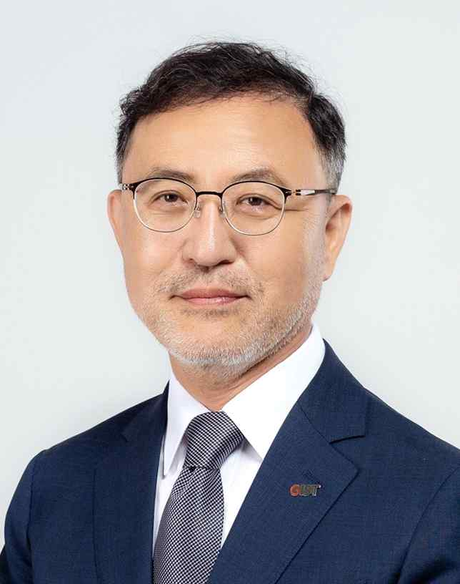
▲ Vice President for R&DB In S. Kim

