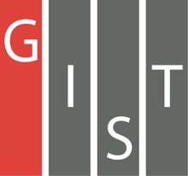
Gwangju Institute of Science and Technology

Official Press Release (https://www.gist.ac.kr/)

Section of Hyo Jung Kim Nayeong Lee
Public Affairs Section Chief Senior Administrator
(+82) 62-715-2061 (+82) 62-715-2062

Contact Person Professor Yong Gu Lee
for this Article School of Mechanical Engineering
(+82) 62-715-2396

Release Date 2019.12.24

Professor Yong Gu Lee's research team wins "Grand Prize" at AI Video Analysis Competition for AI accident assessment system

□ Gwangju Institute of Science and Technology (GIST, President Kiseon Kim) School of Mechanical Engineering Professor Yong Gu Lee's research team won the grand prize award at the 1st Soka X Korean Institute of Information Scientists and Engineers AI Video Analysis Competition * held in Pyeongchang, Korea, on December 20, 2019.

* Soka, the AI Image Analysis Contest, hosted by the Korean Institute of Information Scientists and Engineers, is an AI image analysis contest aimed at implementing new technologies related to next-generation mobility using vehicle black boxes and photographs.

∘ The research team consisted of Professor Yong Gu Lee, Ph.D. student Seong-jae Lee, researchers Ho-jeong Shin, and researcher Jin-soo Kim proposed a 'system to assess accident errors using artificial intelligence technology' after receiving black box images that show the situation at the time of the accident.

□ The core technology of the accident assessment system is that artificial intelligence learns from past data and judges accident errors on its own without human intervention during the analysis.

∘ In particular, the data used for the AI network learning used video sources without data processing, such as image quality improvement and labeling * , to minimize human labor. This allows companies with multiple data sources to utilize the network at no additional cost.

* Labeling: The task of marking the location of cars, traffic lights, etc. on an AI network for learning. This is the most time-consuming and costly step in developing an AI network.

□ Professor Yong Gu Lee said, "The developed network is the world's first video analysis providing an AI legal analysis system, which will be used as the basis for artificial intelligence legal video analysis for legal services by using video recordings, such as CCTV analysis, in addition to black boxes."

□ Professor Yong Gu Lee and his research team have been conducting research related to AI and mobile technology such as 'Autonomous Vehicle Technology Development' since 2018 with the support of the ICT convergence industrial source technology project * and GIST artificial intelligence development project **, which has been promoted by the Ministry of Science and ICT and the Ministry of Strategy and Planning.

* Project name "Developing open data set and cognitive processing technology for dynamic characteristics (police officers, traffic safety personnel, pedestrians, etc.) affecting autonomous driving" (18.05.01 to 21.12.31 (44 months)

** Project name "Building a Pedestrian Path Prediction Dataset for Self-driving Cars," project name "Developing Fruit Detection and Classification System for Smart Farming Using Deep-Learning Algorithms and Grippers"

∘ In the future, the research team plans to expand the function of the artificial intelligence network to analyze various accidents, such as car drivers and motorcycles. In addition, the developed system will be developed as a smartphone application to establish an environment where the accident rate can be measured immediately.

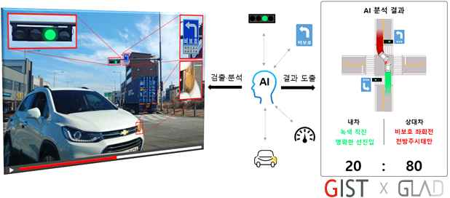
[Figure 1] Accident assessment analysis system using artificial intelligence network

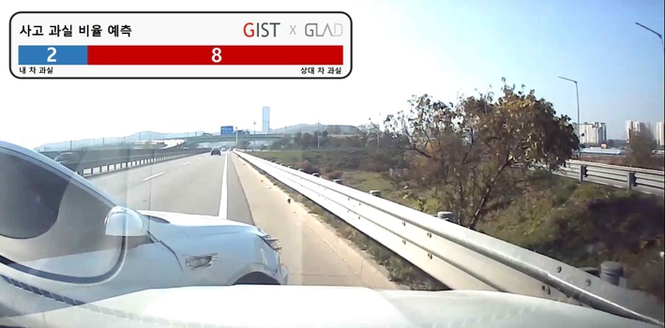
[Figure 2] Network learning results

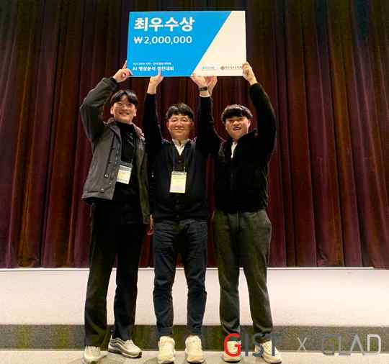
[Photo 1] Winning "Grand Prize" award at the AI Video Analysis Competition

