Tech Fusion for All: An Interview with Prof. Heung-No Lee, Director of GIST Blockchain Intelligence Convergence Center and CEO of Libervance

- Professor Lee Heung-no’s start-up “LiberVance” launched Worldland Mainnet in August.
- LiberVance is preparing the “MY AI Net” service to address obstacles in AI development.

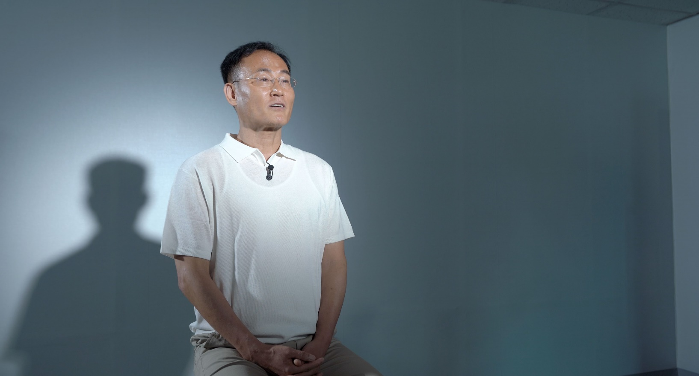
▲ Lee Heung-no, CEO of LiberVance (professor of GIST’s School of Electrical and Computer Engineering)

[Special Report/Technology Integration Innovation①] Paving the Way for the Convergence of Blockchain and AI

Artificial Intelligence (AI) and blockchain – these two technologies are establishing themselves as core universal technologies that can provide new growth momentum in a world where low growth has become the new normal. Not only professionals in related fields, but also the general public now encounter these familiar names represented by AI, such as ChatGPT, and blockchain technology, which forms the basis of virtual assets.

However, despite being recognized as key technologies that will drive future growth, individual technologies have their own limitations when examined closely.

Concerns about bias and ethical violations in AI, issues with errors, and challenges in securing training data are among the key challenges identified by many researchers as issues to be addressed in AI. Even in the recent "AI Week 2023" jointly organized by the Ministry of Science and ICT and Google in July, the importance of researching self-learning AI and interactive AI was emphasized.

Blockchain also has its limitations. The well-known challenges of blockchain, often referred to as the "trilemma," include decentralization, security, scalability, and other technical limitations, which remain as challenges to be overcome for the next-generation blockchain innovation. Independent blockchain mainnet development, in particular, is seen as a significant hurdle in blockchain development. The mainnet is the space where blocks from the initial (genesis) block of the blockchain network to the operating blocks are recorded, and it serves as an independent platform for blockchain projects.

GIST (Gwangju Institute of Science and Technology, Acting President Park Rae-gil) Blockchain Intelligence Convergence Center and professor’s start-up company, LiberVance (CEO, Lee Heung-no) are dedicated to efforts that complement and integrate these two technologies. The recently developed Worldland Mainnet, resulting from joint research by the center and LiberVance, is a prominent achievement of these efforts.

* LiberVance is a company with specialized technical expertise in blockchain and artificial intelligence. It aims to complement the inequalities and gaps that can arise from advancements in growth-oriented technologies such as artificial intelligence with inclusion, transparency, and decentralization through blockchain, allowing all market participants to grow.

Worldland pursues a global decentralized digital network. Serving as a GPU cloud, which is essential for AI training, Worldland provides an environment for advancing AI models transparently, robustly, and innovatively by applying its proprietary technology, the Verifiable Computation Algorithm (VCA). VCA technology boasts high decentralization and advanced encryption capabilities, including quantum resistance and Anti-ASIC characteristics, ensuring high security. Moreover, Worldland, based on Proof of Work (PoW), has implemented Green VCA technology to significantly reduce energy consumption, accounting for over 90% of Bitcoin network energy consumption. LiberVance successfully launched the Worldland Mainnet on August 8th and garnered interest from various blockchain-related experts, politicians, associations, companies, and academic societies at the Mainnet launch event held on the 10th of the same month, including National Assembly Member Yang Hyang-ja, Chairman of the Korea ICT Convergence Association Baek Yang-soon, and Chairman of the Korea Blockchain Forum Kim Ki-heung, who all expressed interest in Worldland Mainnet's vision and technological capabilities.

The presentation of various decentralized applications (dApps) based on the completed Mainnet with high blockchain technology is a key factor in completing the Worldland project. LiberVance is preparing the "MY AI Net" service to address the obstacles in AI development, such as securing high-quality training data and collaborative learning. MY AI Net can give rise to specialized AI agents according to the network users' professions, preferences, and characteristics. Users can train these "MY AI agents" through interactions within Worldland. MY AI Net users can provide application services in various fields such as artificial intelligence research and development, medicine, chemistry, gaming, security, and more, using the completed AI modules. While centralization structures like OpenAI's ChatGPT allow companies to invest and collect all profits, MY AI Net operates on a decentralized model where various users participate and share the results generated under an open-source framework, allowing everyone to benefit from the economic effects generated by MY AI Net – a web 3.0 model that can be shared among all users, not just specific groups.

AI-DEX, a customized investment service that can minimize the impermanent loss (IL) risk inherent in existing decentralized exchanges (DEX) based on blockchain, is also in preparation, utilizing AI engines. The goal of AI-DEX is to prevent the financial risks of DEX users using artificial intelligence technology.

Recently developed by the GIST Blockchain Intelligence Convergence Center research team and LiberVance, the Hyperspectrometer is another application that can enhance blockchain security. Traditional spectrometers had limitations for practical use due to their high cost, large size, and the need for skilled operators. However, the research team has overcome these limitations by developing a portable spectrometer, which is expected to have competitive pricing. Furthermore, with its development as a camera module integrated with smartphones, it can be utilized in various application areas such as constraint/medical, beauty, agriculture, and more, for real-time substance analysis, specific object classification within images, target detection, monitoring, and other diverse applications.

[Special Report/Technology Integration Innovation②] Addressing DEX Risks with AI - AI-DEX

Decentralized Exchanges (DEX) are a type of decentralized application (dApp) that allows for the exchange of cryptocurrencies without central administrators. They operate based on Automated Market Maker (AMM) algorithms to facilitate rapid trade execution. Utilizing algorithm-based DEX enables users to trade virtual assets freely among themselves without needing to trust the opaque systems of centralized exchanges.

One of the most critical aspects of DEX operation is liquidity providers (LPs). LPs provide the necessary liquidity for cryptocurrency exchanges, enabling exchange transactions to be executed immediately. In return, they earn fees proportionate to the transaction amount. However, LPs face financial risks, particularly in the form of impermanent loss, which can deter them from participating in liquidity provision. Due to these risks, if DEX liquidity becomes insufficient, regular users may experience issues such as trade delays or slippage problems, where the order price and execution price differ. Consequently, there is growing demand for new DEX solutions that eliminate impermanent loss to enhance user experiences.

AI-DEX, developed by LiberVance, uses artificial intelligence technology to predict the future prices of asset pairs and process trades while considering changes in asset values when trades are executed, all to address impermanent loss. This reduces the risks imposed on LPs by impermanent loss and provides users with a stable trading experience.

AI-DEX's technical differentiation and competitiveness are provided through AMM algorithms and Price Oracle technology. AI-DEX's AMM algorithm resolves the Price Oracle issue, which informs on-chain smart contracts (SC) of market values. This not only eliminates impermanent loss but also improves market value error issues, slippage, and price impact problems. To achieve this, AI-DEX collects Price Oracle data by aggregating trading data from various markets and predicts future market prices using an AI model, inputting this into on-chain SC. Finally, AI-DEX calculates the trading price using a Dynamic Curve Control technique based on the instantaneous slope of the graph known as the bonding curve, which serves as the basis for price determination. With such technological differentiation and competitiveness, AI-DEX is strategically positioned to compete with major decentralized exchange (DEX) operators like Uniswap, Bancor, and PancakeSwap.

[Special Report/Technology Integration Innovation③] Dreaming of Technological Innovation for All
- Interview with Lee Heung-No, Director of GIST Blockchain Convergence Center and CEO of LiberVance

The GIST Blockchain Intelligence Convergence Center, under the leadership of CEO Lee Heung-No, was established in July 2021. Since then, researchers from Gwangju Institute of Science and Technology (GIST), Korea University, Seoul National University, Ajou University, and others have been conducting technology convergence research in blockchain, artificial intelligence, IoT, and more. As of December 2022, they have achieved outstanding research results, including over 100 papers, with more than 40 of them published in SCI-level journals. Over 140 master's and doctoral students have participated in the center's research, and startups in the blockchain and AI fields, such as SuperBlock, Zailor Labs, and Ulukbuluk Village, have also emerged. The foundation project of the Blockchain-AI Convergence Center, the University ICT Research Center Development Support Project (ITRC), aims to produce a total of 8 startup achievements during the center's operation period (2021-2028).

LiberVance, on the other hand, was born as a faculty startup at GIST, driven by efforts to commercialize R&D technology accumulated by CEO Lee Heung-No. Since its establishment in 2020, LiberVance has spent three years advancing its research and technology to prepare for commercialization. CEO Lee stated, "LiberVance boasts world-class research results and technology, but the commercialization of technology was a different challenge. Many attempts and efforts were required to transform the technology achievements born in GIST's research lab into recognized business models like Worldland, spectrometer, AI-DEX, and more."

In 2021, South Korea's research and development (R&D) investment as a percentage of GDP was the second highest among OECD countries, and the government's R&D budget for 2023 surpassed 30 trillion KRW for the first time in history, amounting to 31.2 trillion KRW. However, despite these investments, the commercialization of R&D achievements remains at a minimal level, mainly due to researchers' perceptions, policy issues, and system deficiencies. In April, the President of South Korea even visited the Massachusetts Institute of Technology (MIT) in the United States and emphasized the need to organize and support scientists in commercializing research outcomes. Efforts to amend related laws are ongoing, but technology commercialization is still considered a challenging area.

Nevertheless, LiberVance continued to strive for the commercialization of its R&D capabilities because of a belief that technology can generate innovation. CEO Lee Heung-No has been conducting research to advance the fusion of blockchain and artificial intelligence in a way that fosters growth for all participants in the market, rather than just being growth-centric. He stated, "LiberVance's business vision is to build a global decentralized digital network, creating a transparent platform where people around the world can trade one-on-one while respecting human rights and personal dignity." He added, "LiberVance's AI project, realized through the Worldland platform, is distinct from centralized AI. Our AI project is decentralized, transparent, and efficient in model training. The network-evolving collective intelligence gathered through MY AI Net can produce innovative results applicable to various situations and domains. We hope Worldland and MY AI Net become the foundation of a global society where humanity helps each other and grows together."

LiberVance's efforts began to bear fruit in 2022, approximately two years after its establishment, when it succeeded in attracting venture capital (VC) angel investments. With the success of angel investments, it was able to secure external investments, including those from the Technology Innovation Support (TIPS) program. CEO Lee expressed his satisfaction, saying, "I'm happy that the efforts we've put into commercializing our technology are finally paying off," and he pledged to continue research and development on proprietary technology to share the value created by knowledge and time with everyone. /End/

