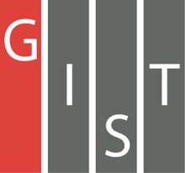
Gwangju Institute of Science and Technology

Official Press Release (https://www.gist.ac.kr/)

Section of Hyo Jung Kim Nayeong Lee
Public Affairs Section Chief Senior Administrator
(+82) 62-715-2061 (+82) 62-715-2062

Contact Person Yong-koo Joo, Section Chief
for this Article Section of Undergraduate Administration Services
(+82) 62-715-3601

Release Date 2019.12.23

Six GIST College physics majors win the
National College Student Math Competition

□ Gwangju Institute of Science and Technology (GIST, President Kiseon Kim) GIST College undergraduate students excelled at the 38th National College Student Math Competition that was held on November 9, 2019.

∘ The award ceremony was held at the Korea Science and Technology Center on December 23, 2019, and GIST College senior Dong-ha Lee won silver in the first category, sophomores Jong-min Park and Chan-hyuk Sung won silver in the second category, and sophomores Hyun-kyu Kim and Jin Park won bronze in the second category. All six winners are majoring in physics.

∘ The National College Student Math Competition is hosted every year by the Korean Mathematical Society and is divided into two categories: the first category is for upper-level students, and the second category is for lower-level students. The questions cover the first- and second-year curriculum for college mathematics. This time, Dong-ha Lee received the honor of winning a prize in the first category despite not being a math major.

□ Of the 43 universities that received awards in the first and second categories, only six, including GIST, produced six or more winners. GIST had excellent results despite not even having a mathematics department.

∘ All six winners belong to the Pencil & Paper student math club and were coached by Division of Liberal Arts and Sciences Professor Hyunsuk Kang and prepared for the competition despite being busy with their studies.

∘ Among the students, Dong-ha Lee won silver for the past three consecutive years and Chan-hyuk Sung won silver for the past two consecutive years, demonstrating their own personal excellence as well as the strength of the math club.

□ Senior Dong-ha Lee said, "Although I had previously won awards in previous competitions, I challenged myself again this year to continue my interest in mathematics. As a non-math major, I enjoyed studying with my friends in the club who have a passion for mathematics. I am happy to have achieved the results that I have through my effort."

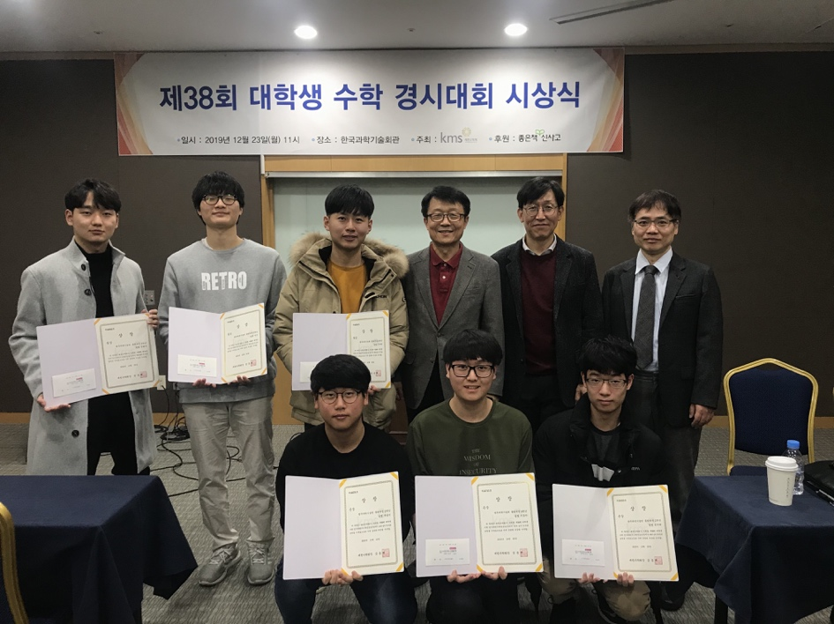
▲ Awards photo

