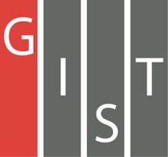
Gwangju Institute of Science and Technology

Official Press Release (https://www.gist.ac.kr/)

Section of Hyo Jung Kim Nayeong Lee
Public Affairs Section Chief Senior Administrator
(+82) 62-715-2061 (+82) 62-715-2062

Contact Person Borang Jung, Administrator
for this Article Global Desalination Research Center
(+82) 62-715-3383

Release Date 2019.12.20

Professor In S. Kim is the first to be awarded the Doosan Yonkang Environmental Research Award

□ Gwangju Institute of Science and Technology (GIST, President Kiseon Kim) School of Earth Sciences and Environmental Engineering Professor In S. Kim received the honor of being selected as the first grand prize winner at the '2019 Doosan Yonkang Environmental Research Award' hosted by BEXCO in Busan on December 12, 2019.

∘ The Doosan Yonkang Foundation was established in 1978 to in memory of the spirit of Doo-byung Park who said, "Education is the driving force of national development," and it has been actively engaged in social contribution activities. In particular, the Doosan Yonkang Environmental Research Award was established this year to help develop environmental studies in Korea and to inspire people in the environment sector to continue extended environmental safety and reseach projects, which the Doosan Yonkang Foundation has conducted for 25 years from 1993 to 2017.

□ Professor In S. Kim was selected for Doosan Yonkang Environmental Research Award for his paper "Selective Removal of Ions by Control of Nitrogen Doping * Graphene Binding Structure," which was the first paper to present a new paradigm of environmental fusion technology as a result of a new material called "nitrogen-doping graphene," which was mainly studied in the field of electronics and semiconductors and was applied to the world's first membrane-based seawater desalination/water treatment system.

* nitrogen doping: the process of adding nitrogen between the carbon of graphene (two-dimensional material with carbon atoms) to create better properties

∘ Professor In S. Kim said, "It is a great honor to be selected as the first winner of the Doosan Yonkang Environmental Research Award. Through this award, I will continue to focus on research without compromising on producing the best research results."

□ In addition to this paper, Professor In S. Kim has published 68 major papers in international SCI journals over the past five years and has continued to make academic achievements by publishing 46 domestic and international conferences/workshop papers. In addition, he contributed to the development of national R&D projects and national competitiveness through the development of global desalination technologies as the head of a large-scale national seawater desalination project, which was conducted for eight years from 2006.

∘ Professor Kim has also served as president of the Korean Environmental Engineering Association and as the president of the Korea Desalination Plant Association. As an Fellow of the International Water Association (IWA) and Director of the International Desalination Association (IDA), he has a strong influence in the field of water and environmental sciences, both domestically and internationally. In 2013, he established the Global Desalination Research Center to serve as an international desalination hub, and he is currently the Dean of Research at GIST.

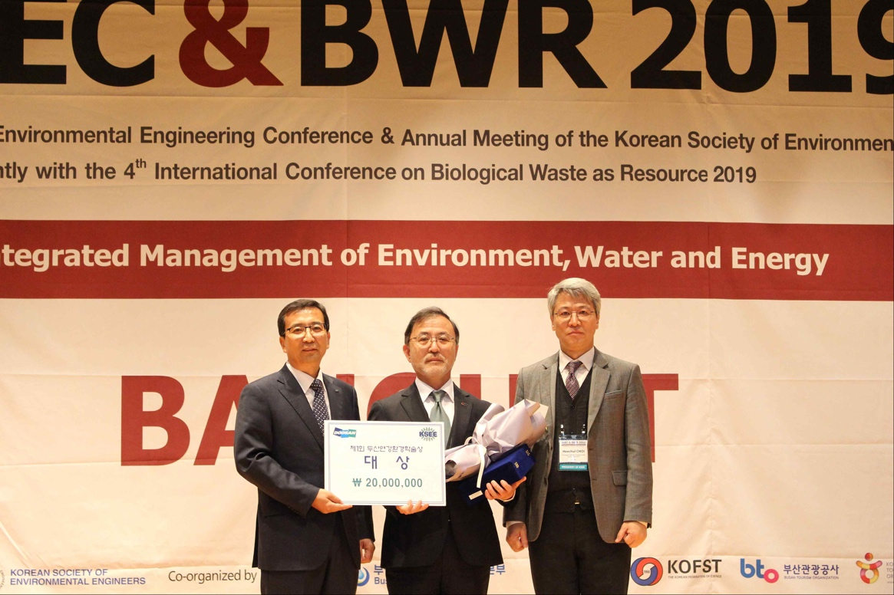
▲ Award ceremony photo (from left): Doosan Yonkang Foundation Vice President Myeong-ho Jang, GIST Professor In S. Kim, and Korean Environmental Engineering
Association President Hee-chul Choi

