Gwangju Institute of Science and Technology

Official Press Release (https://www.gist.ac.kr/)

Section of Hyo Jung Kim Nayeong Lee
Public Relations Section Chief Senior Administrator
(+82) 62-715-2061 (+82) 62-715-2062

Contact Person Professor Chang Hyuck Choi
for this Article School of Materials Science and Engineering
062-715-2317

Release Date 2020.08.07

GIST Professor Chang Hyuck Choi selected as a Young Investigator of the Year by the American Chemical Society

□ GIST (Gwangju Institute of Science and Technology, President Kiseon Kim) School of Materials Science and Engineering Professor Chang Hyuck Choi was selected as a Young Investigator of the Year by the most prestigious journal in the field of chemistry.

∘ Professor Chang Hyuck Choi was selected as a 'JACS Young Investigators 2020,' which was carefully selected from outstanding young researchers among papers published in the Journal of the American Chemical Society in 2019.

□ The related paper is the result of collaboration with the research team of Professor Sang-Il Choi of Kyungpook National University and Professor Hyung-Kyu Lim of Kangwon National University, and it contains details of the electrochemical hydrogen production reaction on the platinum catalyst. Although the hydrogen production reaction (which is a key to realizing the hydrogen economy) is the simplest electrochemical reaction, controlling it remains a major challenge.

∘ Professor Chang Hyuck Choi's research team succeeded in accurately predicting this experimentally and theoretically by introducing a work function model. The American Journal of Chemistry evaluated this study as "very important experimental result for understanding hydrogen production reaction."

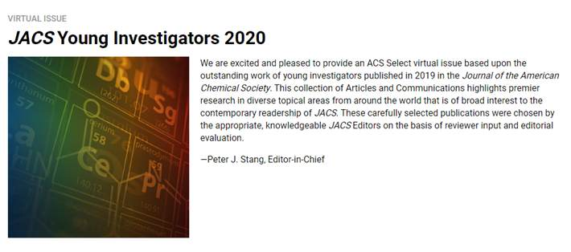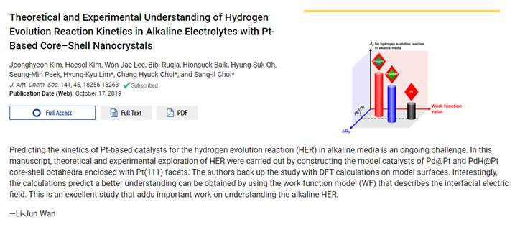
▲ School of Materials Science and Engineering Professor Chang Hyuck Choi was
selected as a Young Investigator of the Year by the American Chemical Society

