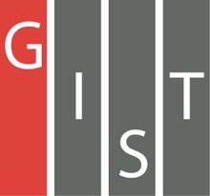
Gwangju Institute of Science and Technology

Official Press Release (https://www.gist.ac.kr/)

Section of Hyo Jung Kim Nayeong Lee
Public Relations Section Chief Senior Administrator
(+82) 62-715-2061 (+82) 62-715-2062

Release Date 2020.10.16

Professor Jaeyoung Lee and Professor Heung-No Lee are appointed as advisors to the Presidential
Policy Planning Committee

□ GIST (Gwangju Institute of Science and Technology, President Kiseon Kim) Professor Jaeyoung Lee (Dean of Earth Sciences and Environmental Engineering) and Professor Heung-No Lee (School of Electrical Engineering and Computer Science, Blockchain Internet Economic Research Center) have been appointed as advisors to the Presidential Policy Planning Committee.

□ The Policy Planning Committee was established in December 2017 and is under the direct control of the president, and it performs the role of a "think tank" to coordinate 100 national affairs tasks, to study policy issues, and to plan national development strategies and policy directions.

∘ It recommends and advises the president on matters related to policy research and policy evaluation on important issues, as well as setting mid- to long-term development goals for the country.

□ GIST Professor Jaeyoung Lee and Professor Heung-No Lee will contribute to presenting the vision and establishing strategies for a balanced regional New Deal in the future by collecting public opinion in the area of the government's Digital New Deal area and to plan policies for On-Line Governance.

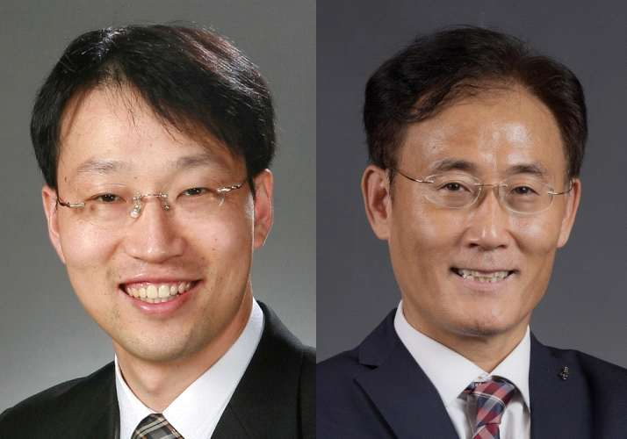
▲ From left: GIST Professor Jaeyoung Lee and Professor Heung-No Lee

