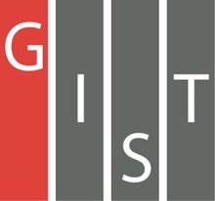
Gwangju Institute of Science and Technology

Official Press Release (https://www.gist.ac.kr/)

Section of Hyo Jung Kim Nayeong Lee
Public Affairs Section Chief Senior Administrator
(+82) 62-715-2061 (+82) 62-715-2062

Contact Person Dr. Kwang-Myung Jeon
for this Article School of Electrical Engineering
and Computer Science
(+82) 62-573-4591

Release Date 2019.09.17

Dr. Kwang-Myung Jeon's company Inflow Co., Ltd., was ranked 1st in the regional qualification for 'Challenge! K-Startup 2019 Innovation
Startup League'

□ GIST (President Kiseon Kim) School of Electrical Engineering and Computer Science graduate Dr. Kwang-Myung Jeon (Advisor: Professor Hong Kook Kim) established Inflow Co., Ltd., which won first place in the Gwangju Regional Qualification for the 'Challenge! K-Startup 2019 Innovation Startup League' held at Gwangju Creative Economy Innovation Center on August 7, 2019.

∘ 'Challenge! K-Startup 2019 Innovation Startup League' is a program hosted by the Ministry of Small and Medium Business that helps businesses with entrepreneurial potential. At the creative innovation centers in 19 regions, 152 teams from individual divisions, including 60 teams selected from across the country, will undergo run-offs (9.30.-10.2), final evaluation (10.29.-30), and final selection (11.28).

□ Intflow, which ranked first in the Gwangju qualification round, is a company that develops intelligent site detection devices that perform image and sound detection using multimodal deep learning recognition technology, and the livestock industry is the first area to commercialize this technology. The company is speeding up commercialization by applying for a technical patent for "Intelligent Customized Livestock Asset Management Model," as well as having regular meetings with farmers in South Jeolla Province.

□ Intflow CEO Kwang-Myung Jeon said, "Livestock in advanced countries such as the Netherlands and Germany have steadily improved their production efficiency by studying ICT-based video and sound analysis for many years, but the domestic livestock industry has had problems with wide variation in production efficiency between farms as many farms stick to traditional methods of relying heavily on management experience and interest. If we introduce the audiovisual AI analysis solution under development in the livestock industry, we expect to see innovative improvements in terms of disease prevention, population management and environmental control."

∘ Based on the excellent hearing intelligence source technology development capability, Inflow Co., Ltd., was selected as the follow-up research project of '2019 AI R&D Grand Challenge' hosted by the Ministry of Science and ICT. The company is planning to conduct joint research with the Korea Institute of Construction Technology (Research Director: Chan-Jun Jeon).

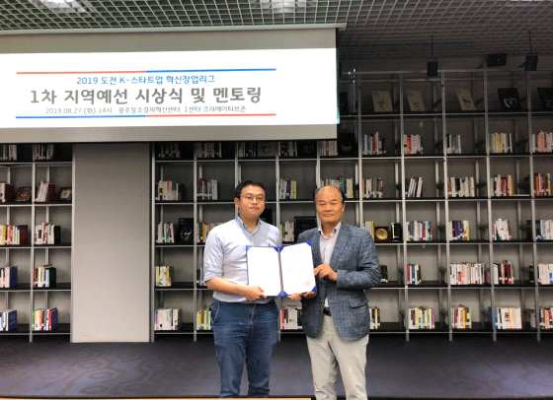
▲ From the left: Intflow CEO Kwang-Myung Jeon and Gwangju Center for
Creative Economy and Innovation Director Il-seo Park

