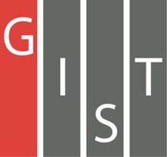
Gwangju Institute of Science and Technology

Official Press Release (https://www.gist.ac.kr/)

Section of Hyo Jung Kim Nayeong Lee
Public Affairs Section Chief Senior Administrator
(+82) 62-715-2061 (+82) 62-715-2062

Contact Person Professor Joon Ha Kim
for this Article School of Earth Sciences and
Environmental Engineering
(+82) 62-715-3277

Release Date 2019.07.17

Professor Joon Ha Kim selected as the first representative for the inaugural meeting of the
Water Management Innovation Forum

□ GIST (President Kiseon Kim) Professor Joon Ha Kim of the School of Earth Sciences and Environmental Engineering was selected as the first representative for the inaugural meeting of the Water Management Innovation Forum.

∘ In recent years, the introduction of a professional-based standard platform was required to unify water management, and the need to improve local government technical support and capabilities is increasing due to the strengthening of the local distribution water management policies. Now, as communication channels for water governance issues are expanded, there is a need for a communication platform to actively discuss and share complex water management issues.

□ The first Water Management Innovation Forum Inaugural General Meeting was held on July 16, 2019, at the Hoam Convention and Exhibition Center of Seoul National University with the attendance of 30 water experts.

∘ School of Earth Sciences and Environmental Engineering Professor Yunho Lee gave a presentation on hazardous substances in wastewater. After the presentation, experts discussed water management issues, water management technologies, policy trends in advanced countries, water management measures, laws, and regulations as well as networking and conducting joint research projects.

□ GIST Professor Joon Ha Kim as the first selected representative said, "The Water Management Innovation Forum will greatly contribute to sustainable water management as well as social conflict resolution by ensuring effective environmentally-friendly water management and equity by acting as a bridge between water management stakeholders and participants in the future. I look forward to the forum's role as a think tank to discuss future water management issues in a candid manner and explore ways to cooperate among water management stakeholders and participants."

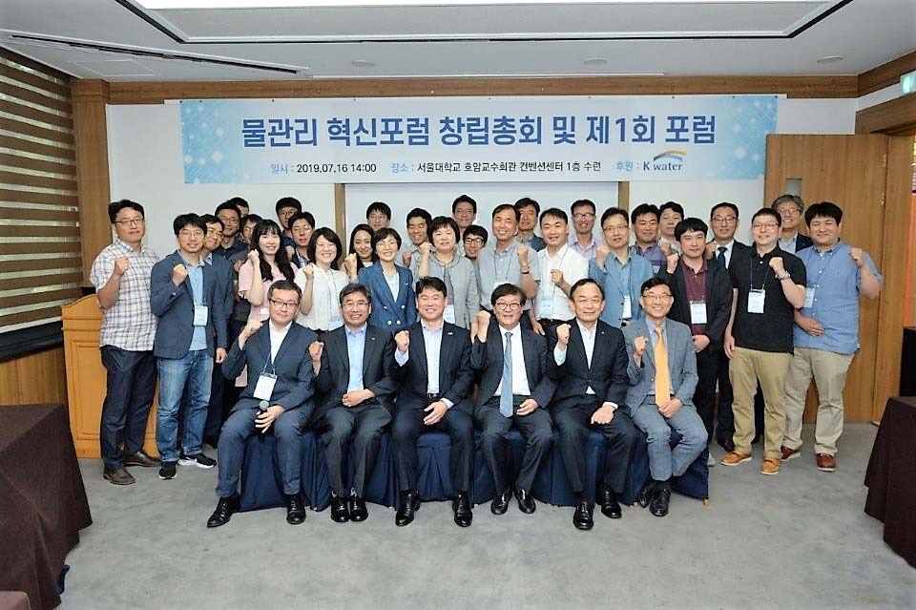
▲ Water Management Innovation Forum commemorative photo

