Three Presidential Science Scholarship Students Selected in 2023

- Yang Eun-gyu of the Division of Liberal Arts and Sciences, Shim Su-yeon of the Division of Electrical and Computer Engineering, and Kim Jeong-seo of the Division of Life Sciences.

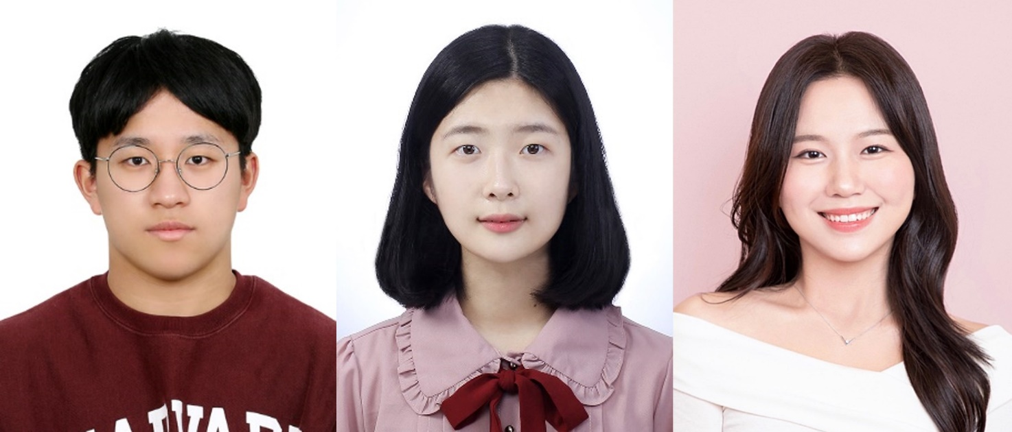
▲(From left) Yang Eun-gyu of the Division of Liberal Arts and Sciences, Shim Su-yeon of the Division of Electrical and Computer Engineering, and Kim Jeong-seo of the Division of Life Sciences.

GIST (Gwangju Institute of Science and Technology, Acting President Park Rae-gil) students − Yang Eun-gyu of the Division of Liberal Arts and Sciences, Shim Su-yeon of the Division of Electrical and Computer Engineering, and Kim Jeong-seo of the Divisionof Life Sciences − were selected as 2023 Presidential Science Scholarship recipients.

If selected as a scholarship recipient, the student will be supported with tuition and academic incentives from this year until graduation. This year, 157 new domestic and foreign scholarship students were selected.

Student Yang Eun-gyu stated, “It is an honor to receive the Presidential Science Scholarship. I will use this occasion to devote myself more to my studies so that being selected as a scholarship student will not be in vain.”

Student Shim Su-yeon said, “I received this good opportunity as a result of participating in various activities and being diligent in educational volunteer work.” She added, “I would like to thank Prof. Son Jin-hee for supporting me in this scholarship as well as the Korea Talent Award, and I will continue to work hard to become an engineer who practices making social contributions.”

Student Kim Jeong-seo related, “Receiving this scholarship is a great honor and motivation.” She continued, “I would like to thank all those who have led the way, and I want to contribute to help people escape the pain of disease by devoting myself to the study of life phenomena.”

The Presidential Science Scholarship is a scholarship awarded by the Korea Student Aid Foundation. It is a scholarship system that fosters world-class core scientists by discovering and supporting the best students in the field of science and technology who are creative and full of potential. Academic performance, science-related activities, growth plans, and volunteer activities are comprehensively evaluated, and selections are made through in-depth interviews.

Since 2003, about 150 domestic and foreign science and engineering students have been selected each year from among first- and third-year undergraduate students. They are receiving full tuition and 2.5 million won per semester as academic incentives until graduation.

