Gwangju Institute of Science and Technology

Official Press Release (https://www.gist.ac.kr/)

Section of Hyo Jung Kim Nayeong Lee
Public Relations Section Chief Senior Administrator
(+82) 62-715-2061 (+82) 62-715-2062

Contact Person Gil Ju Lee, Ph.D. student
for this Article School of Electrical Engineering
and Computer Science
062-715-2658

Release Date 2020.09.16

Ph.D. student Gil Ju Lee selected as the best
graduate student by the US Optical Society

□ GIST (Gwangju Institute of Science and Technology, President Kiseon Kim) School of Electrical Engineering and Computer Science Ph.D. student Gil Ju Lee (advisor: School of Electrical Engineering and Computer Science Professor Young Min Song) was selected as the best graduate student in the field of optical engineering for the first time in Korea by the US Optical Society.

∘ Gil Ju Lee was selected to be a recipient of the 'Robert S. Hilbert Memorial Student Travel Grant' in 2020 by The Optical Society, which select three graduate students with outstanding research achievements among optical engineering papers published in the journal Frontiers in Optics published.

□ Gil Ju Lee's paper was published in the journal Nature Electronics in June of this year as a result of collaboration between Professor Young Min Song's research team and Professor Dae-hyung Kim's research team at Seoul National University. The paper featured a single lens ultra-wide angle camera that mimics the eyes of underwater creatures. The proposed design significantly reduces the number of lenses compared to a commercial wide-angle camera, confirming that it is possible to implement a miniature camera module with a size of 6.3% compared to a commercial camera.

□ Ph.D. student Gil Ju Lee said, "I would like to thank Professor Young Min Song for guiding me to achieve excellent research results as well as the research team of Professor Dae-hyung Kim of Seoul National University whose members conducted joint research with us. In the future, we plan to continue research in the field of next-generation cameras and vision systems that mimic the eyes of living things."

∘ The 'Robert S. Hilbert Memorial Student Travel Grant' was established in 2009 and has been awarded since 2010 to commemorate Robert S. Hilbert, the former president and CEO of Optical Research Associates. Three students from around the world with outstanding research achievements in optical engineering, lens design, and lighting design are selected annually and awarded a $1,100 scholarship so that they can attend the Frontiers in Optics (FiO) conference.

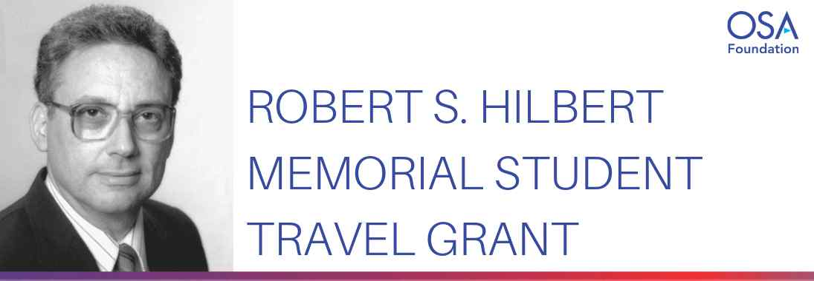
▲ [Photo 1] Gil Ju Lee selected for the 'Robert S. Hilbert Memorial Student Travel Grant'

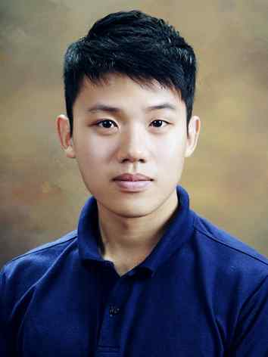
▲ [Photo 2] School of Electrical Engineering and Computer Science Ph.D. student Gil Ju Lee

