GIST Professor Euiheon Chung becomes first Korean chair of the Gordon Research Conference on Optics and Photonics in Medicine and Biology (OPMB)
- After serving as Vice-Chair in 2024, leading the conference as Co-Chair this year; spearheading overall operations, from planning themes and programs to inviting world-renowned scholars
- Facilitating research exchange in biophotonics among 189 global researchers in the field of Optics and Photonics in Medicine and Biology (OPMB), covering topics ranging from fundamental technologies for biological observation and analysis to medical applications such as disease diagnosis and treatment
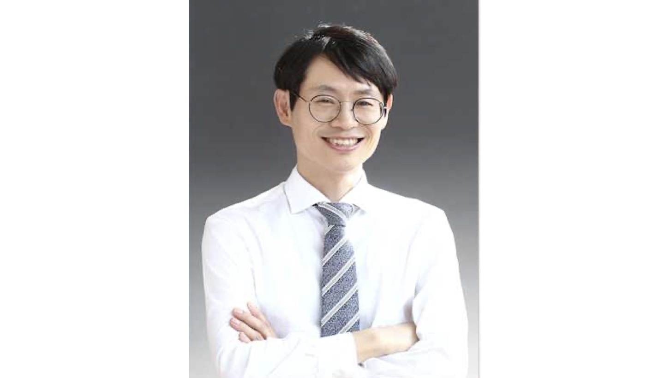

▲ Professor Euiheon Chung, Department of Biomedical Science and Engineering, GIST
The Gwangju Institute of Science and Technology (GIST; President Kichul Lim) announced that Professor Euiheon Chung of the Department of Biomedical Science and Engineering served as a co-chair for the "Optics and Photonics in Medicine and Biology" (OPMB) track at the Gordon Research Conference (GRC), becoming the first Korean to lead the conference in this field.
Professor Chung co-chaired the event with Professor Alex Vitkin of the University of Toronto. He spearheaded the overall organization of the conference—held from July 12 to 17 at Bates College in Lewiston, Maine, USA—by planning the themes and program and inviting researchers from around the world.
The Gordon Research Conference (GRC) is an international academic conference series established in 1931. It is characterized by the sharing of cutting-edge research findings and novel ideas—often prior to formal publication—and by in-depth discussions among researchers. The GRC organizes independent, topic-specific conferences across various fields of science and engineering.
Academic conferences covering various scientific and engineering fields are held under an "off-the-record" policy, which restricts the public disclosure of presentations and discussions to allow researchers to freely exchange unpublished findings and ideas.
Among these, the "Optics and Photonics in Medicine and Biology (OPMB)" conference—established in 1965 and running for nearly six decades—covers a wide spectrum of topics in biophotonics, ranging from fundamental principles to medical applications involving the use of light to observe cells and tissues, as well as to detect and treat diseases.
Professor Chung served as the Vice-Chair for the OPMB field in 2024; in accordance with the GRC’s operational practice where the Vice-Chair assumes the role of Chair for the subsequent conference, he took on the role of Co-Chair this year.
Notably, this marks the first time a Korean researcher has served as the Chair in the OPMB field.
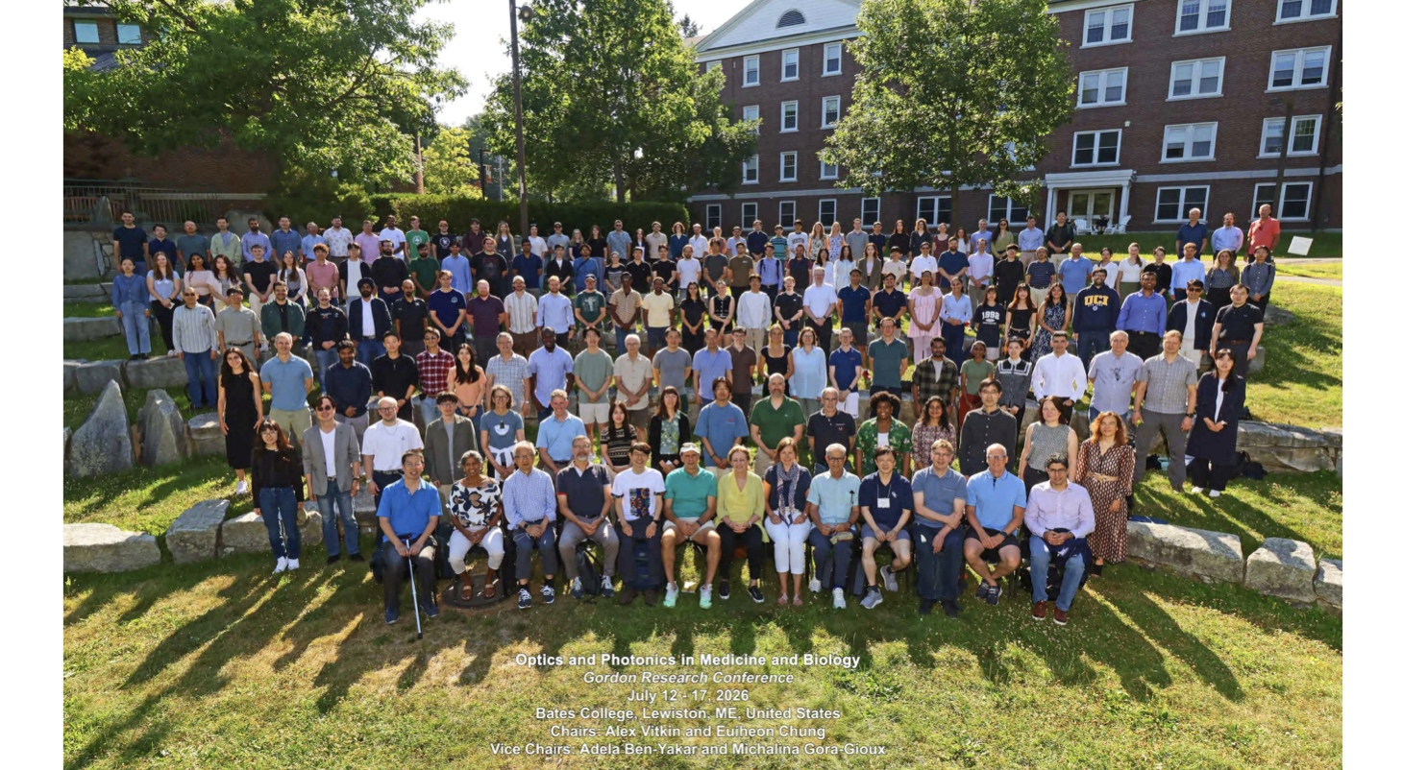

▲ Participants at the Gordon Research Conference (GRC) on OPMB, held at Bates College in Lewiston, Maine, USA, pose for a commemorative photo. (Fifth from the left in the front row: Professor Euiheon Chung, Department of Biomedical Science and Engineering, GIST)
This year’s conference was held under the theme "Enabling Technologies and Clinical Applications to Advance Science and Medicine with Light," addressing a broad range of biophotonics topics—from technologies for the precise observation and analysis of biological systems using light to those utilized for disease diagnosis and treatment.
Key topics included "wave-based imaging," which utilizes wave properties to observe the interior of biological organisms; "AI-based computational biophotonics," which employs artificial intelligence to analyze complex biological optical data and generate images; "neurophotonics," which uses light to observe and modulate the structure and function of the brain and nervous system; and advanced microscopy technologies designed for high-precision biological observation.
In the realm of medical applications, discussions focused on translating fundamental optical technologies into clinical practice. Key areas included "nano-optics-based diagnostic and therapeutic technologies" that utilize nanoscale optical techniques for both disease diagnosis and treatment; "clinical biophotonics," which applies optical technology to patient care; and "point-of-care optical biosensors" that enable rapid disease testing outside of hospitals or specialized laboratories.
The conference drew 189 researchers from around the world and featured 134 poster presentations, fostering active academic exchange and dialogue among the participants.
Professor Euiheon Chung remarked, "It is a significant honor to be the first Korean to serve as chair of the OPMB (Optical Physics in Micro- and Nano-scale Biological Systems) conference under the GRC—an organization with a history spanning over 60 years—and to lead this global gathering of researchers." He added, "I hope the research findings discussed here will serve as a foundation for transforming biophotonics technology into clinical innovations and act as a catalyst for expanding the scope of international collaboration and activity for Korean researchers."
Meanwhile, Professor Chung, a researcher in the fields of biophotonics and translational medicine, conducts research that utilizes advanced optical and imaging technologies to observe the interior of the body and apply these methods to the diagnosis and treatment of conditions such as brain disorders; he also remains actively engaged in international academic activities within these fields.

