GIST Semiconductor Engineering Professor Hoon Hahn Yoon wins PIERS 2026 'Young Scientist Award'
- Recognized for contributions to the advancement of versatile AI optoelectronic device technology capable of analysis, computation, and communication beyond light detection… Expected to strengthen technological competitiveness in the next-generation semiconductor and optoelectronics industries
- Winner of the International Young Scientist Award for the second consecutive year, following the 2D Materials ‘Emerging Young Scientist Award’ last year


▲ Professor Hoon Hahn Yoon of the Department of Semiconductor Engineering at GIST
The Gwangju Institute of Science and Technology (GIST, President Kichul Lim) announced that Professor Hoon Hahn Yoon of the Department of Semiconductor Engineering received the "Young Scientist Award" at the international optics and electromagnetics symposium "PIERS 2026 (PhotonIcs and Electromagnetics Research Symposium 2026)" held in Suzhou, China.
The PIERS Young Scientist Award is presented to young researchers recognized for their outstanding research achievements and potential for academic growth in the fields of optics, photonics engineering, and electromagnetics. Recipients are selected through peer review by the PIERS Award Committee, and starting this year, the age limit for applicants has been changed from under 40 to under 35.
In particular, GIST has once again demonstrated its international research competitiveness as Professor Yoon won the ‘PIERS 2026 Young Scientist Award’ this year, following Professor Ho-Beom Kim of the Department of Materials Science and Engineering winning the ‘PIERS 2025 Young Scientist Award’ last year.
Professor Hoon Hahn Yoon was recognized for his research achievements in developing next-generation high-dimensional photodetector technology capable of analyzing various optical information, such as wavelength and polarization, within a single device, going beyond merely detecting light intensity, and for expanding this into an AI-based optoelectronic system.
Professor Yoon was recognized for redefining the role of conventional photodetectors. Compared to existing photodetectors, which function merely as passive sensors that detect light, Professor Yoon’s active photodetectors can generate high-dimensional photoresponse data by controlling electrical operating conditions and physically enhance the distinctiveness of each photoresponse data point. Professor Yoon not only presented a direction for optimizing the performance of intelligent optoelectronic systems but also advanced the principle of "hardware-algorithm co-design," which involves designing photodetector device hardware and computational reconstruction algorithms together.
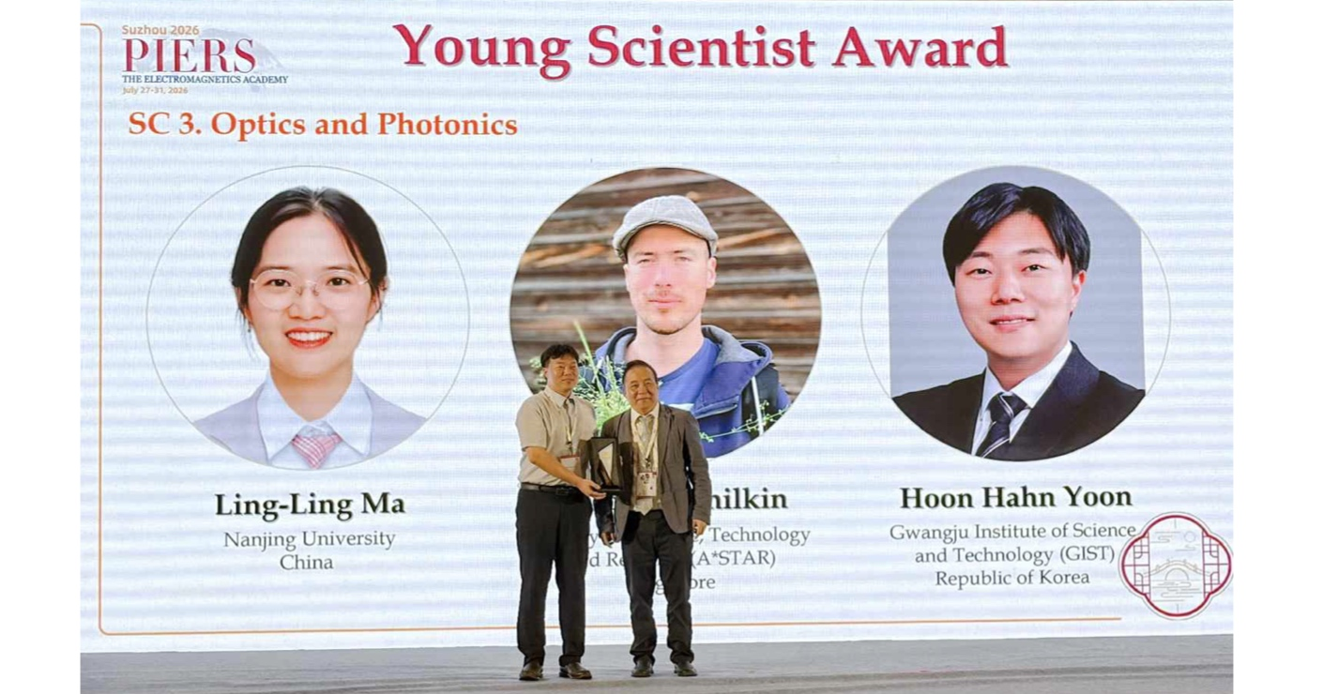

▲ At PIERS 2026, Professor Hoon Hahn Yoon (left) of the Department of Semiconductor Engineering at GIST is receiving the "Young Scientist Award" from Professor Sailing He (right), affiliated with Zhejiang University in China and KTH Royal Institute of Technology in Sweden.
This technology is expected to be utilized in various intelligent optoelectronic fields, such as portable spectrometers, environmental and biosensors, artificial vision for robots and autonomous driving, ultra-low power computing, and data center optical communication, by reducing the burden of data transfer and subsequent computation. It is also projected to contribute to the technological advancement of the next-generation optoelectronic-based optical semiconductor industry.
Following his receipt of the ‘2025 Young Scientist Award for 2D Materials’ from the international journal 2D Materials, published by the Institute of Physics (IOP Publishing) last year, Professor Yoon has earned the honor of receiving an international young scientist award for two consecutive years by winning the ‘PIERS 2026 Young Scientist Award’ this year.
Professor Hoon Hahn Yoon of the Department of Semiconductor Engineering stated, “This award is particularly meaningful as it recognizes our research direction of expanding and developing the ‘physics’ of unique photoelectronic conversion and charge transport occurring at quantum materials and their interfaces into information processing ‘functions.’ I express my deep gratitude to the students who have worked with me and to our domestic and international collaborators.”
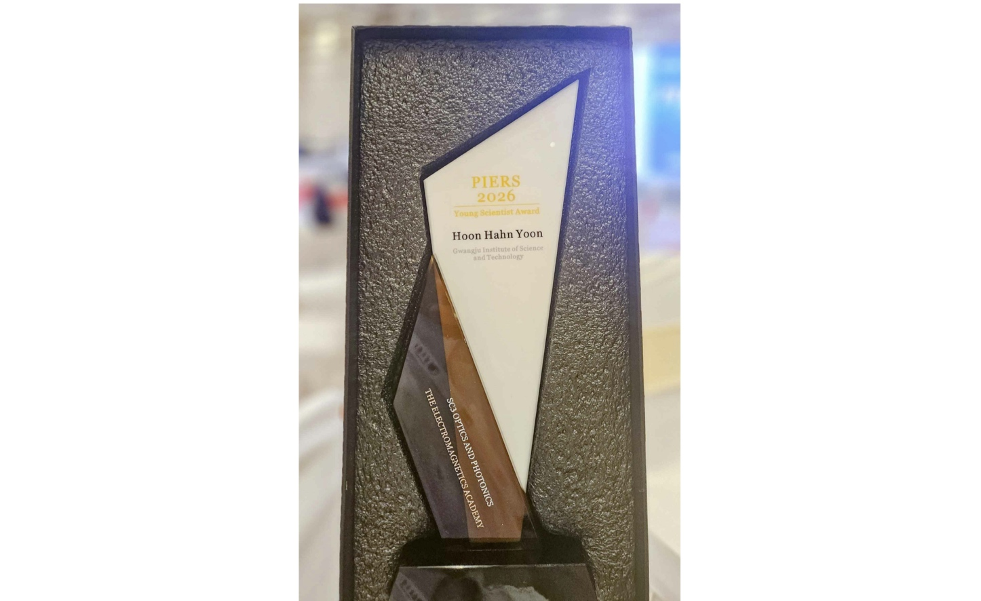

▲ ‘PIERS 2026’ Young Scientist Award plaque
Meanwhile, PIERS (Photonics and Electromagnetics Research Symposium) is a renowned international academic symposium in the fields of optics, photonics engineering, and electromagnetics hosted by the Electromagnetics Academy of the United States. It has been held annually in various countries around the world since 1989.
‘PIERS 2026’ was held in Suzhou, China, from July 27 (Mon) to July 31 (Fri), and ‘PIERS 2027’ is scheduled to be held in Daejeon, South Korea.

