“Approaching the Reason for Excessive Light Focusing via Numerical Analysis” GIST undergraduate student wins 'Outstanding Presentation Award' at the Korean Society for Computational and Applied Mathematics
- Young-hoon Choi, a student in Professor Chi-Ok Hwang's lab (Department of Mathematical Sciences, 4th year, Department of Electrical Engineering & Computer Science), numerically modeled the ‘light overconcentration phenomenon’ of a micro-optical concentrator discovered by the Chonnam National University research team
- Reproducing complex optical phenomena through numerical analysis and computer simulation… Expected to lay the theoretical foundation for designing next-generation solar cells
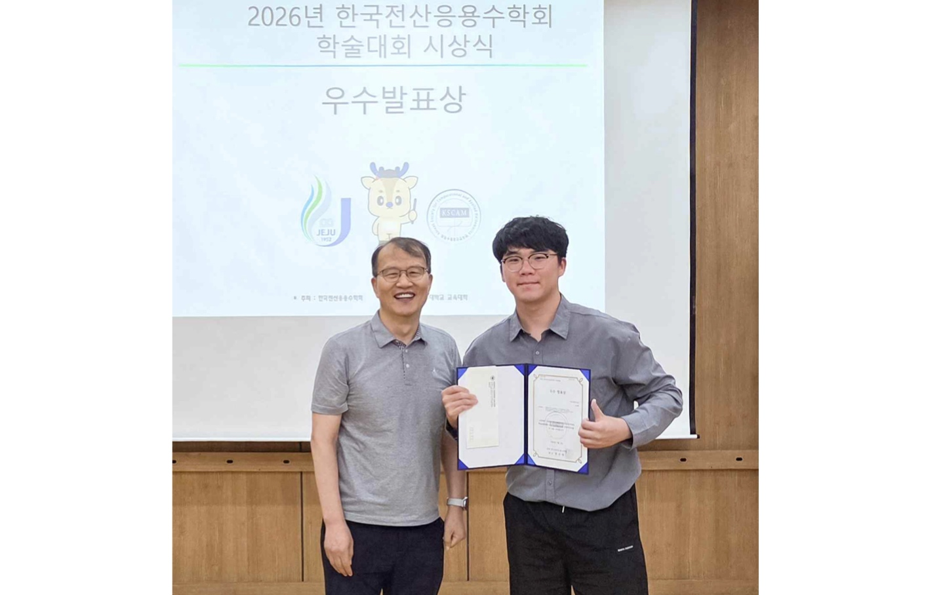

▲ Young-hoon Choi (right), a student in the Department of Electrical Engineering & Computer Science at GIST, who won the ‘Outstanding Presentation Award’ at the awards ceremony of the ‘2026 Korean Society for Computational and Applied Mathematics (KSCAM) Conference,’ is posing for a commemorative photo with Sangtae Jeong (left), President of the Korean Society for Computational and Applied Mathematics.
The Gwangju Institute of Science and Technology (GIST, President Kichul Lim) announced that Department of Electrical Engineering & Computer Science (a senior in the Department of Electrical Engineering & Computer Science), who is conducting research as an undergraduate intern in Professor Chi-Ok Hwang's lab in the Department of Mathematical Sciences, received the Outstanding Presentation Award at the ‘2026 Korean Society for Computational and Applied Mathematics (KSCAM) Conference’ held on Friday, July 3. Choi presented research analyzing the causes of the ‘light overconcentration phenomenon’ discovered by Professor Young-Ho Kang’s research team in the Department of Physics Education at Chonnam National University using numerical analysis and simulation.
This presentation introduces the results of a numerical approach to the ‘light overconcentration phenomenon’ discovered by Professor Young-Ho Kang’s research team at the Department of Physics Education, Chonnam National University, while designing a micro (μ) size fixed dielectric light concentrator* that is tens of times smaller than the thickness of a human hair.
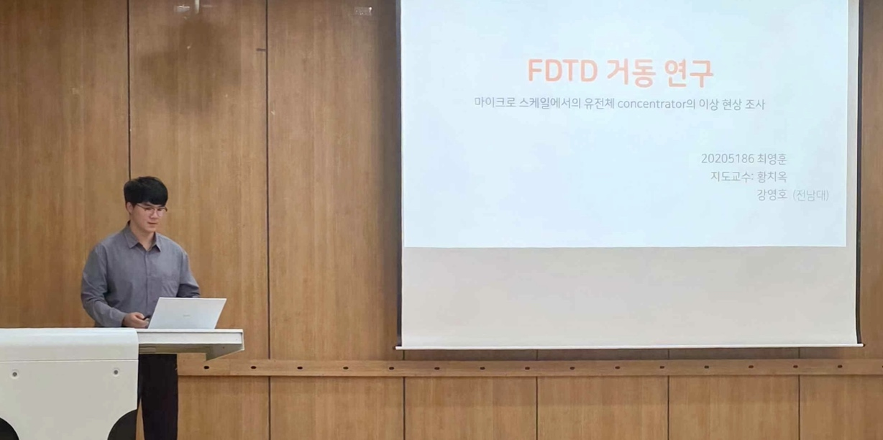

▲ Young-hoon Choi, a student in the Department of Electrical Engineering & Computer Science at GIST, is presenting at the ‘2026 Korean Society for Computer and Applied Mathematics (KSCAM) Conference.’
Through numerical analysis and optical simulation, the research team investigated from various angles the principles behind the phenomenon where light energy concentrates at a single point more strongly than expected under specific conditions.
* fixed-type dielectric light concentrator: A next-generation solar technology capable of efficiently collecting light without changing direction to follow the movement of the sun.
Since last year, Young-hoon Choi has been conducting follow-up research on this phenomenon at Professor Chi-Ok Hwang’s lab (GIST Scientific Computing Laboratory) in the Department of Mathematical Sciences at GIST. Utilizing the optical simulation software ‘RSoft,’ he reproduced the phenomenon of abnormal concentration of light energy at specific angles of incidence and precisely verified the conditions and mechanisms of its occurrence.
Noting that the reliability of results can vary depending on simulation conditions in complex optical structures, the team proposed a systematic analysis procedure to verify results by applying various computational resolutions (grid sizes) and boundary conditions.
The optical simulation software ‘RSoft’ used in the study is a program based on the ‘FDTD (Finite-Difference Time-Domain)’ technique, which calculates the movement of light over time; its developer, Keysight, provided a one-year license free of charge for the research.
Student Young-hoon Choi stated, “I am conducting research to identify the cause of the ‘light overconcentration phenomenon’ discovered by the Chonnam National University research team through mathematical modeling and precise simulation.” He added, “In the future, I want to expand the scope of analysis to include high incident angle environments to establish a theoretical foundation that can be utilized in the design of next-generation photovoltaic devices.”
Professor Chi-Ok Hwang, the student’s advisor, remarked, “It is a very meaningful result that an undergraduate student actively participated in collaborative research to numerically analyze complex optical phenomena and even achieved the Outstanding Presentation Award.” He continued, “I hope that based on this research experience, he will steadily build his capabilities in the field of scientific computing and continue to produce excellent research results in the future.”
Meanwhile, student Young-hoon Choi will continue his research as an undergraduate intern until his graduation next year, and plans to develop this research into a thesis topic and conduct follow-up research.

