GIST student club 'G-BungE' wins first national competition award with self-built electric vehicle 'Mk.5'

- Awarded the Best Technology Idea Prize at the ‘2026 Student Baja Korea’

- Recognized for vehicle optimization technology through analysis of actual driving data and design improvements

▲ Students from GIST’s student car club, ‘G-BungE,’ pose for a commemorative photo after receiving the ‘Best Technology Idea Award’ in the technology category.

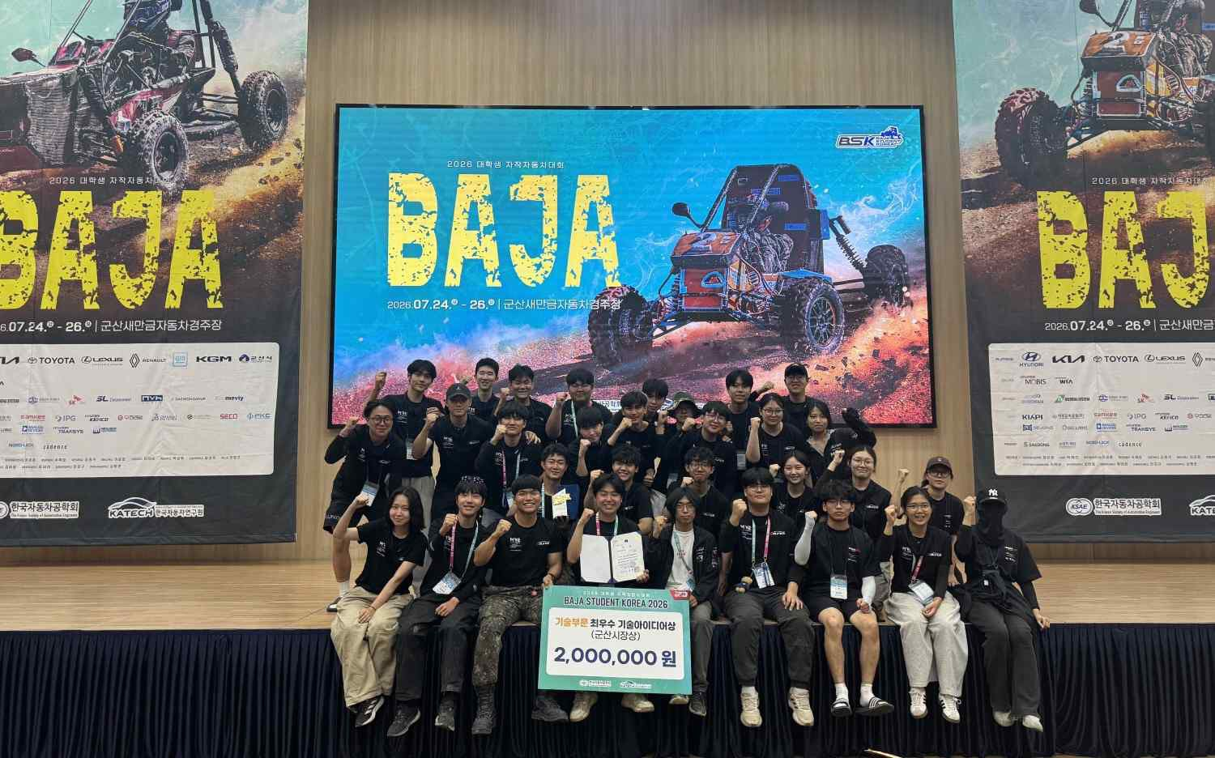
The Gwangju Institute of Science and Technology (GIST, President Kichul Lim) announced that its student car club, ‘G-BungE,’ won the ‘Best Technology Idea Award (Gunsan Mayor’s Award)’ in the technology category at the ‘Baja Student Korea 2026,’ a student car competition held at the Gunsan Saemangeum Racecourse from July 24 (Fri) to 26 (Sun).

This award marks the first victory for ‘G-BungE’ after their fourth attempt at the national competition. Following their success in completing all races for the first time last year, the club achieved their first national award this year by receiving the top prize in the technology category, in recognition of the design and technical prowess of their self-developed vehicle.

In particular, this award holds great significance as it was achieved through the voluntary collaboration of GIST students—who do not have automotive majors—without the automotive departments themselves, at a national competition attended by numerous universities with automotive engineering departments.

The team, ‘G-BungE,’ has developed its automotive manufacturing capabilities by having students from different majors combine their expertise to directly carry out the entire process, from vehicle design and manufacturing to the implementation of electrical systems and the analysis of driving data.

At this competition, G-BungE entered the ‘Mk.5’ (Mark Five), the club’s fifth self-built electric vehicle, into the Off-Road (Baja) category.

The ‘Mk.5’ was designed with the goal of optimizing the powertrain, improving motor control, and stabilizing the electric system, based on an analysis of issues identified in the previous vehicle, the ‘Mk.4’ (Mark Four). In particular, body safety was enhanced to prepare for collisions and rollovers, and the vehicle height, steering and braking performance, and driver interface were improved to ensure stable driving even on rough terrain.
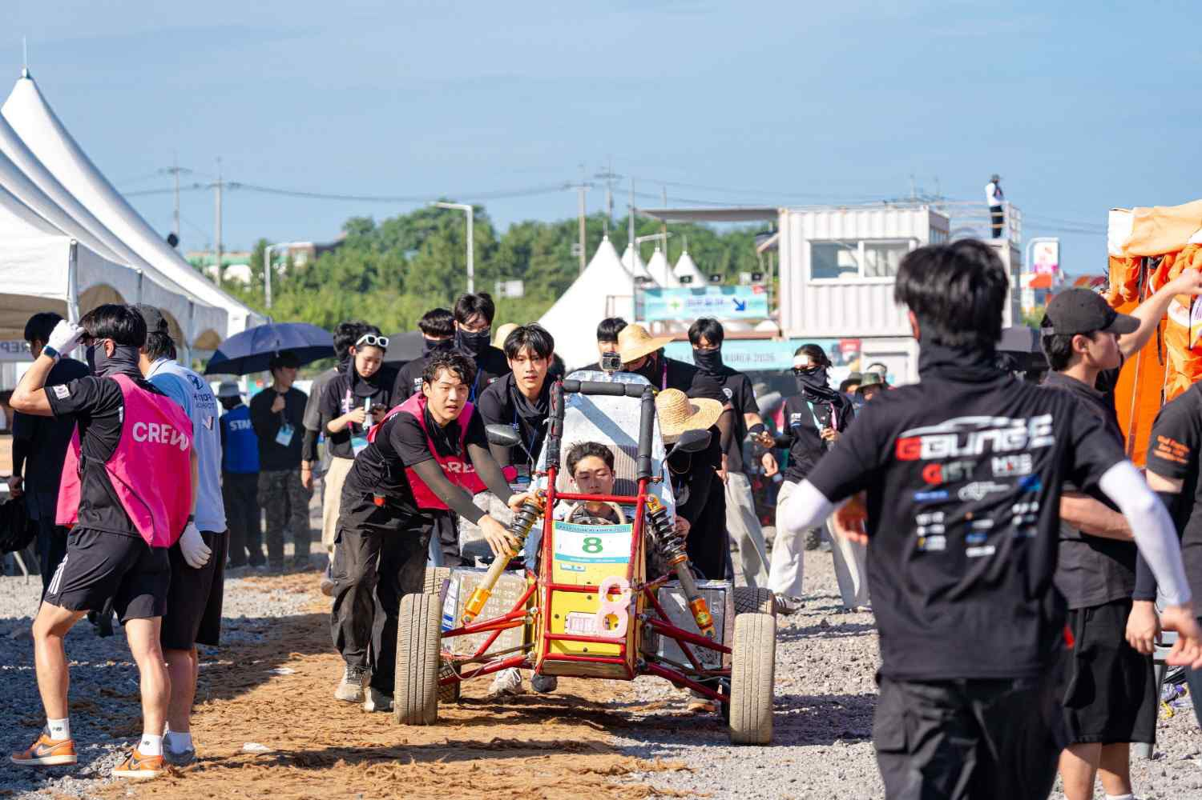
▲ Students from ‘G-BungE’ are moving the self-built electric vehicle ‘Mk.5’ at the competition venue of the ‘2026 University Student Self-Built Car Competition’.

Meanwhile, based on actual driving data accumulated during the development of the Mk.5, G-BungE participated in the technical category held on the first day of the competition.

They submitted a technical idea report and presented a poster under the theme of "Optimization of Track Driving for Student Model Vehicles (BSK, Baja Student Korea) Based on Real-World Logs (E-BAJA)."

In particular, the poster presentation introduced a design plan to achieve vehicle performance suitable for the competition course by analyzing data accumulated during the operation of the electric model vehicle.

"G-BungE" received recognition for its vehicle optimization technology by explaining the process of optimizing the power transmission method and motor output characteristics to suit driving conditions and reflecting the results in the vehicle design.
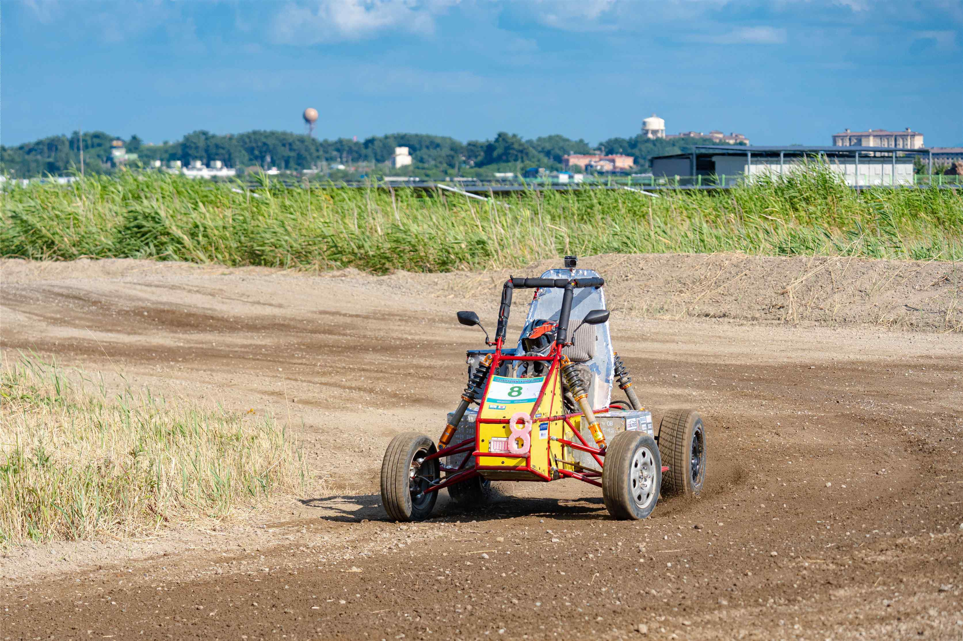
▲ The electric self-built car ‘Mk.5’, produced by the students of ‘G-BungE’, is racing at the ‘2026 University Student Self-Built Car Competition’ track.

Ha-ram Lee (1st year, Department of Mechanical and Robotics Engineering), who served as the Project Manager (PM), said, “It is very meaningful to win an award for the first time since the club was founded.” Ha-ram Lee added, “I believe this is the result of all team members working together with one heart to develop the vehicle and prepare for the competition, and I am grateful to all the club members who worked hard together.”

Ha-ram Lee continued, “Based on this experience, we will further improve the completeness of the vehicle and continue to show steady progress in the future.”

