“We will finish the race even if the axle breaks” GIST student self-built car club ‘G-BungE’ competes in national competition with self-built electric vehicle ‘Mk.5’
- Approximately 30 students from various majors, including mechanical, electrical, and semiconductor engineering, collaborated for a year to design and build their own electric vehicles
- Competing in the Baja category of the ‘2026 University Student Homemade Car Competition,’ held for three days starting Friday, July 24
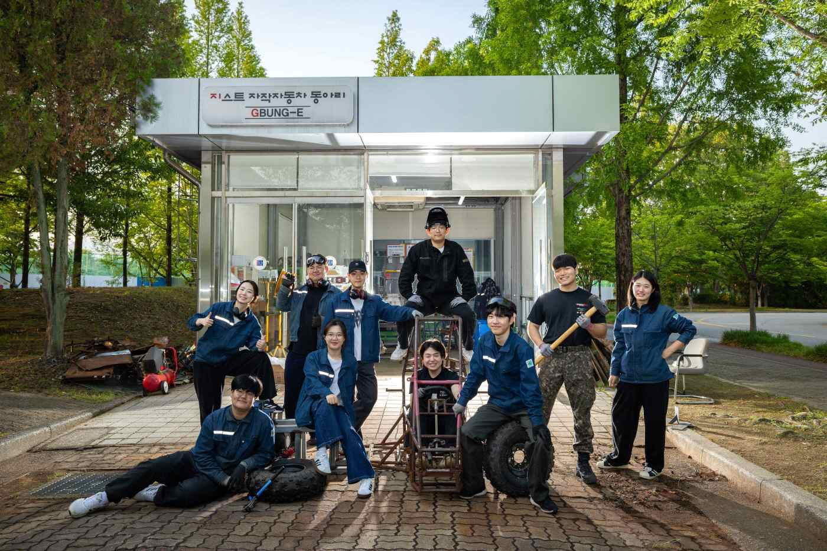

▲ Students from the GIST student car club ‘G-BungE’ are taking a group photo in front of their workspace.
“It was the most intense year of my university life.”
During the first preliminary test drive held on Saturday, July 4, the axle of the student-built electric vehicle (hereinafter referred to as the ‘self-built car’) broke while driving on rough terrain, causing the vehicle to come to a stop.
A week later, during the second test drive, an unexpected incident occurred when a circuit box fell off. The students temporarily secured it with tape and continued driving to the end, completing the scheduled course.
The fifth student-built car, ‘Mk.5,’ was completed after numerous failures and refinements. This single vehicle embodies the design, fabrication, and countless trials and errors of the past year.
The Gwangju Institute of Science and Technology (GIST, President Kichul Lim) announced that its student self-built car club, ‘G-BungE,’ will participate in the ‘2026 University Student Self-Built Car Competition,’ which will be held at the Gunsan Saemangeum Circuit from July 24 (Fri) to 26 (Sun), with its self-built electric car, ‘Mk.5.’
Co-hosted by the Korean Society of Automotive Engineers (KASE) and the Korea Automotive Technology Institute (KATECH), this competition serves as a venue for university students to showcase the performance and technical prowess of vehicles they have designed and built themselves. "G-BungE" is participating in the "Baja" category, which involves driving on harsh off-road terrain such as dirt roads and inclines.
"G-BungE" is a student car club composed of students from various majors at GIST, including the Department of Mechanical and Robotics Engineering, the Department of Electrical Engineering and Computer Science, the Department of Semiconductor Engineering, and the Challenge & Exploration Program. The name incorporates the "G" from GIST and the "E" from electric vehicle. Divided into Frame, Powertrain, and Electric teams, the club directly carried out the entire vehicle manufacturing process, including body structure design, drivetrain development, and the construction of circuit and battery systems.
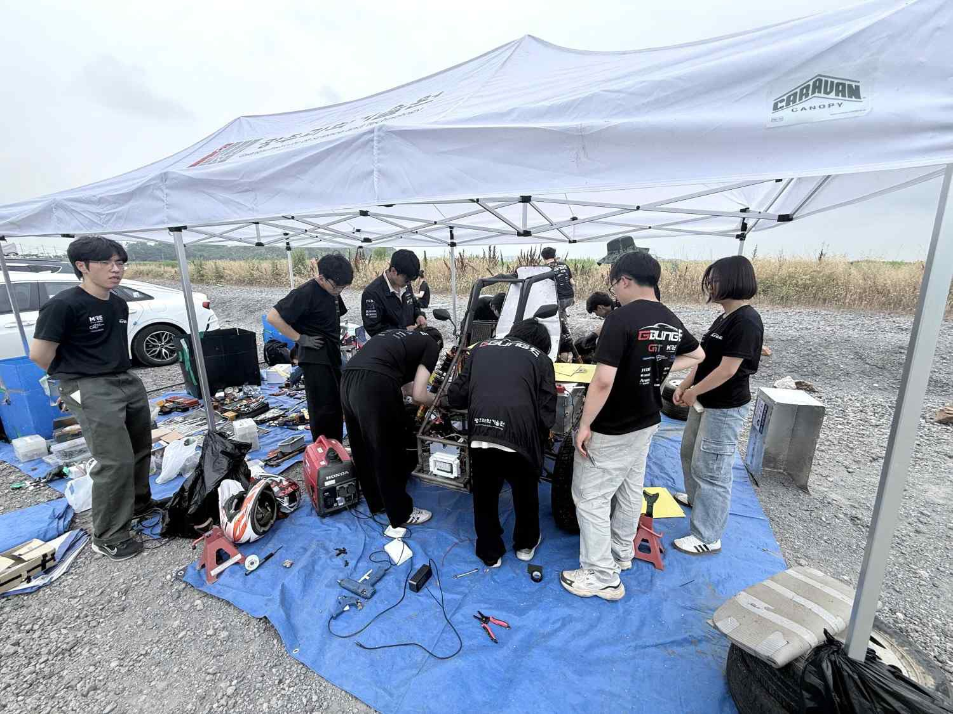

▲ Students from "G-BungE" inspecting their self-built electric vehicle, "Mk.5," at the preliminary driving site.
"G-BungE" has produced five self-built vehicles to date. The first vehicle (Mk.1) was developed for educational purposes, while the four vehicles produced thereafter (Mk.2–Mk.5) were developed as competition vehicles with the goal of participating in the University Student Self-Made Car Competition.
Among the approximately 40 club members, 30 are scheduled to participate in this competition and complete the entire schedule, including ▴ acceleration evaluation, ▴ dynamic performance evaluation, ▴ preliminary rounds, and a ▴ 90-minute endurance race.
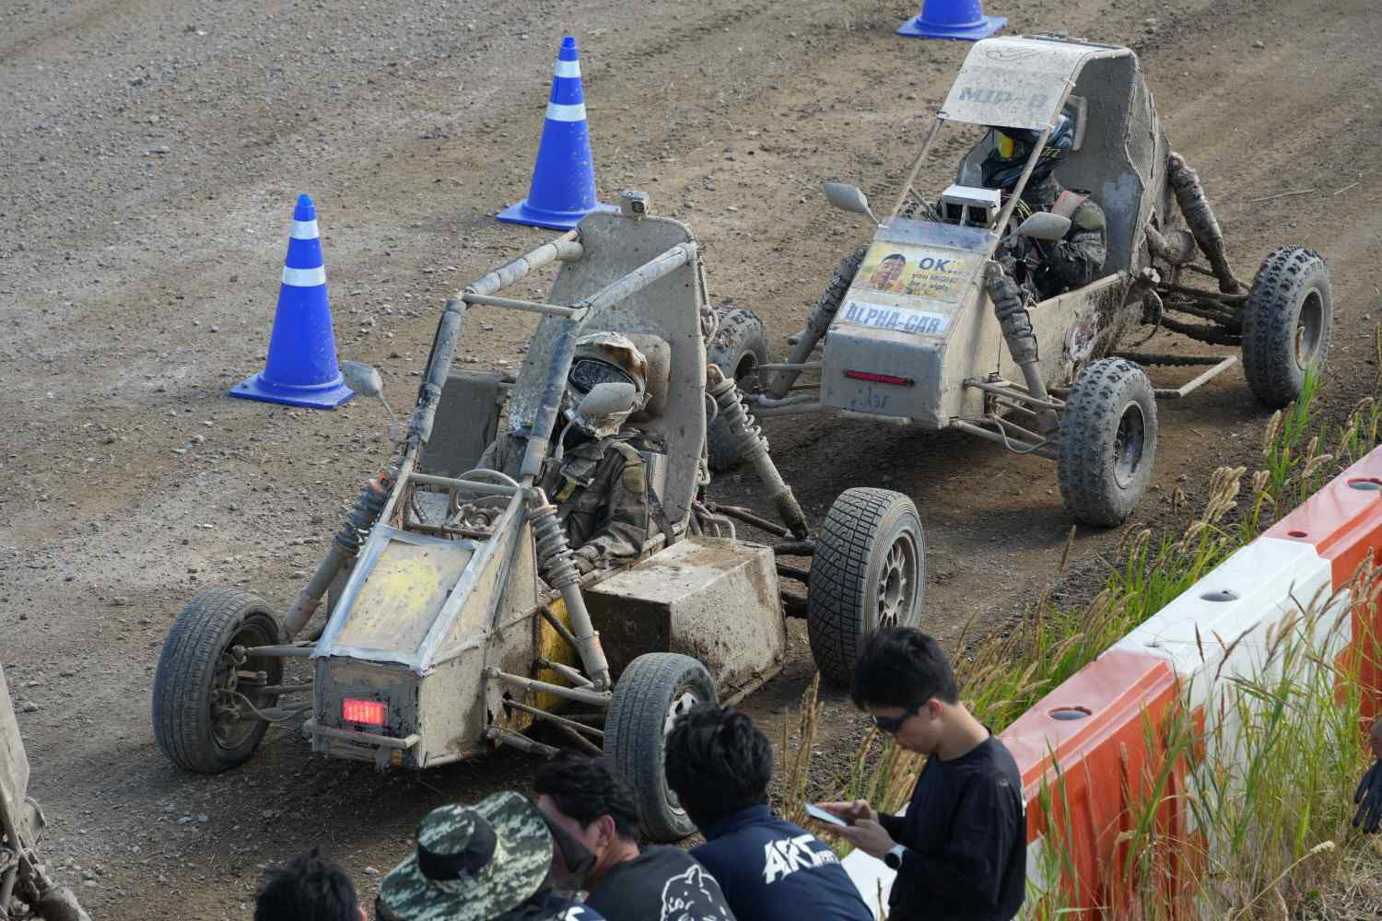

▲ Students from the ‘G-BungE’ group are conducting a driving test of their self-built electric vehicle, the ‘Mk.5’ (front), at the preliminary driving site.
The production of the Mk.5 took approximately one year. The students began preparations last summer by studying competition regulations and the theories required for vehicle design and manufacturing. After proceeding with the design work from the end of last year, they began actual vehicle production in April of this year and completed the Mk.5 in early July.
Approximately 21 million won was invested in the production. The students personally took the initiative to secure funding by collecting club dues and attracting corporate sponsorships, and were able to complete the vehicle with the support of the school, their supervising professor, and sponsoring companies.
While self-built electric vehicles offer excellent initial acceleration, they faced the limitation of increased vehicle weight due to the need to install large-capacity batteries.
Dong-hyuk Kim (a third-year student in the Department of Mechanical and Robotics Engineering) explained, “If an internal combustion engine vehicle is a marathon runner, an electric vehicle is like a sprinter carrying sandbags.” He added, “Although we are at a disadvantage in terms of weight, we focused on maximizing the explosive acceleration performance unique to electric vehicles.”
The process of realizing the design drawings into an actual vehicle was also not easy. If the dimensions or assembly positions of the parts differed from the design, rework or structural modifications were required, and the students completed the vehicle through iterative modifications and verifications.
Above all, collaboration among the three teams and schedule management were crucial during the vehicle manufacturing process.
Vehicle manufacturing is a task that requires the frame, powertrain, and electrical system to work together organically. Since delays in one team's work affect the entire production schedule, Ha-ram Lee (a first-year student in the Department of Mechanical and Robotics Engineering), who served as the Project Manager (PM), managed the production schedule by frequently coordinating the progress of each team.
The students improved the vehicle's quality by addressing defects identified during preliminary runs. Based on their accumulated design and manufacturing experience and teamwork, they are preparing for the competition with the goal of completing the race and verifying performance.
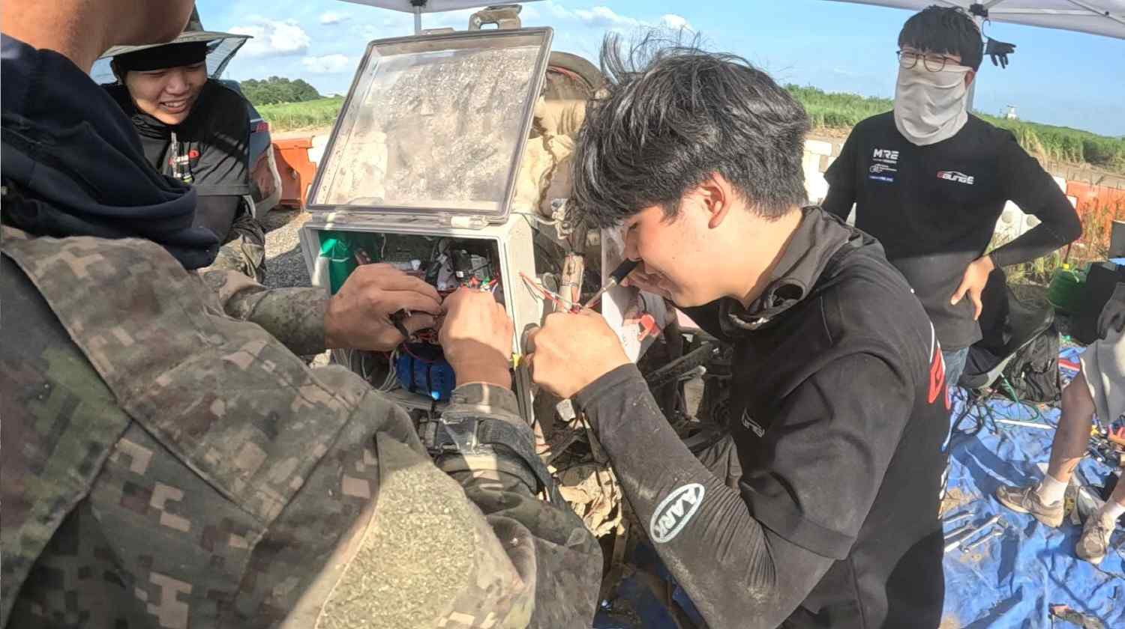

▲ The "G-BungE" students are maintaining their self-built electric vehicle, "Mk.5," at the preliminary run site.
Ha-ram Lee said, "When I saw the vehicle I designed moved for the first time, I felt a thrill that felt like all the hard work I had put in was being rewarded." Ha-ram Lee added, "Having personally experienced the process of mechanical, electrical, and control technologies being organically connected within a single vehicle, the process of collaboration and problem-solving itself will remain a significant asset to us, not just the competition results."
Ha-ram Lee added, “Using this experience of building an off-road vehicle for Baja as a stepping stone, I would like to challenge myself in the future at ‘Formula Student Korea,’ a competition for university students to build Formula cars.”

