“Learning new sounds while maintaining existing sound recognition ability” GIST-Hanwha Vision win 1st place in world at international acoustic AI competition ‘DCASE 2026’
- Joint research team of Professor Hong Kook Kim and Hanwha Vision R&D Center sweeps top 1st to 4th place in system rankings with all 4 submitted systems
- Development of ‘Acoustic Continuous Learning Technology’ that retains existing knowledge even in new environments, overcoming the chronic AI limitation of ‘Fatal Forgetting’… Expected to be applied to next-generation security solutions such as intelligent CCTV and AI video security
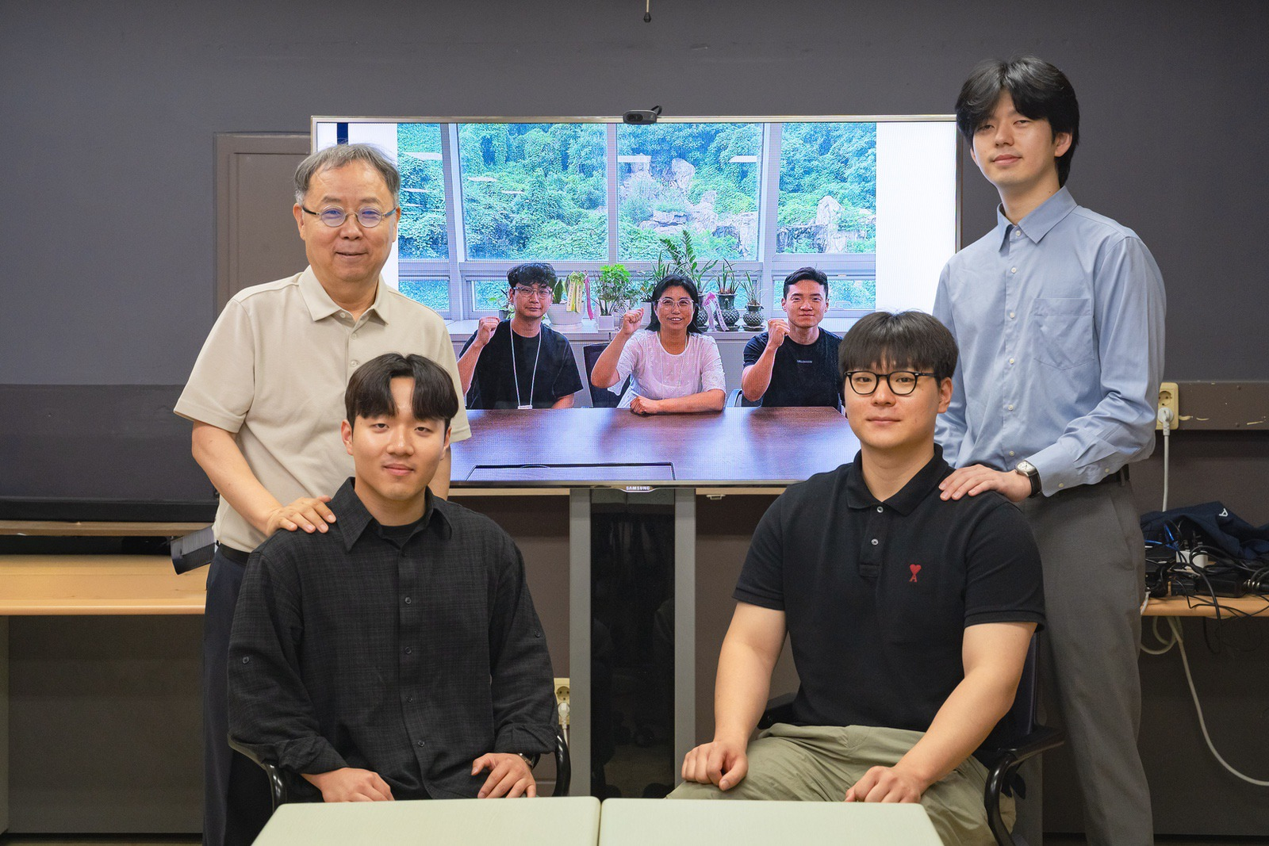

▲ Group photo of the GIST-Hanwha Vision joint research team. (Back row left) Professor Hong Kook Kim of the Department of Electrical Engineering and Computer Science, (Back row right) Jong-Yeon Park, integrated master's and doctoral student, (Front row left) Do-Hyun Lim, master's student, (Front row right) Sang-Won Park, master's student, (From left in the frame) Kyung-Deuk Ko, Principal Researcher at the AI ​​Research Institute of Hanwha Vision R&D Center, Jung-Eun Lim, Director of the AI ​​Research Institute, and Hyung-Cheol Kim, Senior Researcher.
The Gwangju Institute of Science and Technology (GIST, President Kichul Lim) announced that the joint research team led by Professor Hong Kook Kim of the Department of Electrical Engineering and Computer Science and the AI ​​Research Institute of Hanwha Vision R&D Center took first place in the official Teams Ranking at the ‘DCASE 2026 Challenge,’ a world-renowned acoustic artificial intelligence (AI) competition.
This achievement is the result of global recognition for acoustic AI technology based on ‘Continual Learning,’ which retains previously learned sound information while learning additional sounds from new environments.
The ‘DCASE (Detection and Classification of Acoustic Scenes and Events) Challenge,’ organized by the Institute of Electrical and Electronics Engineers (IEEE), is a leading international AI competition in the field of analyzing and recognizing acoustic environments and various sounds. It is a contest where researchers and corporate research teams from around the world compete to showcase their acoustic AI technological capabilities.
The joint research team participated in Task 7, titled ‘Domain-Agnostic Incremental Learning for Audio Classification,’ out of the seven tasks in the competition.
This task requires the accurate classification of 10 types of sounds, such as crying babies, barking dogs, and fire alarms, under ‘Domain-Agnostic’ conditions, where the environment in which the input sound was collected is not disclosed.
Existing audio recognition AI has faced limitations in field application due to performance degradation caused by changes in the environment—such as recording equipment, location, or ambient noise—and the "catastrophic forgetting" problem, where previously learned information is forgotten during the process of learning new data.
To address these issues, the joint research team developed a "Continual Learning" technology that maintains previously learned sound recognition capabilities while learning new environments.
The team preserved the AI ​​model exactly as it was learned at each learning stage, ensuring that new learning does not compromise existing knowledge.
In particular, by applying a "Deep Inversion-based Generative Replay" technique that reproduces and utilizes previously learned sound characteristics without repeatedly saving or retraining the original data, the team minimized the problem of existing knowledge being lost even when learning new environments.
Furthermore, by applying an "Ensemble Technique" that synthesizes the prediction results of multiple AI models to make a final decision, they achieved higher accuracy and more stable classification performance compared to using a single model. As a result, the final submitted system achieved an average accuracy of 79.62%, ranking first in the official Teams Ranking.
Furthermore, the four submitted systems—three single systems and an ensemble system combining them—occupied the top four spots in the official Systems Ranking, demonstrating the completeness of the technology.
Professor Hong Kook Kim stated, "This achievement is a case that demonstrates the potential of continuous learning technology, which allows existing knowledge to be maintained without retraining the entire model whenever a new environment is added." He added, "It is significant in that it proves that AI can learn efficiently even in changing environments."
In particular, this technology is expected to evolve into a next-generation AI security solution capable of simultaneously analyzing video and audio information when combined with Hanwha Vision's intelligent video security technology.
Meanwhile, this research was supported by the Hanwha Vision project, “Development of Lightweight Deep Learning-Based Sound Source Classification, Multilingual Embedding, and Speech Recognition Models for CCTV and On-Device Environments,” and the Ministry of Trade, Industry and Energy project, “Development of AI-Based Active Driver Assistance Systems/Services for the Road-Impaired.”
The “DCASE 2026 Workshop,” where research results will be presented and awards will be presented, is scheduled to be held in Boston, USA, from October 28 to 29.

