“In the era of generative AI, what will differentiate humans?” Former GIST President Seung-hyun Moon publishes 『Intelligence Power』
- Discusses the evolution of ‘human intelligence’ in the AI ​​era… “Humans are ultimately the agents creating new value”
- ‘Creativity+Power’—adding execution to ideas—and expertise and self-reflection are human weapons
- Moving beyond ‘users of knowledge’ to ‘architects of knowledge’… Proposes strengthening integrated intelligence
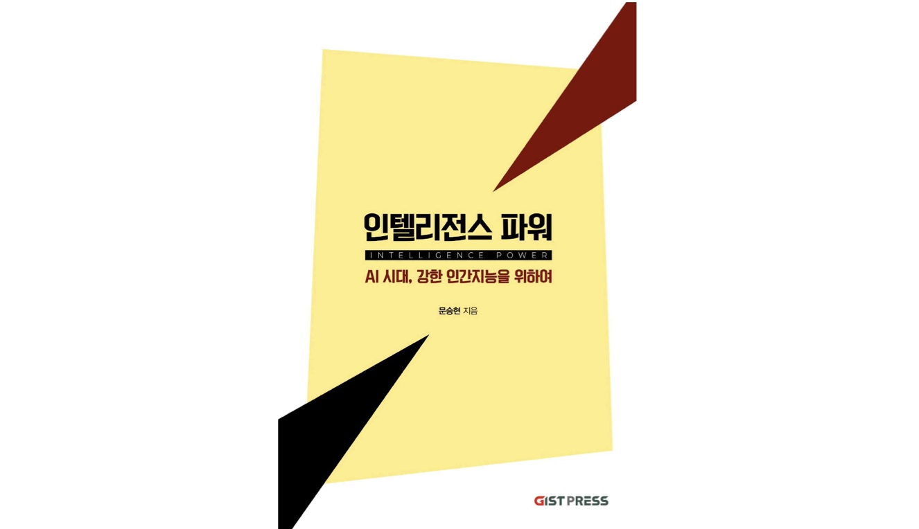

▲ Cover of the book Intelligence Power
“Even though artificial intelligence defeated go, people did not lose interest in the game, nor did go tournaments disappear. Just because AI paints pictures and composes music does not mean our creative activities will cease.”
As generative artificial intelligence (AI) expands its scope of application to include writing, creative work, and research, interest is growing regarding what role humans should play and what capabilities they must possess.
The Gwangju Institute of Science and Technology (GIST, President Kichul Lim) announced the publication of Intelligence Power, a new book by Visiting Scholar Seung-hyun Moon of the Department of Environment and Energy Engineering, which explores the role and future direction of "human intelligence" in the AI ​​era based on these questions.
Set against the backdrop of an era where generative AI is rapidly spreading across daily life and industry, Intelligence Power begins with the question of what intellectual capabilities humans must possess. While diagnosing the reality that AI is transforming human memory, thinking, and learning methods, it emphasizes that humans are ultimately the agents designing the future and creating new value.
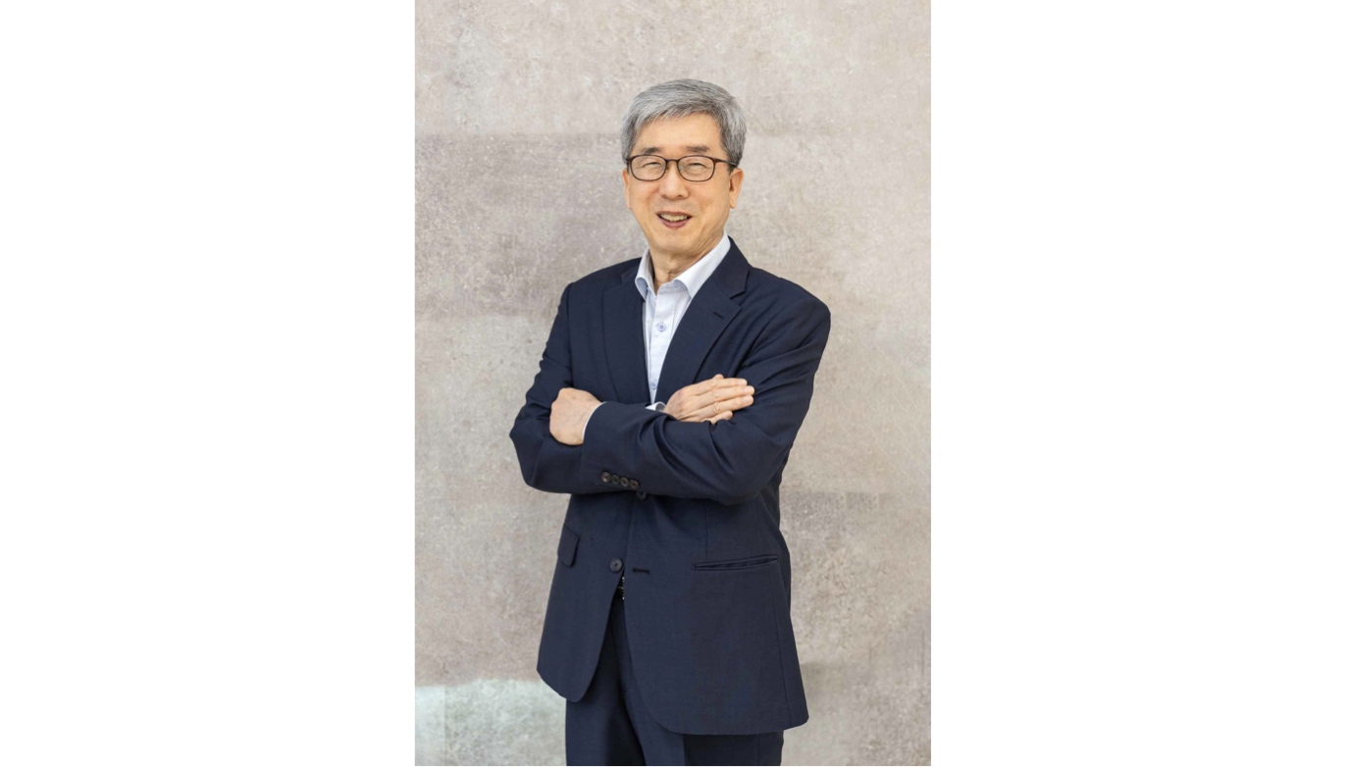

▲ Seung-hyun Moon, Visiting Scholar, Department of Environment and Energy Engineering, GIST
Professor Moon, who served as the 7th President of GIST (2015–2019), has consistently contemplated the impact of scientific and technological advancements on human society, having experienced not only research and education in the environmental and energy fields but also university management and talent development.
In particular, following the publication of the specialized science and technology book Electrochemical Processes of Ion Exchange Membranes (2021), he has expanded his perspective in this latest work to the relationship between human intelligence and AI, exploring the role of humans in the AI ​​era and the direction of human intelligence development.
Noting the recent impact of AI development on all aspects of human cognitive activity, the author argues that humans must not compete with AI, but rather possess the capacity to understand and utilize it while critically evaluating its results.
Furthermore, he presents “intelligence” as an integrated concept encompassing knowledge, intelligence, and intellect, emphasizing that humans must remain the agents creating new knowledge and values.
To this end, the author explains that enhancing human intelligence is a key task for maintaining and developing thinking and judgment skills even in the age of AI.
The author describes an experience where, while searching for research papers using generative AI, non-existent papers were presented complete with titles, authors, and journal information. Through this, the author emphasizes that while AI is a powerful tool capable of rapidly generating and organizing vast amounts of information, the role of judging the authenticity and value of the results still lies with humans.
Based on this critical perspective, Intelligence Power covers the meaning and future direction of human intelligence across a total of six chapters.
Chapter 1 examines the impact of the digital environment on human cognitive abilities through the concepts of the Flynn Effect and brain debt, while Chapter 2 compares the differences between human intelligence and AI to explore the role humans must play as designers of knowledge and the meaning of intelligence.
Subsequently, Chapters 3 through 6 present four key elements for enhancing human intelligence: ▴ building expertise, ▴ creativity plus power, ▴ value judgment, and ▴ self-reflection.
In particular, the book presents "creativity plus power" as a core element for strengthening human intelligence, describing it as a competency combining creativity, execution ability, and a spirit of challenge, as well as the power of action that connects creative ideas to real-world changes and achievements.
The author points out that creativity should not be limited to merely the ability to come up with new ideas. Explaining that "creativity + power" is fully realized only when the ability to execute and translate ideas into actual change and results is combined with the challenging spirit to choose new paths, the author predicts that in the AI ​​era, such practical capabilities will determine human competitiveness.
Furthermore, presenting value judgment and self-reflection as unique human competencies that AI finds difficult to replace, the author emphasizes that humans must not remain mere users of technology but must become the agents determining direction.
In addition, through diverse examples spanning history, science and technology, education, and social phenomena in each chapter, the book illuminates the potential of human intelligence and offers perspectives for reflecting on the differences between AI and human intelligence.
The author predicts that as the era of AI assisting human intellectual activities grows, deep thinking and critical judgment based on expertise will become even more critical, presenting a direction for the evolution of human intelligence.
Professor Seung-hyun Moon stated, "While AI is a powerful tool, the agents who design the future and create new value are ultimately humans," adding, "I hope this book serves as an opportunity for readers to examine and develop their own intelligence."

