GIST postdoctoral researcher Da-Young Lee wins ‘Best Poster Award’ at Materials Research Society (MRS)
- Research team led by Professor Myung-Han Yoon of the Department of Materials Science and Engineering develops lattice-type composite structure for wearable electrodes
- Selected in the top 1% of approximately 1,800 research achievements worldwide… Recognized for composite material technology that enhances breathability, comfort, and stability of wearable electrodes


▲ Postdoctoral researcher Da-Young Lee, GIST
Da-Young Lee, a postdoctoral researcher at the AI+Nano Convergence (AI-ACE InnoCORE) Research Group for Early Diagnosis of Brain Diseases at the Gwangju Institute of Science and Technology (GIST, President Kichul Lim), received the ‘Best Poster Award’ at the Materials Research Society (MRS) conference.
The MRS, the world’s largest materials society, hosts over 50 symposiums annually with the participation of researchers in the fields of materials science and engineering.
In the concurrently held poster session, winners are selected from over 1,000 research submissions from around the world based on a comprehensive evaluation of criteria such as creativity, academic completeness, and presentation skills.
Postdoctoral Researcher Da-Young Lee was named among the 18 winners, representing the top 1% of approximately 1,800 research submissions made this year. Postdoctoral researcher Da-Young Lee presented her research results under the topic of ‘Grid-Type PEDOT:PSS Microfiber–Ion Gel Composites for Soft Electrodes.’
With the recent advancement of wearable electronic devices, the importance of "electrodes"—which attach to the skin to read the body's electrical signals or transmit stimuli—is growing. However, existing commercial electrodes suffer from low breathability and limited skin adhesion, causing discomfort during prolonged use.
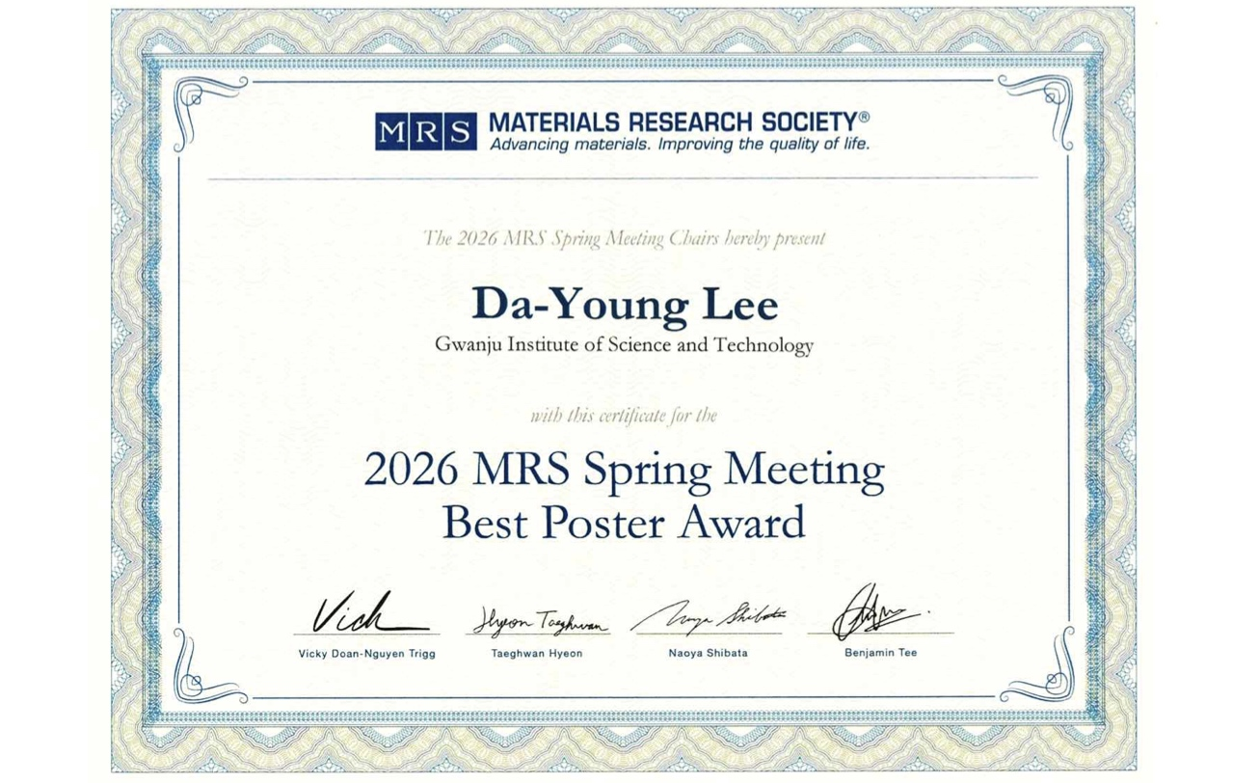

▲ The Best Poster Award received by GIST Postdoctoral researcher Da-Young Lee at the Materials Research Society (MRS) conference. To overcome these limitations, Dr. Lee designed a composite structure combining a grid-structured conductive polymer electrode with a nanofiber ion gel.
As a result, the device maintains airflow, ensuring excellent breathability and providing a comfortable user experience even during extended wear. Furthermore, it enables precise electrical contact, allowing for the maintenance of stable functionality.
The research achievement holds great potential for future applications as it improves user comfort and ensures uniform performance through structural design. Additionally, by presenting the possibility of expanding from a two-dimensional grid structure to a three-dimensional porous structure, its application as a platform for next-generation wearable electronic devices is anticipated.
Professor Myung-Han Yoon of the Department of Materials Science and Engineering at GIST explained, “For skin-attached electrodes, not only performance but also comfort and continuous usability are very important,” adding, “This study is an example demonstrating that these factors can be improved simultaneously through structural design.”
Postdoctoral researcher Da-Young Lee said, “I am deeply honored to have my research achievements recognized by an internationally prestigious academic society,” and added, “In the future, based on the control of the structure and interfacial properties of conductive polymers, I plan to expand my research into various functional composite materials, including not only bioelectronic devices but also electrochemical catalysts and energy materials.”
Meanwhile, the research results were presented at the 2026 Society for Materials Science (SMS) conference held in Hawaii, USA, from April 26 to May 1.

