"What kind of existence will humans have in the AI era?" GIST Vice President for Public Affairs Yonghwa Chung publishes 『The Last Human』
- A civilizational reflection questioning the future of human existence and community in the era of ai and digital control
- From ‘Homo Sapiens’ to ‘Homo Spiritus’… Emphasizing inner human maturity and the restoration of relationships
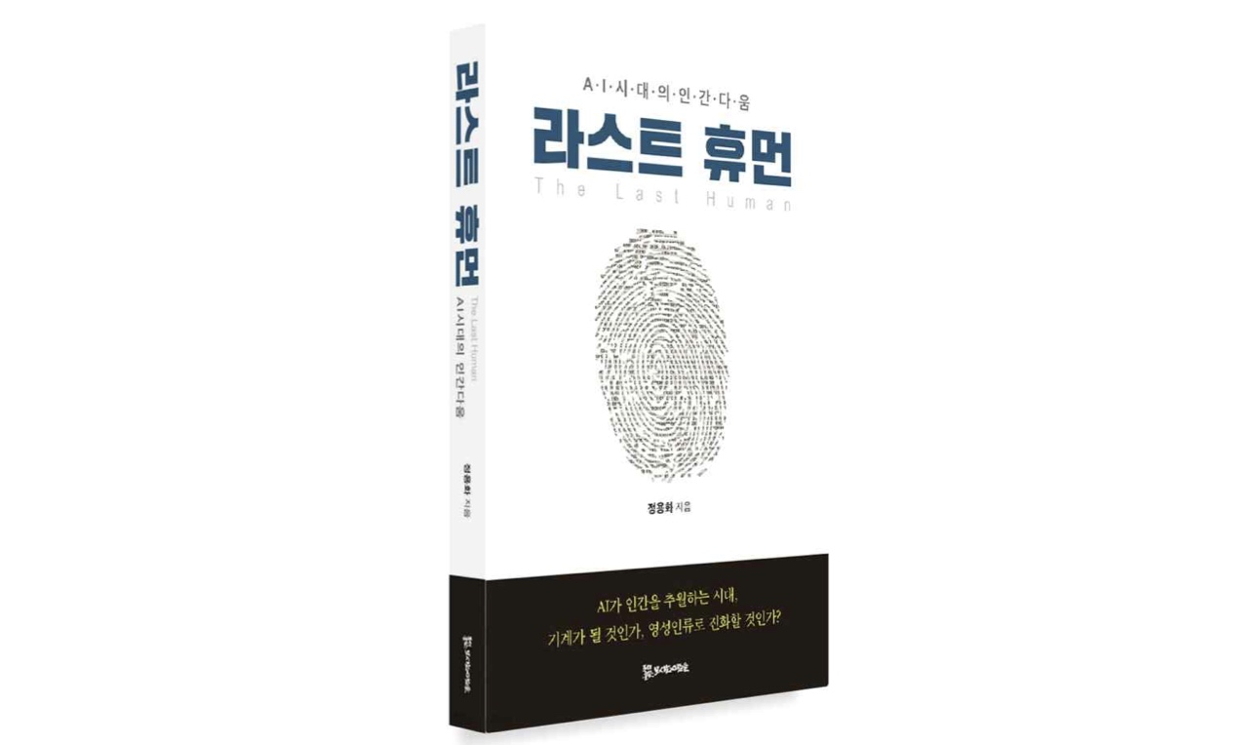

▲ Book cover of 『The Last Human』
The Gwangju Institute of Science and Technology (GIST, President Kichul Lim) announced that Vice President for Public Affairs Yonghwa Chung published the new book 『The Last Human』 on May 15, in which he reflects on the meaning of human existence in the era of artificial intelligence (AI) and the direction of future civilization.
Set against the backdrop of an era where generative AI and automation technologies have surpassed human capabilities and begun to shake the very foundation of humanity, 『The Last Human』 poses the fundamental question, "What makes a human human?" It distinguishes itself from existing AI discourse by contemplating the future of human life, freedom, community, and spirituality in the post-AI era, going beyond the possibilities and dangers of technological advancement.
The author, Vice President for Public Affairs Yonghwa Chung, earned his bachelor's, master's, and doctoral degrees in Diplomacy from Seoul National University. He has served as the ▴ Presidential Speechwriting Secretary, ▴ a Research Professor at Yonsei University, ▴ a Visiting Researcher at Harvard University and the University of Tokyo, ▴ a Visiting Scholar at Peking University, and ▴ a Member of the Korean National Commission for UNESCO. He has been serving as the Vice President for External Affairs at GIST since January 2024.
Vice President Jeong stated that during his tenure at GIST, he directly experienced the field of science and technology research and development and came to reflect more deeply on the relationship between humans and technology through his lecture series with students, "Special Topics on AI: Humanity in the AI ​​Era." He explained that he sought to explore a new ideal of humanity in the AI ​​era by integrating humanities and social science perspectives into the field of science and technology.
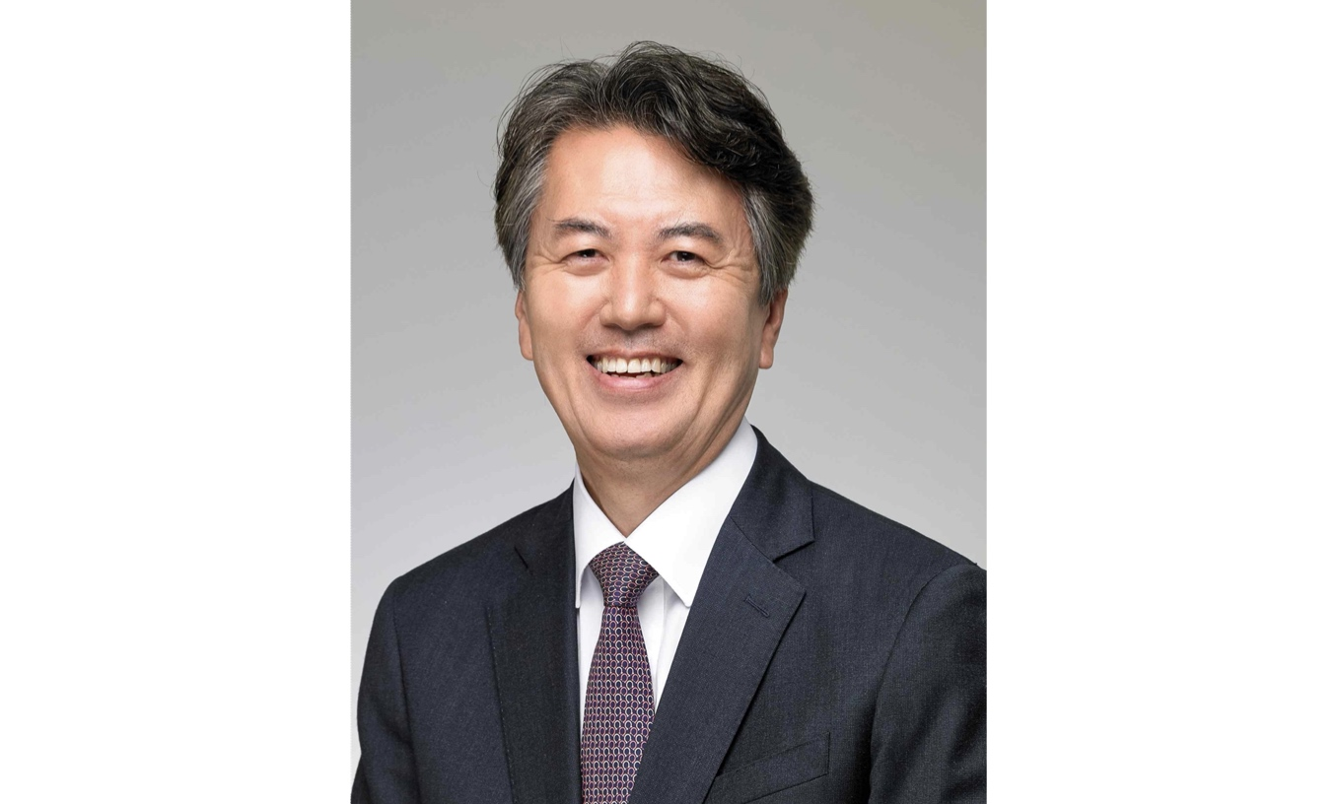

▲ Yonghwa Jeong, Vice President for External Affairs at GIST
In this book, Vice President Jeong approaches the issue of AI by expanding its scope beyond the perspectives of technological ethics or labor replacement to encompass human evolution and the transformation of civilization. He comprehensively surveys issues such as generative AI, digital control, the crisis of liberal democracy, the limitations of capitalism, and the climate crisis within a single framework of civilizational critique, diagnosing that the core of the problem lies not in technology itself, but in the narrowness of our understanding of humanity.
In particular, moving beyond the existing view of humans as competitive and instrumental beings, he presents relational ontology, an ethics of interdependence, and the harmony of intellect, emotion, and spirituality as new alternatives. Explaining the next stage of human evolution as a transition from "Homo Sapiens" to "Homo Spiritus," the author emphasizes that what is needed in the AI ​​era is not stronger humans, but deeper humans.
The book also captures the critical perspective that the last remaining unique qualities for humans in the AI ​​era lie in "spirituality" and inner maturity. It emphasizes that technological advancement alone does not complete humanity, and that the next stage of human evolution is not an expansion of capabilities but a change in the way of being. The message that we must move beyond a civilization of competition and domination toward a civilization of empathy and coexistence is the core theme that runs throughout the book.
It is notable that the book invokes 『Brave New World』 (1932) to reflect on how technological civilization reshapes human life. Diagnosing that Aldous Huxley’s critical perspective—which satirized humans as "standardized beings"—aligns with today’s era of AI and biotechnology, the author argues that what is ultimately needed is not a technological revolution, but an internal "self-revolution" within humans.
The book is composed of four parts. Part 1 covers human evolution, technological advancement, and future imagination, while Part 2 analyzes the impact of AI on human existence, democracy, and the capitalist system. Subsequently, Part 3 identifies the problems of modern civilization in the "economic man" and a view of humanity centered on instrumental reason, and Part 4 proposes a relational ontology and a new community model called the "affectionate society."
Vice President Jeong stated, "The core question of the AI ​​era is not 'Can machines defeat humans?' but 'What kind of beings will humans become?'" He added, "As technology advances, the maturity of the human heart and the restoration of relationships will become even more important." He added, “『The Last Human』 is not so much a book that predicts the future, but rather a book that contemplates how to prepare for and contemplate the future together.”

