GIST Energy Valley Institute of Technology Researcher So-jeong Noh receives commendation from Gwangju Mayor for contribution to promoting investment attraction
- Performing the role of a cooperation hub by connecting policy, technology, and on-site demands of Gwangju's energy industry through the operation of divisional planning committees and network events involving industry, academia, research institutes, and government
- Contributing to the establishment of a sustainable energy industry ecosystem and cooperation platform through the development and support of business models linked to corporate investment attraction
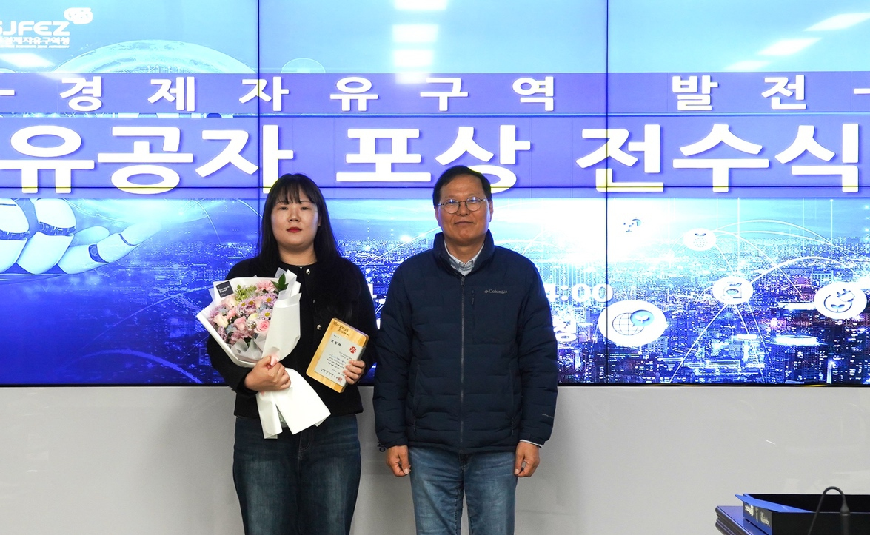

▲ (First from the left) Researcher So-jeong Noh of the GIST Energy Valley Institute of Technology received a commendation from the Mayor of Gwangju on April 10 (Fri) in recognition of her contributions to revitalizing investment attraction.
The Gwangju Institute of Science and Technology (GIST, President Kichul Lim) announced that Researcher So-jeong Noh of the GIST Energy Valley Institute of Technology received a commendation from the Mayor of Gwangju on April 10 (Friday) in recognition of her contributions to establishing a foundation for industry-academia-research-government cooperation and linking activities to attract corporate investment to revitalize Gwangju's energy industry.
Researcher Noh has contributed to strengthening the foundation of Gwangju's energy industry through a wide range of field-oriented activities centered around the GIST Energy Valley Technology Institute, including: planning energy policies, projects, and R&D; establishing cooperation networks among industry, academia, research, and government; planning and operating energy technology exchange meetings and events; and supporting the linkage of corporate investment attraction.
The GIST Energy Valley Institute of Technology was established at GIST in 2015 in accordance with the "Cooperation Agreement for the Creation of an Energy Valley" signed between GIST, Gwangju Metropolitan City, and Korea Electric Power Corporation (KEPCO), with the goal of conducting research projects and developing policies to expand new energy industries in the Gwangju region.
The GIST Energy Valley Institute of Technology, which organizes and operates thematic energy expert planning committees to reflect the annually changing energy industry environment and policy and industrial demands, is discussing the direction of the regional energy ecosystem and preparing planning reports centered on distributed energy, batteries, hydrogen, and the Gwangju-type RE100 industrial complex.
Starting this year, a new "Renaissance Energy" subcommittee has been established and is being operated to proactively respond to the paradigm shift in the energy industry and to advance the region-based energy ecosystem.
In addition, various networking events are being held for energy industry experts, including energy industry technology exchange meetings, expert seminars, and advisory meetings.
Last February, the institute hosted the Gwangju-Jeonnam Integration Briefing and the Gwangju-type Energy Business Model (BM) Development Seminar and Advisory Meeting to share the vision and development direction of the energy industry following the integration with local companies and institutions. Furthermore, it generated tangible linkage results by connecting local companies with investment intentions with target companies.
Energy Industry Technology Exchange Meetings were held in the first and second halves of 2025 to share the latest technological trends and strengthen the foundation for mutual cooperation among experts from industry, academia, research institutes, and government in the energy sector. A total of 230 experts participated in the events, yielding significant results such as enhancing technical understanding and laying the groundwork for identifying research and cooperation projects.
In addition, the institute is contributing to the creation of a cooperative ecosystem that connects policy, technology, and investment information by participating in the planning and operation of major energy events, including the RE100 Seminar, the Cheongrok Hydrogen Seminar, the Gwangju Future Industry EXPO, and the BIXPO 2025 Conference.
Researcher So-jeong Noh stated, "I have worked with a sense of responsibility on the ground to ensure that the Gwangju energy industry leads to tangible investment and cooperation," adding, "The GIST Energy Valley Institute of Technology will continue to do its utmost to foster a cooperative ecosystem where Gwangju, local companies, and institutions can grow together."
Meanwhile, the GIST Energy Valley Institute of Technology will participate in the ‘Korea Climate, Environment, and Energy Exhibition (KEET 2026),’ held at the Yeosu Expo Digital Gallery from April 20 to 22, as part of efforts to expand the foundation for energy industry cooperation and revitalize the industrial ecosystem.
Through this, the institute plans to promote the development of Gwangju-style energy business models and planning achievements in the fields of distributed energy, hydrogen, and batteries, as well as to pursue the discovery of joint projects and investment linkages among related companies.

