GIST strengthens philosophy education as a solution for the AI ​​era… Successive recruitment of Harvard philosophy faculty
- Strengthening education encompassing AI ethics, language, and philosophy of art… "Philosophy remains key as technology replaces humans"
- Harvard alumni Professors Kanghun Ahn and Jinho Kang join, accelerating the cultivation of ‘thinking future leaders in science and technology’
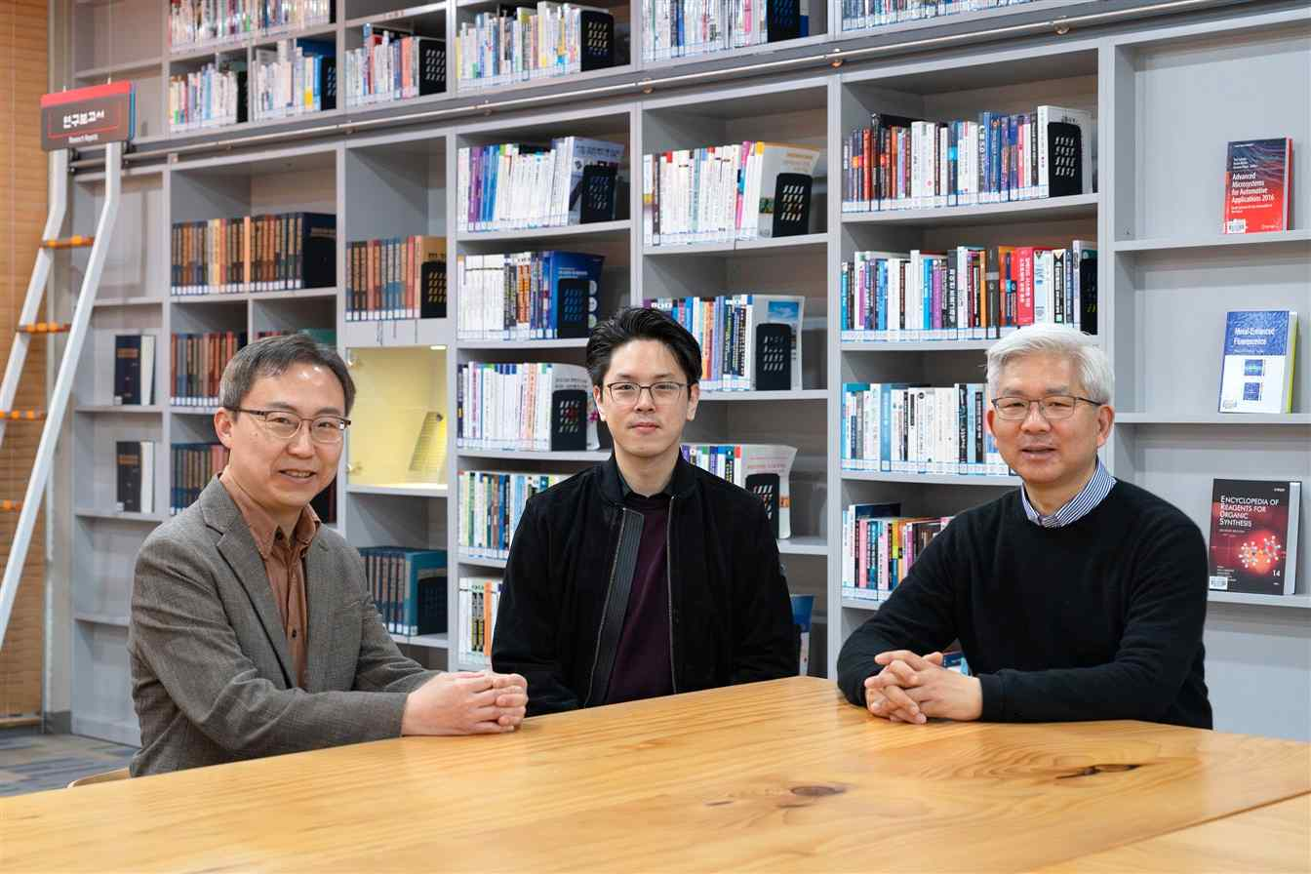

▲ (From left) GIST Dean of the School of Humanities and Social Sciences Gunoo Kim, Professor Kanghun Ahn, and Professor Jinho Kang.
The Gwangju Institute of Science and Technology (GIST, President Kichul Lim) announced that it has expanded its foundation for humanities-based education and research to lead the era of artificial intelligence (AI) by successively recruiting philosophy faculty members.
GIST recently secured new faculty members for its School of Humanities and Social Sciences in the fields of Eastern philosophy, philosophy of art, philosophy of language, and philosophy of AI. With this, the university has established a robust philosophy education system, a rarity among science and technology-focused universities.
The GIST School of Humanities and Social Sciences (Department Head Gunoo Kim) has newly appointed two philosophy professors starting from the first semester of the 2026 academic year.
Professor Kanghun Ahn, who has just joined the faculty, will conduct interdisciplinary research focusing on Eastern thought, comparative philosophy, and philosophy of art, while Professor Jinho Kang plans to incorporate global trends in the fields of philosophy of language and philosophy of AI into his lectures and research.
With this, GIST has expanded the scope of thought connecting technology and humanity by forming a total of three full-time philosophy professors encompassing Eastern philosophy and philosophy of language, along with Dean of the School of Humanities and Social Sciences Gunoo Kim, who majored in legal philosophy and AI ethics.
Professor Kanghun Ahn, appointed as an Assistant Professor, earned his Ph.D. from the Department of East Asian Languages ​​and Civilizations at Harvard University. Recently, he has been expanding his research scope into comparative philosophy and philosophy of art, bridging the philosophies of Deleuze and Zhuangzi. This semester, he will be teaching courses such as Introduction to Eastern Philosophy and Art and Philosophy: Aesthetic Imagination.
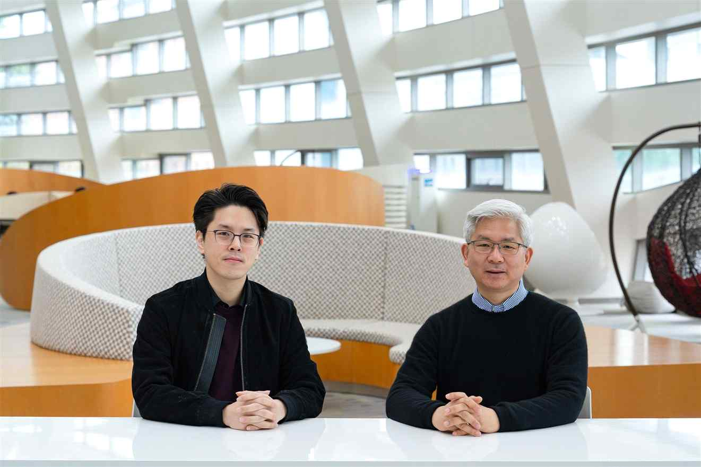

▲ (From left) Professor Kanghun Ahn and Professor Jinho Kang of the GIST School of Humanities and Social Sciences.
Professor Ahn expressed his aspirations, stating, “I was deeply attracted to GIST’s educational philosophy, which aims for the convergence of science and technology with the humanities.” He added, “I want to open new horizons of integrated thinking for science students by connecting Eastern philosophy with modern scientific thought and the philosophy of art.”
Professor Jinho Kang, recruited as a visiting scholar, holds a Ph.D. in Philosophy from Harvard University and is an authority in the field of philosophy of language, having served at the Department of Philosophy at Seoul National University for 15 years. This semester, he will be teaching courses such as Fundamental Problems of Philosophy and Philosophy of Artificial Intelligence.
Professor Kang stated, “Philosophical reflection is essential to move beyond simple statistical AI toward true intelligent AI equipped with an epistemological foundation,” adding, “I will explore the nature of knowledge and the potential of AI to present a new standard for philosophy education in the AI ​​era.”
GIST’s expansion of its faculty is based on the judgment that as technological advancements accelerate, philosophical thinking skills and critical reasoning abilities will become core competencies for future science and technology talent.
Dean Gunwoo Kim emphasized, “As technology replaces human domains, human thought and the ability to construct meaning become increasingly important,” noting that “philosophy will become an essential educational infrastructure for the AI ​​era.”
President Kichul Lim stated, “Innovation in the AI ​​era is not completed by technology alone; it only reveals its true value when combined with humanistic insight,” adding, “With the appointment of Professors Kanghun Ahn and Jinho Kang, we will actively support students so that they can grow into creative leaders equipped with deep thinking.”

