"Plants that always die when I grow them... Finding care methods with a single photo" GIST undergraduate startup team partners with SK Intellix to launch pilot test for AI home gardening app
- Student team Lutive, originating from GIST’s extracurricular program ‘Infinite Challenge Project,’ begins full-scale verification of business feasibility for AI-based companion plant care app
- Reviewing technology implementation and commercialization possibilities through proof of concept (PoC) with SK Intellix
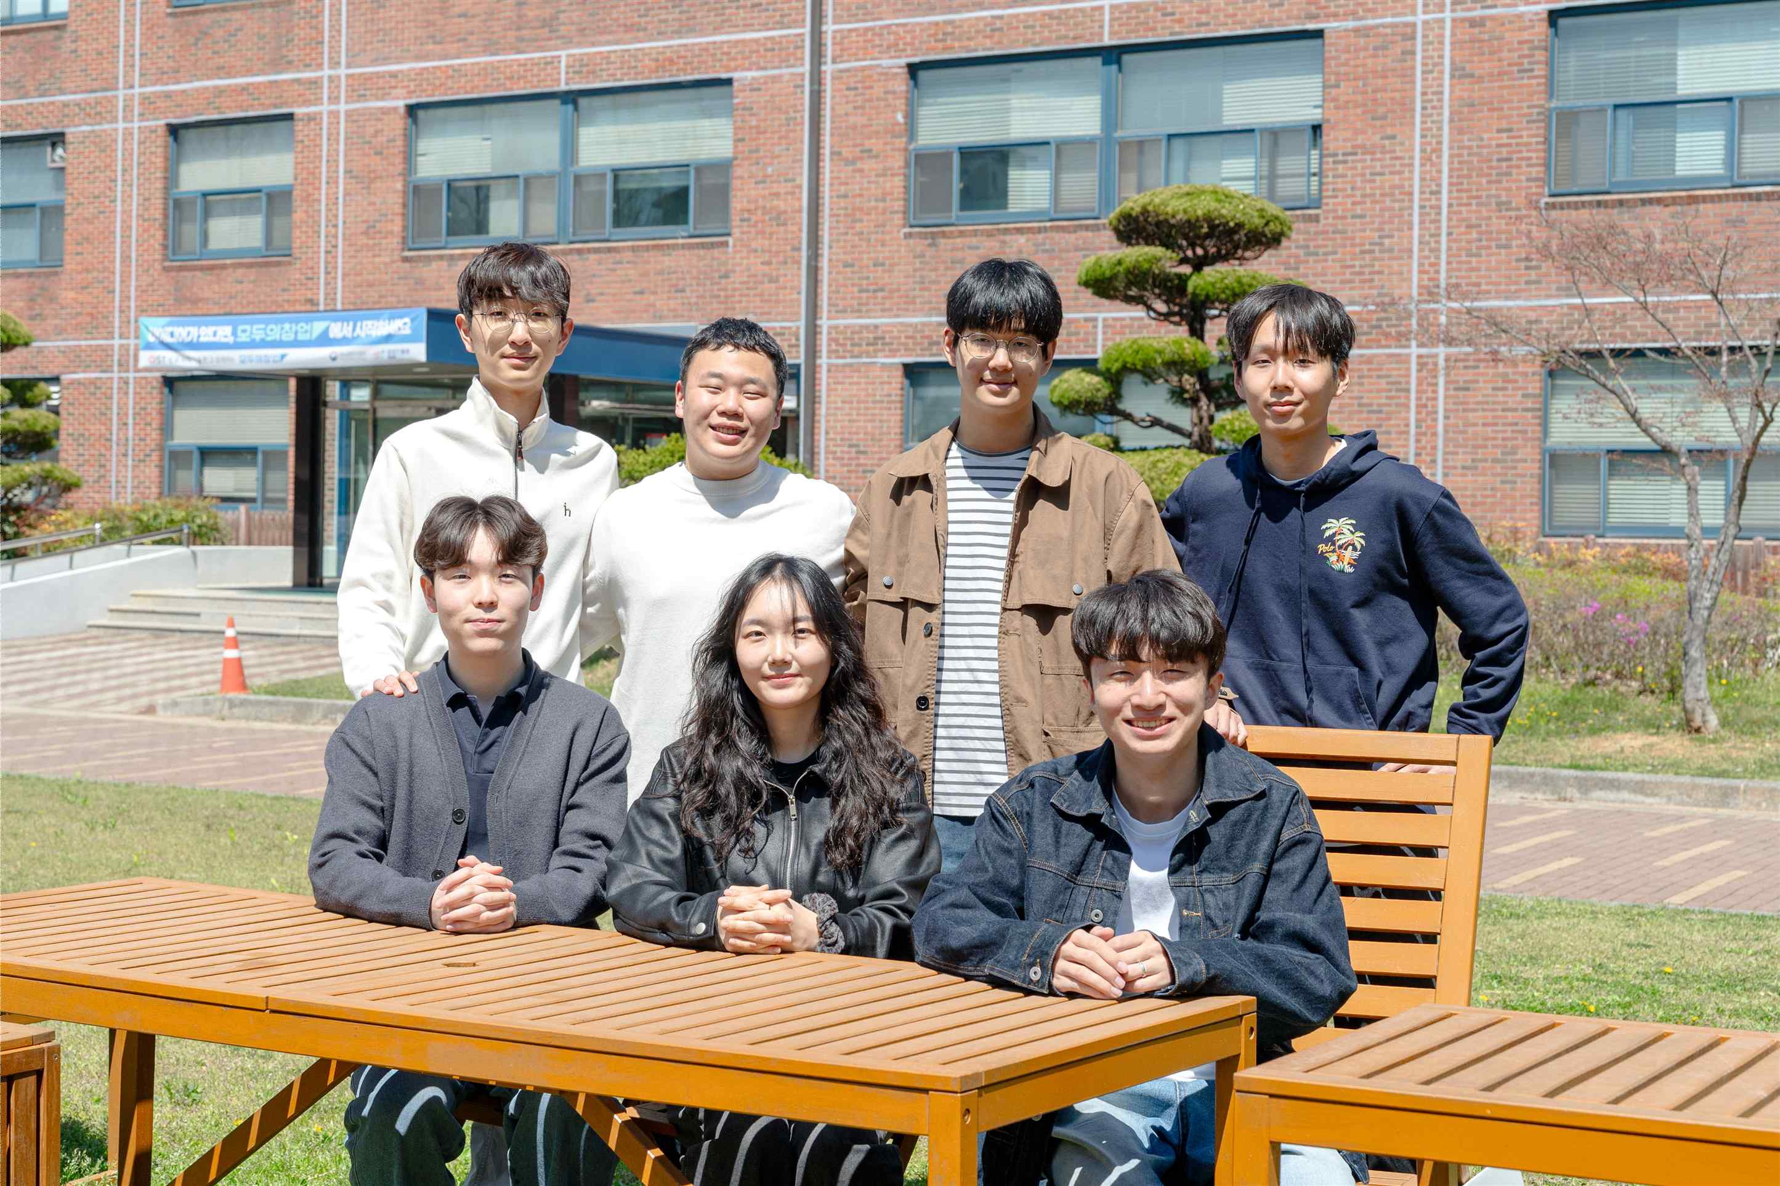

▲ GIST undergraduate startup team Rootive. (Back row from left) Jeong-won Choi (1st year, Challenge & Exploration Program), Dong-heon Ryu (2nd year, Department of AI Convergence), Seok-woo Jang (2nd year, Department of Electrical Engineering and Computer Science), Seo-jun Lee (2nd year, Department of Life Sciences), (Front row from left) Ki-yong Kim (2nd year, Department of AI Convergence), Yeon-ju Kim (3rd year, Department of Electrical Engineering and Computer Science), Jae-won Choi (2nd year, Department of Electrical Engineering and Computer Science)
The Gwangju Institute of Science and Technology (GIST, President Kichul Lim) announced that the "Rootive" team (led by Jae-won Choi, a sophomore in the Dep Department of Electrical Engineering and Computer Science), composed of current students, has officially commenced a proof of concept (PoC) for an AI home gardening app developed by the team in collaboration with SK Intellix (CEO Moo-in Ahn).
On Friday, March 20, the Rootive team signed a proof of concept (PoC) agreement with SK Intellix to verify and test the application service.
Under this agreement, the Rootive team plans to develop a home gardening application that provides customized care solutions for companion plant users over the next six months. Following testing and verification processes, they will review business feasibility, including whether the application can be applied to SK Intellix’s wellness robotics, "NAMUHX."
The Rootive team originated from the ‘G-Quarium’ team, which participated in the ‘Infinite Challenge Project,’ a representative extracurricular creative and challenge program at GIST, and has grown based on this foundation. ‘Rootive’ is a portmanteau of ‘Root’ and ‘Innovative,’ signifying the team’s commitment to implementing user-centric innovative services.
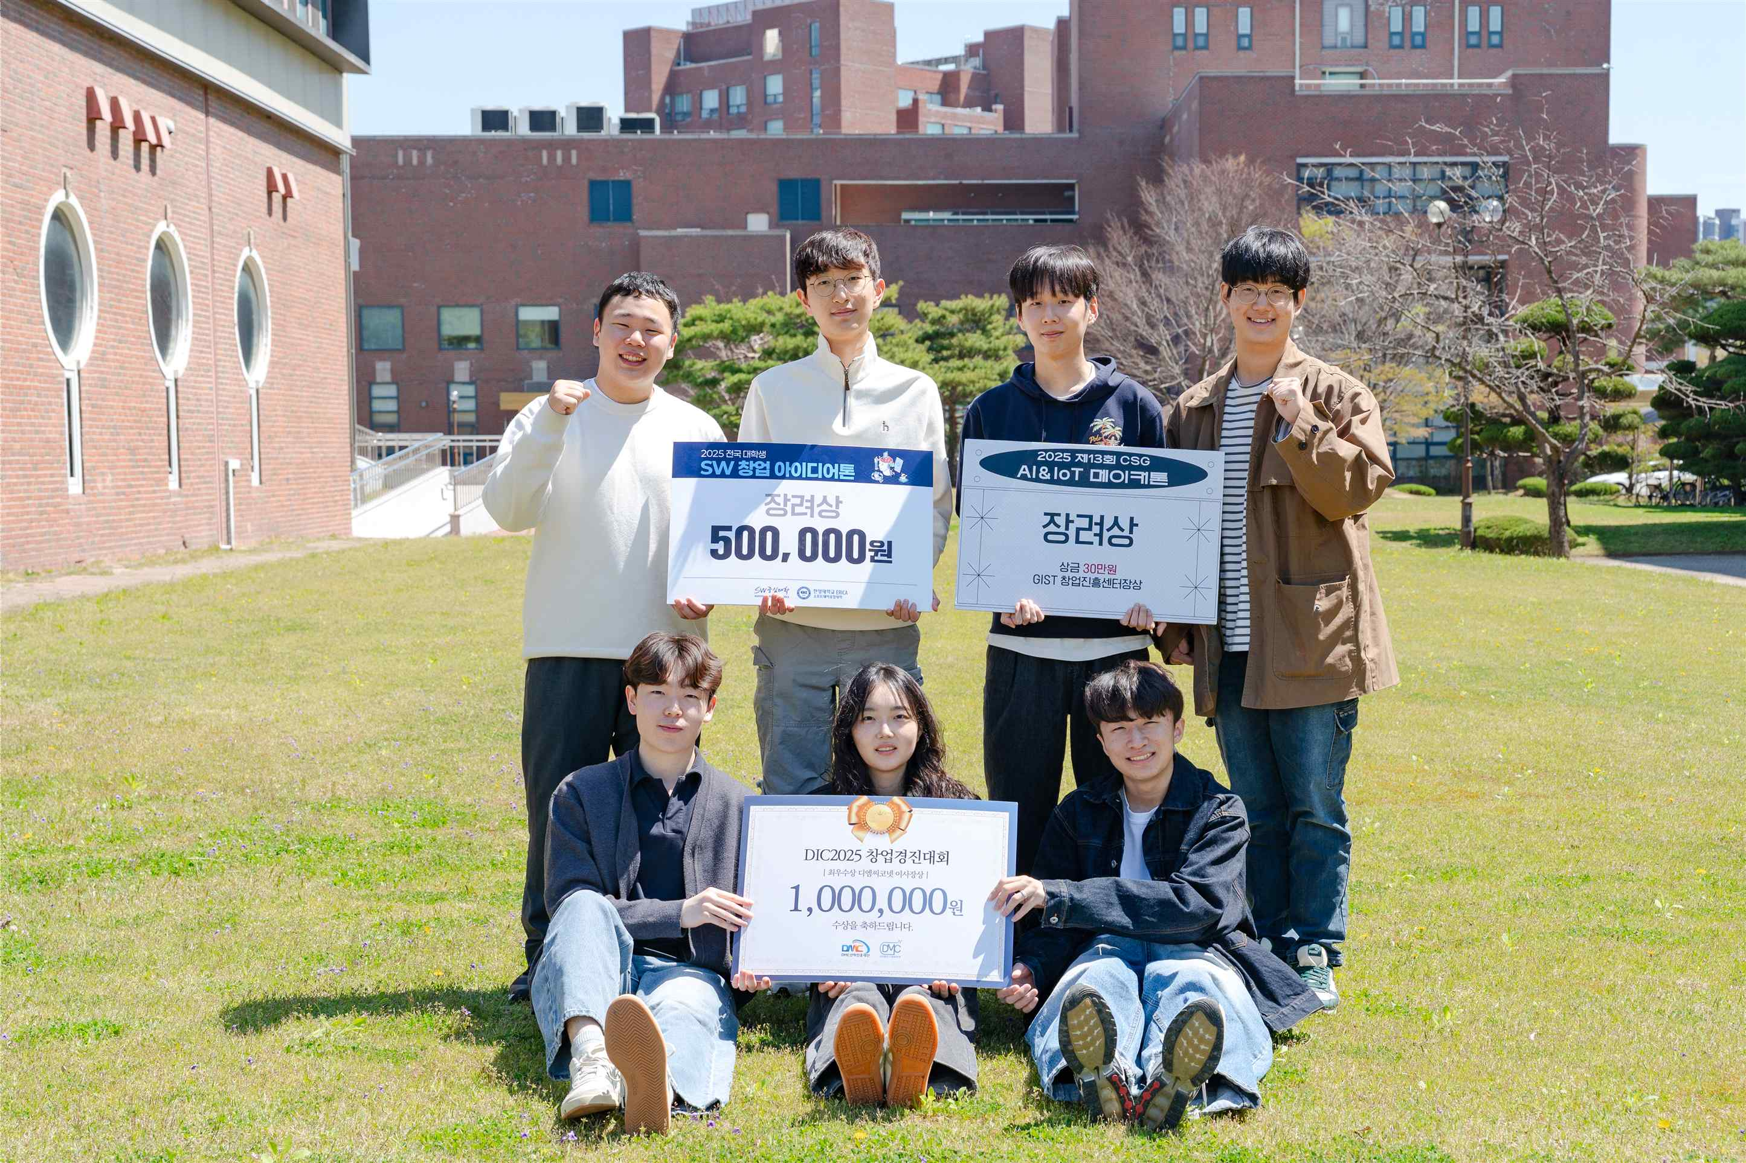

▲ Rootive, a GIST undergraduate startup team. The team has achieved consecutive awards, recognized for the innovativeness of its method of providing cultivation guidelines optimized for plants and its interactive care features that allow companion plants to interact with users.
‘My Little Garden,’ a home gardening application currently under development by the Rootive team, is characterized by its ability to use AI to analyze and diagnose the growth status of companion plants based solely on photos taken by the user, and to provide customized management solutions tailored to both the user and the plant's condition. In particular, the team demonstrated the competitiveness of their idea by receiving recognition for the innovativeness of their interactive care function, which guides users on cultivation methods suitable for different plant types and enables interaction between users and plants. They won the Excellence Award at the ‘1st NAMUHX Hackathon’ hosted by SK IntelliX on December 5, 2025 (Fri), followed by the Grand Prize (2nd Place) at the ‘2025 DMC Innovation Camp Startup Competition (DIC2025).’
Currently, they are participating in the ‘2026 Pre-Startup Package,’ organized by the Ministry of SMEs and Startups and the Korea Institute of Startup & Entrepreneurship Promotion, to simultaneously advance their technology and verify the potential for commercialization.
This collaboration is noteworthy because it involved a team of undergraduate students developing an idea through an on-campus program and proceeding to a proof of concept (PoC) with a company.
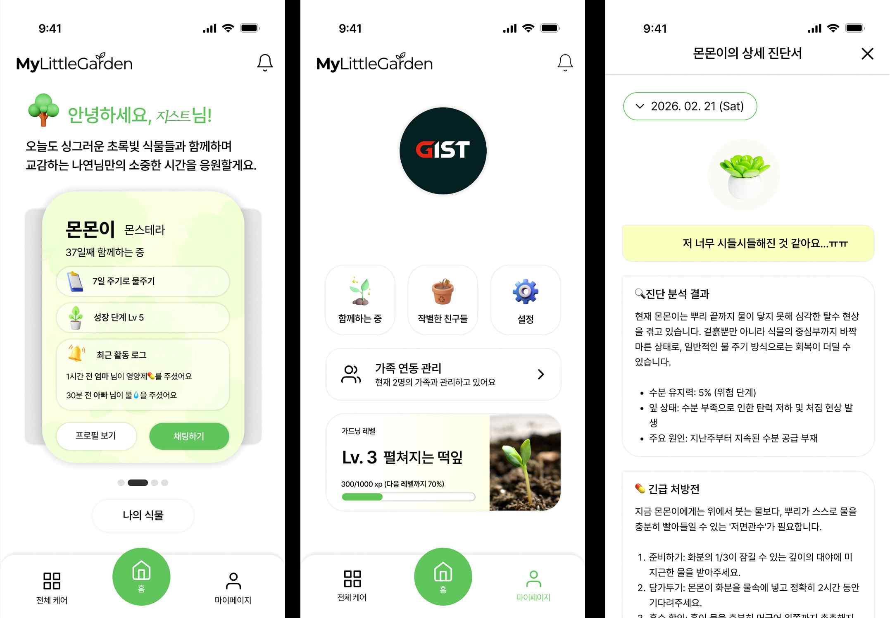

▲ Image of the prototype for the hyper-personalized home gardening application by Rootive, a GIST undergraduate startup team.
The Rootive team plans to verify the feasibility of the overall technology, including: ▴image data collection by connecting AI camera devices and software; ▴Google AI-based plant recognition; ▴diagnosis of growth conditions using proprietary AI models; and ▴establishment of a server (API), which serves as the core infrastructure for the application.
This case is particularly significant in that a student idea has led to actual industrial collaboration.
Jae-won Choi, CEO of Rootive, stated, "We were able to achieve meaningful results thanks to GIST's 'Infinite Challenge Project,' the systematic support from the Startup Promotion Center, and the unsparing guidance from our faculty, including Professor Jae Woong Soh of the Department of Electrical Engineering and Computer Science." He added, "During the agreement period, we will do our utmost to further enhance the completeness of the technology so that it can lead to an actual service."

