GIST graduate student team wins international AI game competition: Krafton-hosted ‘Entertainment Game Agent Challenge,’ a competition featuring 117 participating teams sponsored by NVIDIA, AWS, and OpenAI... Won first place in the small language model (SLM) category and received a $6,000 prize
- The ‘A Great Toe’ team, composed of four graduate students from the Department of AI Convergence (advisor Professor Kyung Joong Kim), designed an AI agent structure capable of making stable decisions even in environments with limited resources
- Demonstrated reasoning, strategic, and adaptive capabilities through continuous gameplay of various games, demonstrating potential for general application
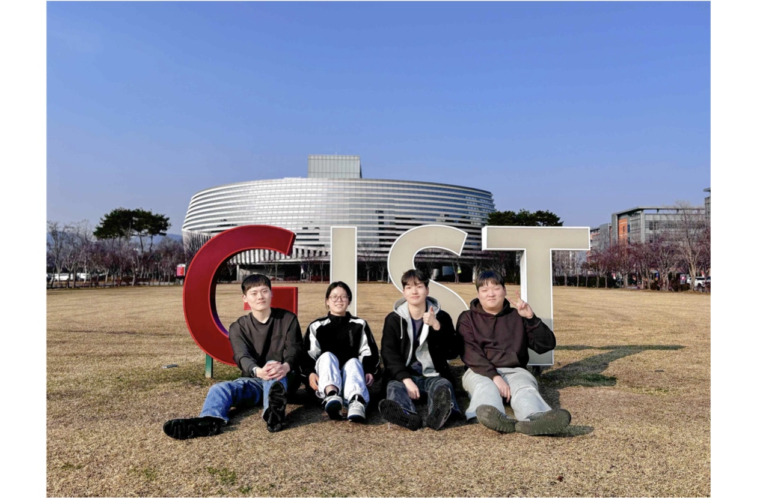

▲ The ‘A Great Toe’ team, winners of the ‘Entertainment Game Agent Challenge.’ (From left) master’s students Gyung-Bo Kim and Yujin Kim from the Department of AI Convergence, integrated master’s and Ph.D. student Yucheon Park, and master’s student Geum-Hwan Hwang
The Gwangju Institute of Science and Technology (GIST, President Kichul Lim) announced that the ‘A Great Toe’ team, composed of graduate students from the Department of AI Convergence (including integrated master’s and doctoral student Yucheon Park, master’s students Gyung-Bo Kim, Yujin Kim, and Geum-Hwan Hwang; supervised by Professor Kyung Joong Kim), won first place in the ‘Small Language Model’ track of the international AI game play competition, the ‘Orak Game Agent Challenge.’
The competition was organized by Krafton, a global game company that developed titles such as Battlegrounds, TERA, and inZOI, with NVIDIA, Amazon Web Services (AWS), and OpenAI participating as official sponsors. The total prize pool was $20,000, and the results were announced on March 6.
In this competition, which had a total of 117 participating teams, the ‘A Great Toe’ team took first place in the ‘Small Language Model’ track and won a prize of $6,000.
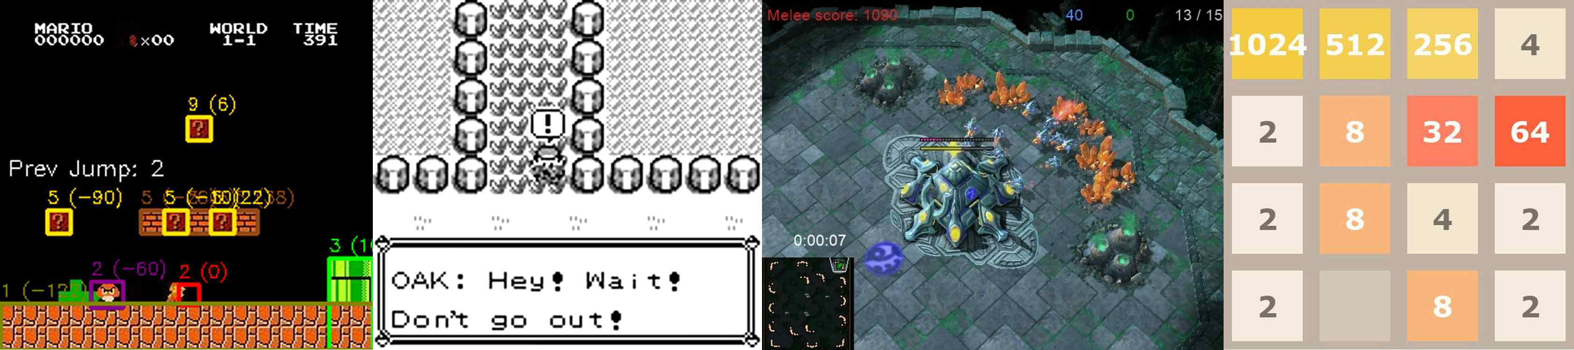

▲ Gameplay scenes of language model-based systems. (From left) Super Mario, Pokémon Red, StarCraft II, 2048
The ‘Entertainment Game Agent Challenge’ is an international competition where AI competes in the ability to solve sequential tasks by directly playing in various video game environments.
In particular, it is characterized by a comprehensive evaluation of the AI’s judgment, strategic planning capabilities, and adaptability to the environment.
In the ‘Small Language Model’ track, teams must design agents (artificial intelligence programs) under constraints of limited computational resources and the scale of the AI ​​model (amount of learned information and computational power). Participating teams competed in performance by learning and optimizing strategies under these conditions.
Small language models refer to AI that focuses on efficiency and lightweight design, reducing model size and computational load compared to large language models (LLM).
Each team had to play four different types of games consecutively ▴ Super Mario, ▴ Pokémon Red, ▴ StarCraft II, and ▴ 2048 using a single language model. This process requires complex capabilities such as spatial reasoning, strategic decision-making, resource management, and mathematical reasoning.
The 'A Great Toe' team designed a new system structure based on 'action candidate generation' to enhance the stability of the AI's judgments.
Existing language model-based AIs had limitations in that they made unrealistic or inconsistent choices because they interpreted the game situation and decided on actions immediately.
To improve this, the 'A Great Toe' team first introduced a 'structural analysis module' that organizes feasible actions. This module analyzes the game state to generate action candidates and priorities considering search direction, resource status, and feasibility. Subsequently, the AI ​​selects the optimal action from these candidates.
Furthermore, various stabilization mechanisms were applied to ensure the system operates stably across different game environments. These included verifying whether the actions selected by the AI ​​are actually executable, restricting action generation to a defined format, and correcting errors through additional instructions.
“This achievement holds great technical value in that it demonstrates the potential for the general application of small language models (SLMs) across various game environments,” said Professor Kyung Joong Kim, the supervising professor. “I am proud of the students for overcoming a highly uncertain environment with creative algorithms.”
Student Yujin Kim shared her thoughts, saying, “I am happy to have achieved good results by collaborating with my team members. I would like to continue researching AI systems capable of making stable decisions in diverse environments.”

