A GIST graduate student research team won the 32nd Samsung HumanTech Paper Award
- The team of electrical, electronic, and computer engineering students, JuHyeong Lee, Gyurin Kim, and Juhwan Kim (advisor: Professor Hyeon-Ho Jeong), developed heat-generating and water-repellent nanomaterials for autonomous driving sensors... Their research demonstrated sensor signal stability even in low-temperature and rainy environments, demonstrating their competitiveness in related fields
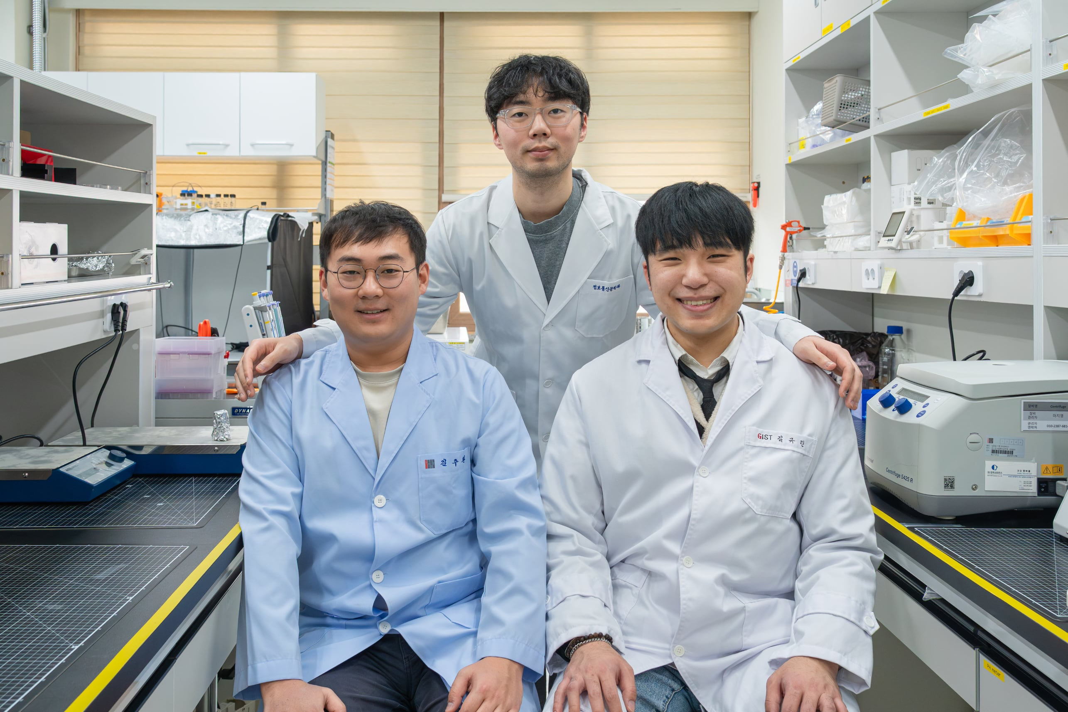

▲ (From left) Juhwan Kim, JuHyeong Lee, and Gyurin Kim, students in the combined master's and doctoral program in the Department of Electrical Engineering and Computer Science
The Gwangju Institute of Science and Technology (GIST, President Kichul Lim) announced that the research team of JuHyeong Lee, Gyurin Kim, and Juhwan Kim all of whom are in the combined master's and doctoral program in the Department of Electrical Engineering and Computer Science, under Professor Hyeon-Ho Jeong's laboratory, won the Encouragement Award at the 32nd Samsung HumanTech Paper Awards.
The Samsung HumanTech Paper Awards, hosted by Samsung Electronics and co-sponsored by the Ministry of Science and ICT and the JoongAng Ilbo, is a leading science and technology paper award established in 1994. The award recognizes research papers submitted by undergraduate, graduate, and high school students, and is presented after a thorough review process, with the goal of discovering future leaders in science and technology.
GIST has consistently won awards in this competition since 1996, demonstrating its educational and capacity as a research-oriented university.
This year's competition received a record 3,172 papers, of which 120 were selected as award winners. The awards ceremony was held at Samsung Electronics' Seocho building on the 11th.
The research team developed weather-adaptive sensor protection technology that helps autonomous driving sensors operate normally even in inclement weather. In particular, they were recognized for demonstrating the sensor's stable operation even in actual rain and low-temperature environments.
Student JuHyeong Lee expressed his gratitude, saying, "I would like to express my gratitude to Professor Hyeon-Ho Jeong for his meticulous guidance throughout the entire research process, and to my research teammates for their thoughtful discussions and collaborative discussions." He added, "I hope to further develop this research and apply it to various externally exposed optical and electronic sensors, expanding the technology to enable stable data acquisition even in adverse weather conditions."
Student Juhwan Kim added, "It is meaningful to have achieved such a significant result at a time when autonomous driving technology is rapidly expanding. I look forward to advancing this research beyond the laboratory and into real-world industrial technology, potentially expanding it into various optical product fields."
Student Gyurin Kim shared, "Through this technological development, I deeply recognized the importance of convergence research and learned the importance of material design and process optimization."
Meanwhile, Professor Hyeon-Ho Jeong's NanoSystems Lab, which produced this year's winner, conducts multidisciplinary research on developing nanoscale optical devices, elucidating optical properties, and controlling light-matter interactions. Building on this foundation, the lab is conducting research aimed at practical application in cutting-edge fields such as 3D nanofabrication, active nanophotonics/metasurfaces, chiral plasmonics, and micro/nanorobotics.
In particular, the lab is securing the potential for expansion into diverse optoelectronic applications, such as displays, sensors, and photodetectors, by developing three-dimensional nanostructure fabrication technology that goes beyond conventional planar structures and designing nanodevices based on light-matter interaction control.

