Professor Emeritus Jae-Suk Lee of GIST publishes a policy report through the Korean Academy of Science and Technology: A polymer synthesis authority presents a materials design paradigm for the AI ​​era
- Presents national strategic direction, including AI-based material design and data-driven synthesis research... Helical polymers are identified as an optimal field for AI-integrated research
- As a polymer synthesis authority who discovered the world's first "living polymerization" characteristics, he proposes industrial structural innovation through the combination of manufacturing competitiveness and AI technology... Emphasizing that "accumulating domain knowledge determines the success or failure of AI innovation"
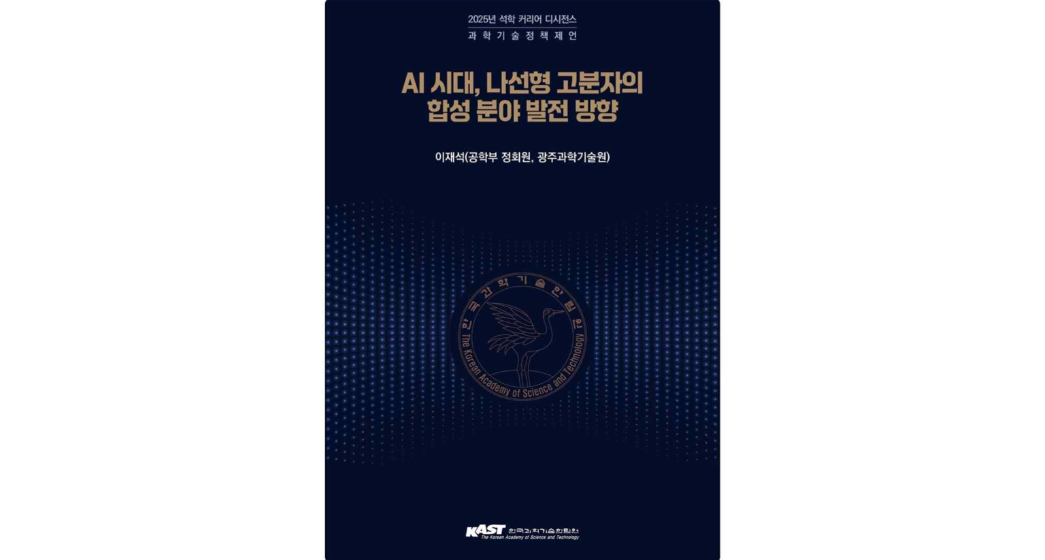

▲ Cover of the book "Development Direction of Helical Polymer Synthesis in the AI ​​Era"
The Gwangju Institute of Science and Technology (GIST, President Kichul Lim) announced that Professor Emeritus Jae-Suk Lee of the Department of Materials Science and Engineering has published a policy proposal report titled "Development Direction of Helical Polymer Synthesis in the AI ​​Era" as part of the "Distinguished Researcher Career Decisions" project hosted by the Korean Academy of Science and Technology (KAIST).
"Distinguished Scholar Career Decisions" is a lecture and policy program where Korea's top researchers share their research experiences and insights, offering direction and inspiration to future scientists and engineers. Professor Lee's report was published in December 2025.
This report, centered on the convergence vision of "AI × Polymer Synthesis," proposes key national policy directions, including AI-based material design strategies, data-driven synthesis research systems, and professional talent development plans.
In particular, it analyzes the structure and limitations of the petrochemical and polymer industries, which have driven Korea's economic growth, and systematically organizes the scientific principles and developmental processes of polymer synthesis technology, which can serve as a foundation for policy discussions.
Using peptides, a representative biomolecule that forms helical structures, as an example, Professor Lee explained the concept and characteristics of helical polymers. He emphasized that helical polymer research is well-suited for AI convergence, as areas with sufficiently accumulated research data are more advantageous for AI analysis and design.
He also evaluated "living anionic polymerization," which has been developed over decades, as a representative technology in polymer science. He predicted that it will play a crucial role in the future development of AI-based polymer design and synthesis technologies, as it allows for the precise design of polymers with desired properties.
Based on insights gained from his extensive research experience, Professor Lee proposed that "physical AI," which combines polymer synthesis with real-world physical environments, will become important in the AI ​​era. He also proposed a new research strategy for future generations of researchers.
* peptide: A short molecular chain composed of amino acids linked together, it is the basic structural unit of proteins. Under certain conditions, it forms a helix structure.
* living polymerization: A polymerization characteristic in which polymer chain growth continues without stopping, allowing for precise control of molecular weight and structure. This characteristic is observed in certain reaction methods, such as anionic polymerization.
The report proposes "domain knowledge" as a key condition for scientific and technological innovation in the AI ​​era. Domain knowledge refers to the specialized knowledge and experience accumulated by researchers in a specific field over a long period of time.
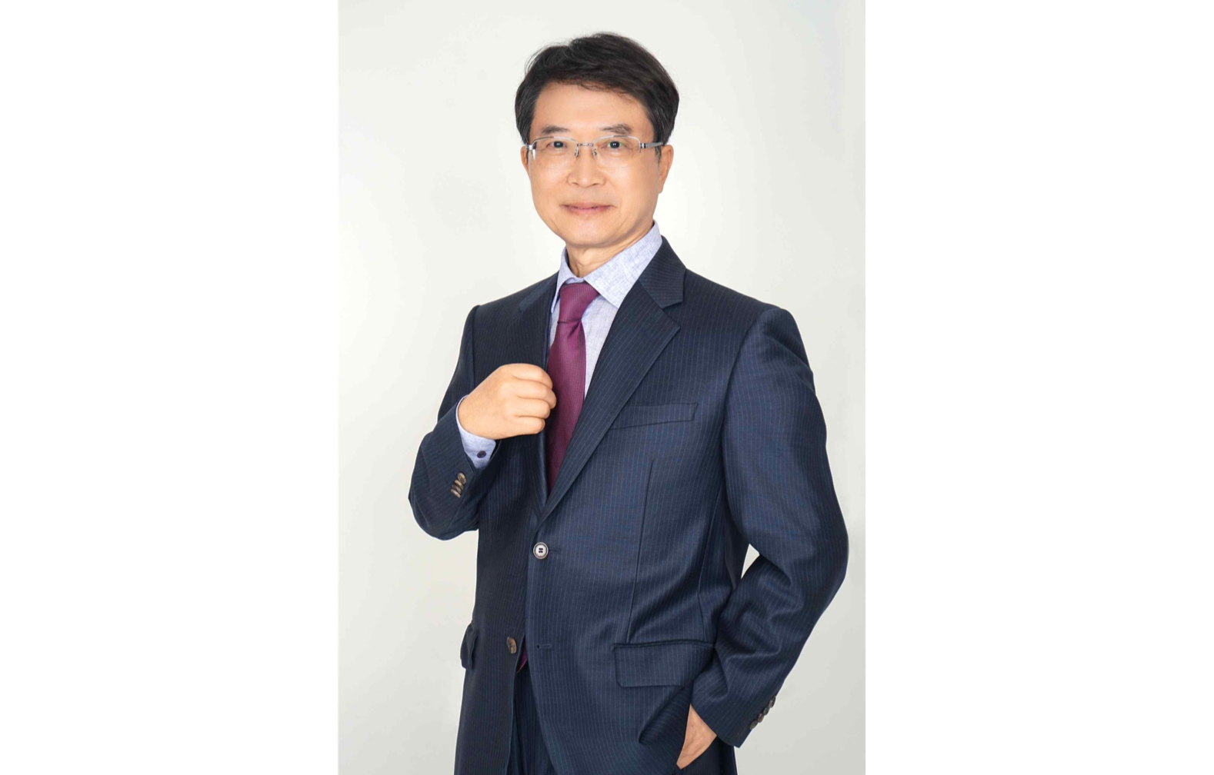

▲ Jae-Suk Lee, Professor Emeritus, Department of Materials Science and Engineering at GIST
Professor Lee cited the research of new materials, polymer materials, and polymer synthesis, particularly helical polymers, as examples. He explained that in fields where expertise is accumulated, more reliable data is secured, enabling AI to perform more accurate analysis and design.
This explanation is significant because it demonstrates that AI is not a technology that replaces research, but rather a complementary tool that expands and enhances the knowledge accumulated by human researchers.
Professor Lee, a full member of the Korean Academy of Science and Technology, is an authority in polymer synthesis and has contributed significantly to the advancement of polymer science by first discovering the core principles for the precise design of new polymers. In particular, he was the first to discover "living polymerization characteristics" in the anionic polymerization of isocyanates, paving the way for freely controlling polymer length and structure.
* anionic polymerization of isocyanates: A reaction method that uses the chemical isocyanate to create long-chain polymers, allowing for precise control of molecular length and structure.
After retiring from GIST, he published "My Education, Research, and Community Service," which documents his experiences in education, research, and community service. He has also continued to share his research philosophy and experiences through lectures at the "Distinguished Scholar Career Decisions" event.
In particular, he posed the fundamental question, "Is polymer stereoregularity control possible?" to his juniors, emphasizing the continued challenge of addressing unsolved problems.
Regarding the publication of this report, Professor Lee suggested, "If Korea combines the manufacturing competitiveness of the world's top five powers with the AI ​​technology of the top three, it can overcome the structural limitations of the petrochemical industry and secure a new edge in global competition."

