Professor Byeong Ha Lee of GIST receives the 37th Optical Society of Korea Academic Award
- This is the most prestigious award in the field of optics in Korea, awarded annually to one individual... Professor Byeong Ha Lee of the Department of Electrical Engineering and Computer Science has accumulated key research achievements in optics, including 3D optical imaging technology, since joining GIST in 1999
- Based on his academic impact, including over 150 international journal papers, over 5,200 cumulative citations, and ranking among the world's top 2% of researchers, he contributes to expanding the industrial application of his research results and fostering the next generation of researchers
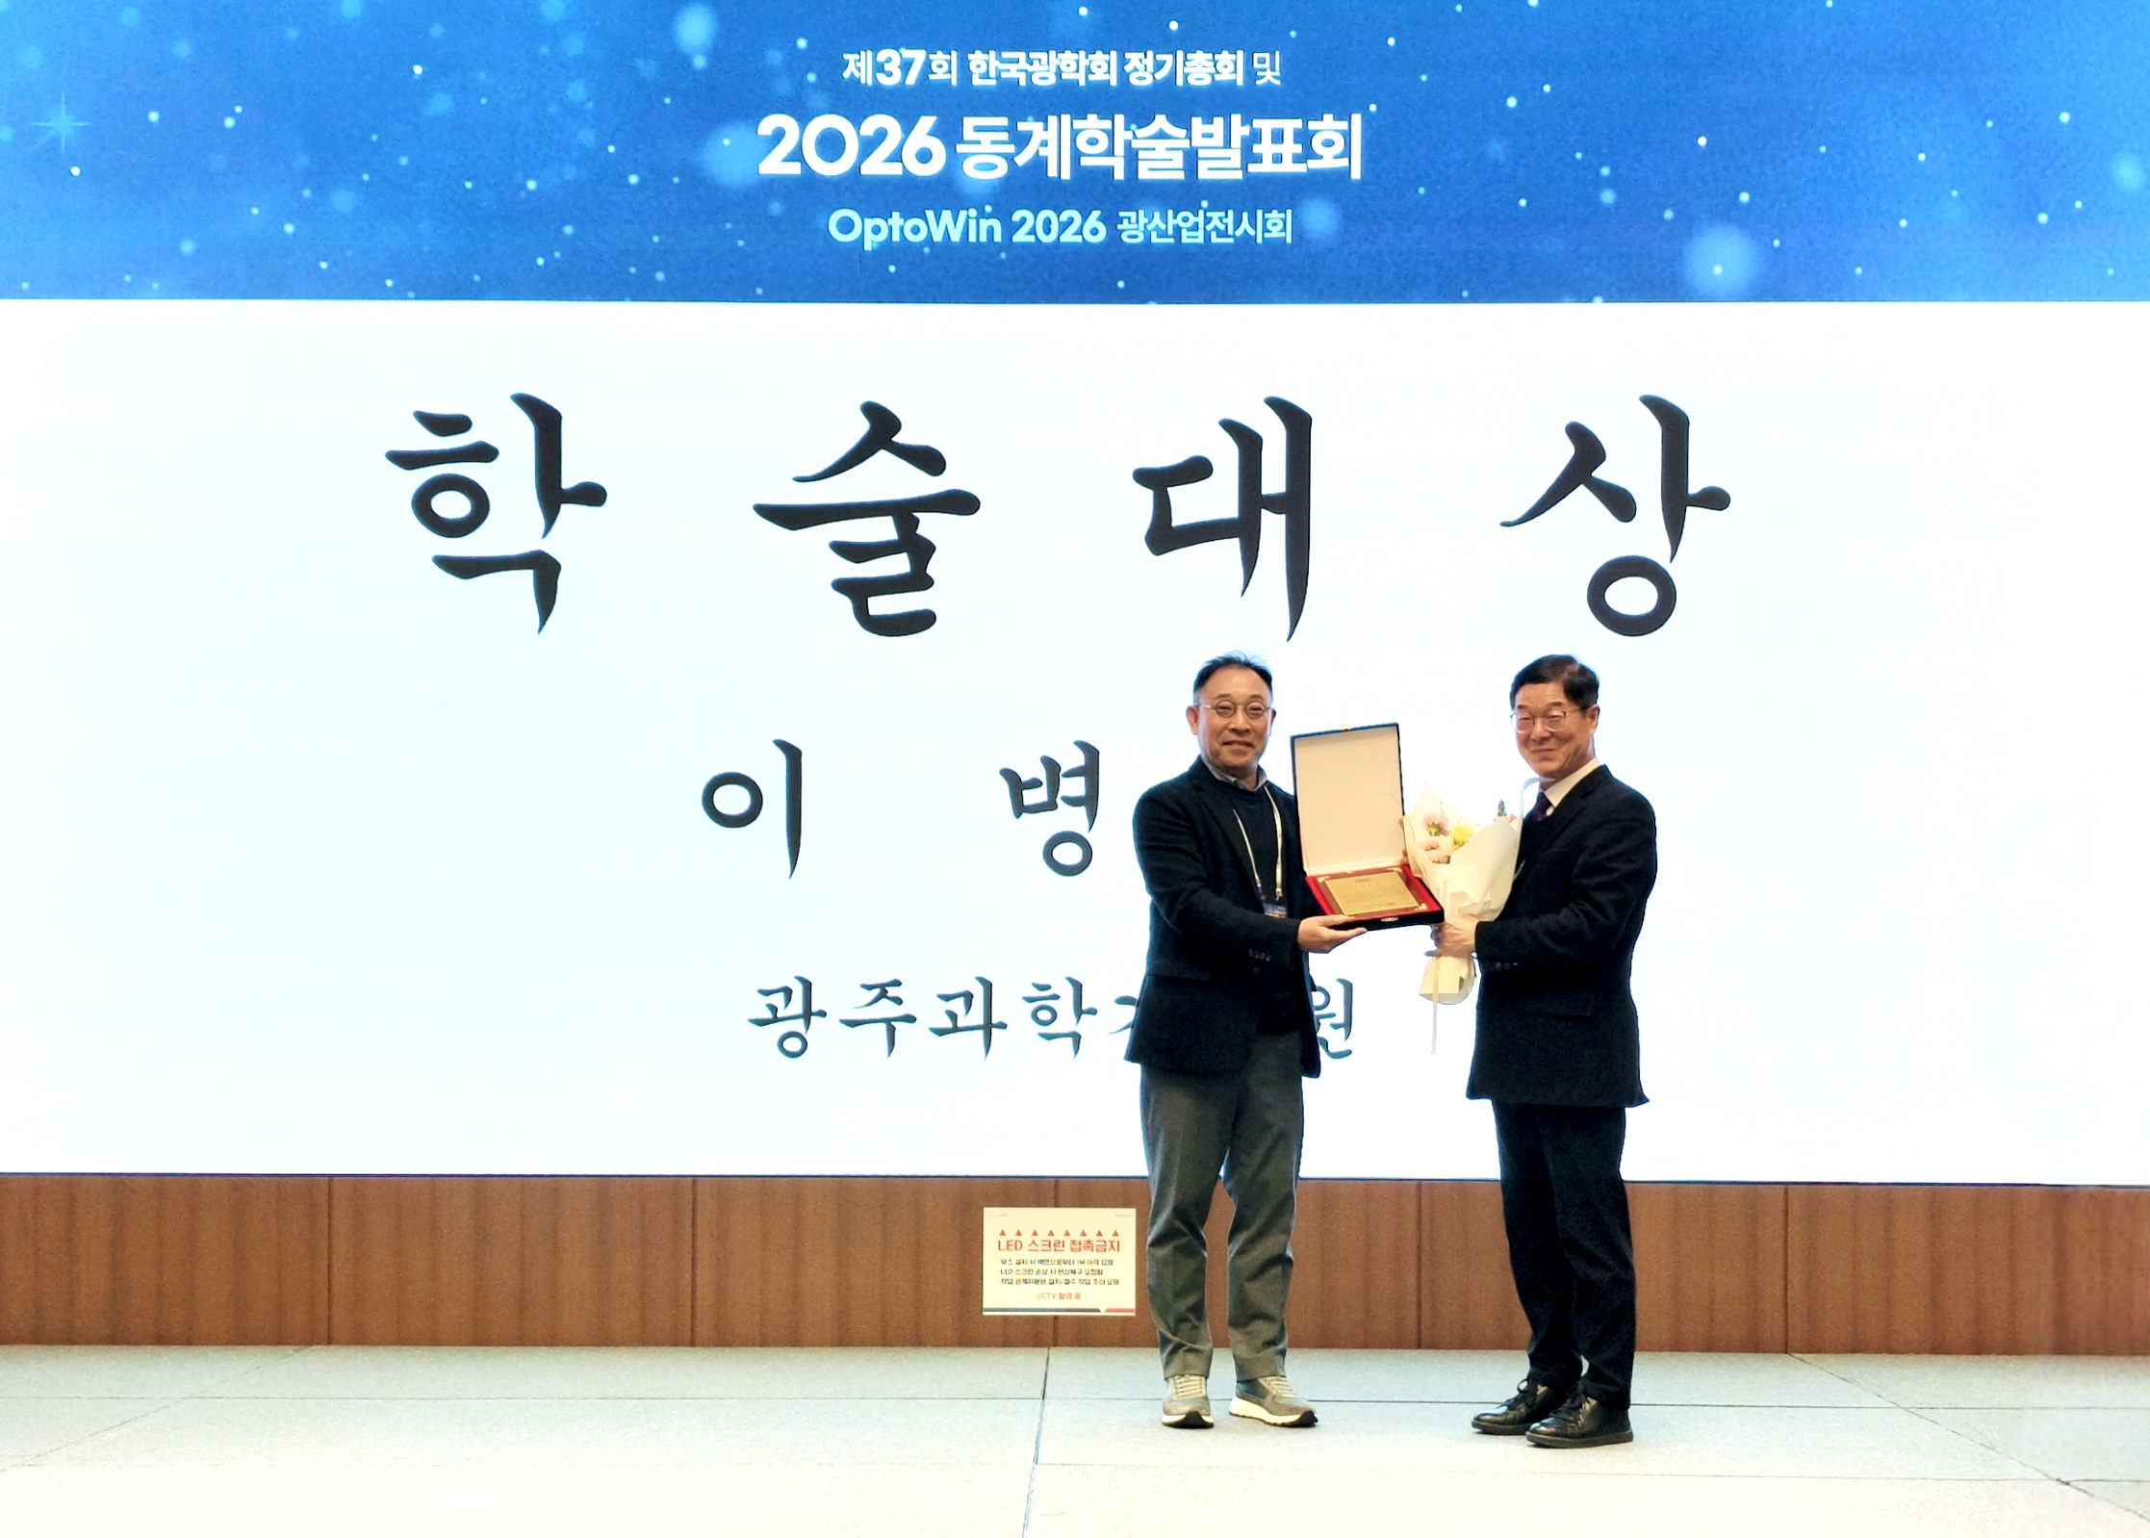

▲ Professor Lee Byung-ha of the Department of Electrical, Electronic, and Computer Engineering at GIST poses for a commemorative photo after receiving the Academic Award at the Optical Society of Korea Awards Ceremony held at the BEXCO Convention Hall in Busan on February 5th. (From left) President Lee Sang-min of the Optical Society of Korea and Professor Lee Byung-ha
The Gwangju Institute of Science and Technology (GIST, President Kichul Lim) announced that Professor Lee Byeong Ha Lee of the Department of Electrical Engineering and Computer Science received the 37th Optical Society of Korea Academic Award in recognition of his contributions to the academic advancement and technological dissemination of optics in Korea.
The Optical Society of Korea Academic Award is the most prestigious award in the field of optics, presented to a scientist who has made outstanding achievements in the advancement of optics-related academics and technologies. Only one recipient is awarded each year. This year's award ceremony took place on Thursday, February 5th, immediately following the Optical Society of Korea's regular general meeting at the BEXCO Convention Hall in Busan.
The Optical Society of Korea, established in 1990, is Korea's top-level optical society. It has led the development and expansion of Korea's optical technology through technological exchanges, global joint research, and training of specialized personnel based on cooperation between industry, academia, and research institutes.
Professor Byeong Ha Lee, who joined GIST in 1999, has conducted creative and innovative research in the field of optics, accumulating a wide range of research achievements, from basic research to applications and industrialization.
He has been recognized for both academic excellence and industrial practicality in core areas of optics, including fiber optic grating devices and optical sensor systems, optical coherence-based tomography imaging, and photoacoustic-based 3D imaging and non-destructive testing.
Professor Lee has published over 150 papers in international academic journals, presented over 500 research results at domestic and international conferences, and applied for over 30 domestic and international patents, demonstrating his active research activities. His papers have been cited over 5,200 times, demonstrating not only the quantitative scale of his research but also its significant academic impact.
Furthermore, he has contributed significantly to nurturing the next generation of researchers, producing 24 doctoral and 28 master's degree holders. In 2023, he was selected as one of the "Top 2% of Researchers in the World" by Stanford University and Elsevier, a global academic information analysis company, demonstrating his international influence.
Professor Byeong Ha Lee stated, "Winning the Korea Optical Society Academic Award is a great personal honor, as it recognizes my lifelong dedication and passion for optical research." He added, "I will continue to contribute to strengthening the nation's scientific and technological competitiveness by striving to popularize optical technology and expand the industrial application of research findings."

