[Greetings] Gwangju Institute of Science and Technology (GIST)
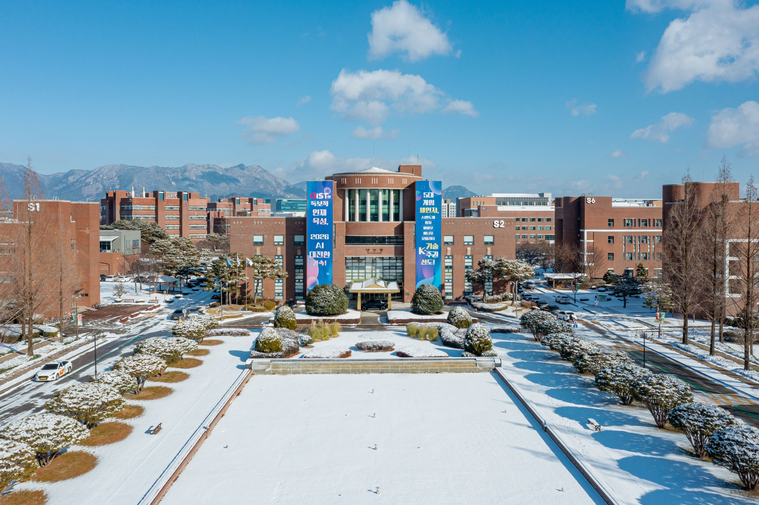

▲ Panoramic view of GIST campus
□ Position
Department Head | 2026. 2. 1.
Department of Biomedical Engineering | Tae Kim

Center Director | 2026. 2. 1.
Center for Human Rights and Legal Affairs | Mi Ryeong Cha

Managing Director | 2026. 1. 28.
R&D Strategy & Innovation Center | Hyeon-taek Lim

Office Manager | 2026. 2. 1.
Facilities and Management Team (also serving as construction Team Leader) | Chang-hyun Kang
Science and Technology Innovation Division (also serving as Technology Commercialization Center Office Manager) | Seong-geun Ki
Startup Acceleration Center | Yong-Ryul Kim
Technology Commercialization | Young-il Joo
Advanced Photonics Research Institute Management Support | Young-soo Choi
GIST Academy Secretary General | Byeong-gwan Cho
Global Cooperation | Kyung-Sook Min

Team Leaders | 2026. 2. 1.
School of Humanities and Social Sciences | Sang-hoon Yoo
Planning Team | Ho-jong Kang
Management Innovation Team | In-ho Hwang
Student Services Team | See Jin Cho
Admission Team | Mi-yeon Kim
General Affairs Team | Chang-hoon Choi
Human Resources Team | Yong-un Cho
Contract Team | Dong-seon Cho
Facilities and Management Team | Yeong-rok Jeon
Center for Human Rights and Legal Affairs (also Team Leader of the Human Rights Center) | Deuk-jin Lee
Media and Public Relations Team | Jee-hoon Kim

