Professor Chun Taek Rim of GIST has been appointed as the only Korean member of the IEEE Fellows Review Committee for the 2026-27 term
- Professor Chun Taek Rim of the Department of Electrical Engineering and Computer Science participated in the review and final recommendation process for promotion to Fellow (Distinguished Member) for two years, 2026-27... He will serve as a member of the core decision-making body of the world's largest electrical and electronic engineering society
- IEEE Fellow, the highest honor, with only 0.1% of the global membership selected each year. Professor Rim, recognized as a global authority in wireless power transmission, has been appointed based on the trustworthiness of the international academic community.
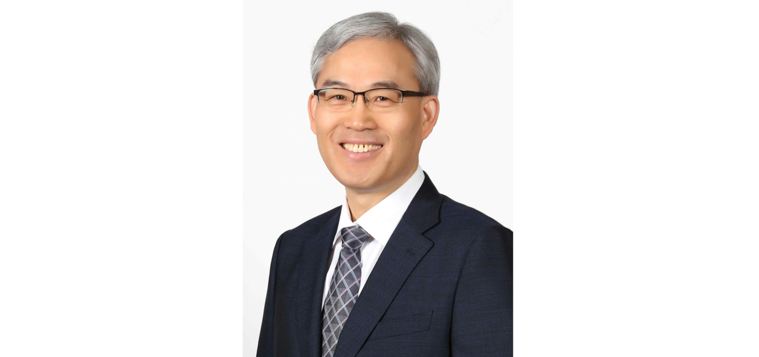

▲ Professor Chun Taek Rim of the Department of Electrical Engineering and Computer Science at GIST
The Gwangju Institute of Science and Technology (GIST, President Kichul Lim) announced that Professor Chun Taek Rim of the Department of Electrical Engineering and Computer Science has been appointed to the Fellows Committee of the Institute of Electrical and Electronics Engineers (IEEE), the world's largest electrical and electronics engineering society.
Professor Rim will serve as a member of the IEEE Fellows Committee for two years, from 2026 to 2027. He will participate in the candidate review and final recommendation process for promotion to Fellow, the highest rank of IEEE membership. As of this term, Professor Rim is the only Korean member of the committee.
This appointment is significant, as it allows Professor Rim to participate in the IEEE's core decision-making process, building on his academic achievements and international reputation in his field.
‘IEEE Fellow’ is the highest level of membership awarded only to researchers who have been recognized for outstanding research achievements and international contributions in the fields of electrical, electronic, and information and communications technology. The criteria are so strict that only 0.1% of all voting members are selected each year.
The IEEE Fellows Committee is the most prestigious committee, comprised of 52 IEEE Fellows representing 10 IEEE regions, 46 academic societies, technical committees, and various affiliations worldwide. Each year, it evaluates over 1,200 candidates for Fellow promotion and submits a final list of recommendations to the IEEE Board of Directors.
Professor Chun Taek Rim stated, "Through my work on the IEEE Fellows Committee, I will interact with outstanding researchers from around the world and contribute to the development of the academic community through fair and rigorous evaluations. This committee work will also help promote GIST's research capabilities and status to the international community."
Meanwhile, Professor Chun Taek Rim is a world-renowned authority in the field of wireless power transfer. He has been leading research on next-generation power transfer technologies for electric vehicles and mobile devices. In recognition of these contributions, he was appointed an IEEE Fellow in 2020.
He was also selected for five consecutive years as one of the "Top 1% of Researchers in the World" in the field of electrical and electronic engineering by Elsevier and Stanford University last year. To date, he has published 208 papers in renowned international journals and applied for 178 patents.
Furthermore, he is the first Korean researcher and only the seventh in the world to receive the Milan M. Jovanović Award, the most prestigious academic award in the field of wireless power, presented by the Power Electronics Society (PELS), an affiliate of IEEE. He continues to produce world-class research results and is internationally recognized for his excellence.

