[Greetings] Gwangju Institute of Science and Technology (GIST)
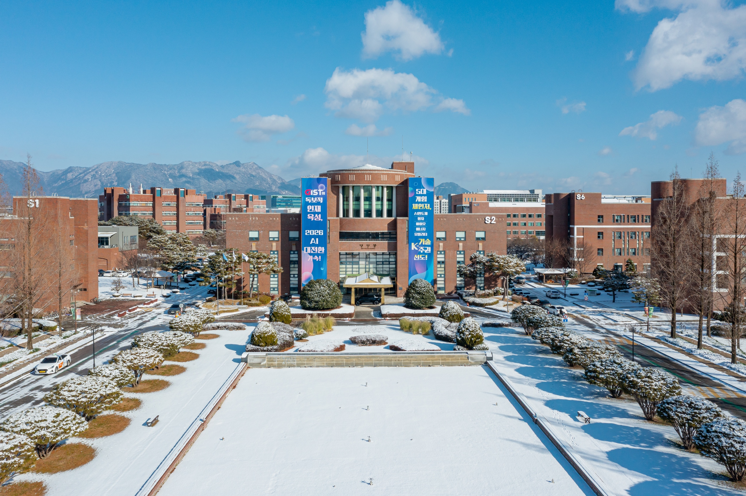

▲ Panoramic view of GIST campus
□ Positions
▲ Department of Electrical Engineering and Computer Science, Dean Byung-Geun Lee
▲ Department of Mathematical Sciences, Dean Minki Kim
▲ Department of Mechanical and Robotics Engineering, Dean Jae Hun Seol
▲ School of Humanities and Social Sciences, Assistant Dean Wonil Choi
From February 1, 2026

