Two graduate students from the Department of Materials Science and Engineering at GIST won awards at the first Hyundai Mobis Electrification Outstanding Paper Contest
- Chang-hyun Lee and Jin-hyun Cho, Department of Materials Science and Engineering students in Professor KwangSup Eom's lab, received the Excellence Award and Encouragement Award, respectively... Their research achievements, which simultaneously improved the stability and fast-charging performance of lithium metal batteries, were recognized for their innovation
- Presenting the practical potential of next-generation batteries while securing industrial applicability... The Electrochemical Energy Systems Laboratory (EESL) led by Professor KwangSup Eom demonstrates research competitiveness in the field
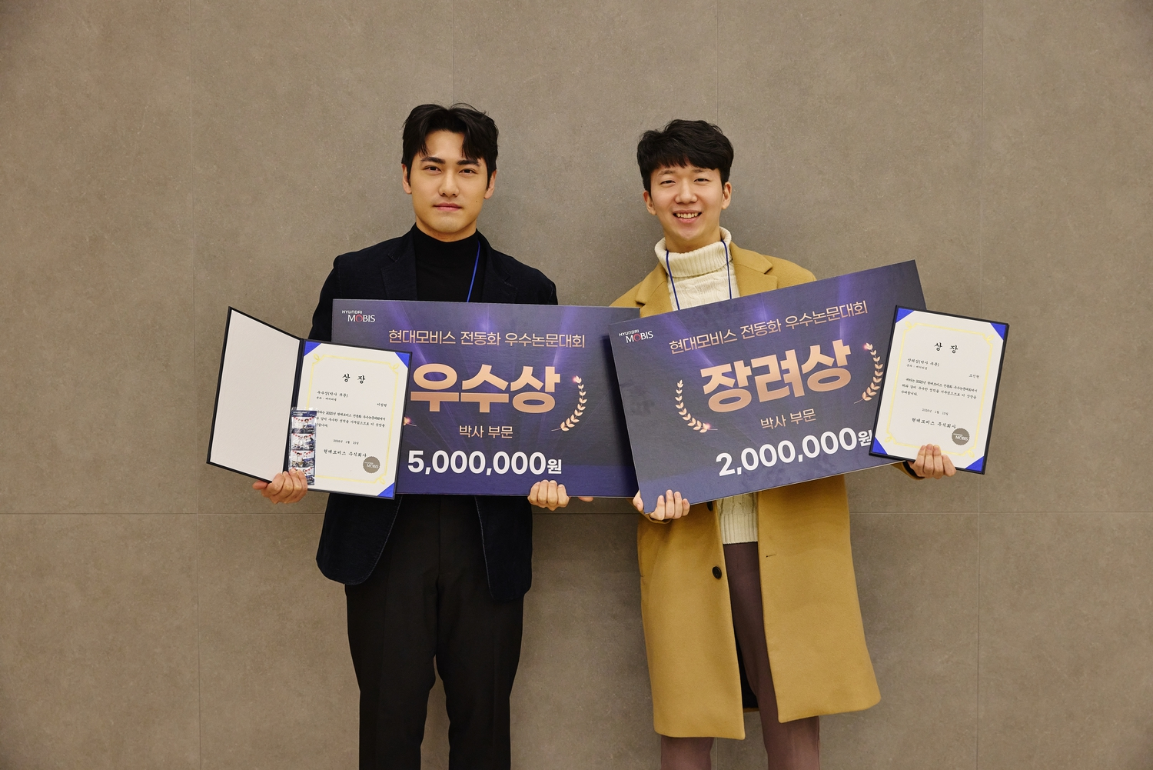

▴ (From left) GIST Department of Materials Science and Engineering integrated master's and doctoral students Chang-hyun Lee and Jin-hyun Cho, who won the Excellence Award and Encouragement Award at the '1st Hyundai Mobis Electrification Excellent Paper Contest,' are taking a commemorative photo at the awards ceremony.
The Gwangju Institute of Science and Technology (GIST, President Kichul Lim) announced that two undergraduate students from Professor KwangSup Eom's lab in the Department of Materials Science and Engineering received Excellence and Encouragement Awards, respectively, at the "1st Hyundai Mobis Electrification Outstanding Paper Contest."
The awards ceremony was held on the 15th at the Hyundai Mobis Uiwang Research Center in Uiwang, Gyeonggi Province. A total of 16 teams received awards in both the master's and doctoral programs (8 each). At GIST, Chang-hyun Lee and Jin-hyun Cho, both integrated master's and doctoral students, received Excellence and Encouragement Awards, respectively, in the battery cell division and doctoral program.
The "Hyundai Mobis Electrification Outstanding Paper Contest," hosted by Hyundai Mobis, is an academic paper competition held for the first time this year to discover outstanding research achievements in the fields of electrification and core future mobility technologies.
The competition evaluated graduate students (Korean nationals only) from domestic and international universities across five categories covering core electrification technologies: gearboxes, battery cells, battery systems (BSA), integrated charge control units (ICCU), and power semiconductors. The total prize pool amounted to 102 million won.
The awardees were officially recognized for their research capabilities and technological potential as key researchers in the field of electrification.
Chang-hyun Lee, the recipient of the Excellence Award, proposed a novel interface design technology to address the instability of lithium metal anodes, a key challenge in next-generation batteries.
Focusing on the problem of uneven lithium deposition, which shortens battery life, Lee developed a method for rapidly forming a thin protective layer using a very small amount of tin (Sn). This protective layer effectively suppresses the formation of dendrites, which grow like sharp needles within the battery during charge and discharge, damaging the electrode and reducing its lifespan and safety.
As a result, the device demonstrated minimal performance degradation over extended battery life and demonstrated the potential for stable operation in next-generation electrification battery environments that require both high energy density and high safety. The research was particularly praised for demonstrating practical industrial applicability, as it involved a simple and time-consuming process.
Jin-hyun Cho, the recipient of the Encouragement Award, proposed a new battery structure design to address the problem of batteries swelling and becoming more susceptible to damage during rapid charging.
Noticing that lithium adheres to only one surface when charging at high speeds, which reduces performance, Jin-hyun Cho designed a structure that ensures the lithium is evenly distributed throughout the internal space. As a result, he created a lithium metal battery that operates stably without swelling, even under fast charging conditions, with charging and discharging completed in approximately 12 minutes.
Chang-hyun Lee said, "It's even more meaningful that lithium metal anode technology, previously discussed primarily at the research level, is now recognized for its practical application." He added, "I'm grateful to Professor KwangSup Eom for his guidance in thoroughly considering the direction and depth of my research."
Jin-hyun Cho added, "I hope this research will offer new directions for high-speed charging, and I will continue to pursue creative and challenging research."
Meanwhile, Professor KwangSup Eom's Electrochemical Energy Systems Lab (EESL), which produced this year's winner, is identifying the causes of performance degradation in electrochemical-based energy conversion and storage systems, such as fuel cells and batteries, and conducting research on materials and structural design to improve these factors.
In particular, the lab focuses on developing next-generation energy systems that simultaneously achieve high output and energy density, along with long life and high reliability. The lab continues to produce practical research results with high potential for industrial application.
Furthermore, in 2025 to commercialize his research findings, Professor KwangSup Eom established "LVB," a faculty-led startup developing and manufacturing next-generation secondary battery electrode materials. He is also actively pursuing the commercialization of next-generation battery technologies, including the development of cathode materials for lithium metal batteries.

