GIST faculty startup AunionAI selected as a promising AI technology case at CES 2026

- The AI-based automatic dubbing solution, "AunionAI-DUB," was featured as an innovative example of multilingual content production in the Samjeong KPMG Economic Research Institute's "Future Industry Trends from CES 2026" report

- The technological differentiation of the "AI agent" approach, which self-evaluates and corrects dubbing results, was highlighted alongside key technologies from global tech companies... A representative example of faculty-led startups and technology commercialization, where university research results were translated into the market

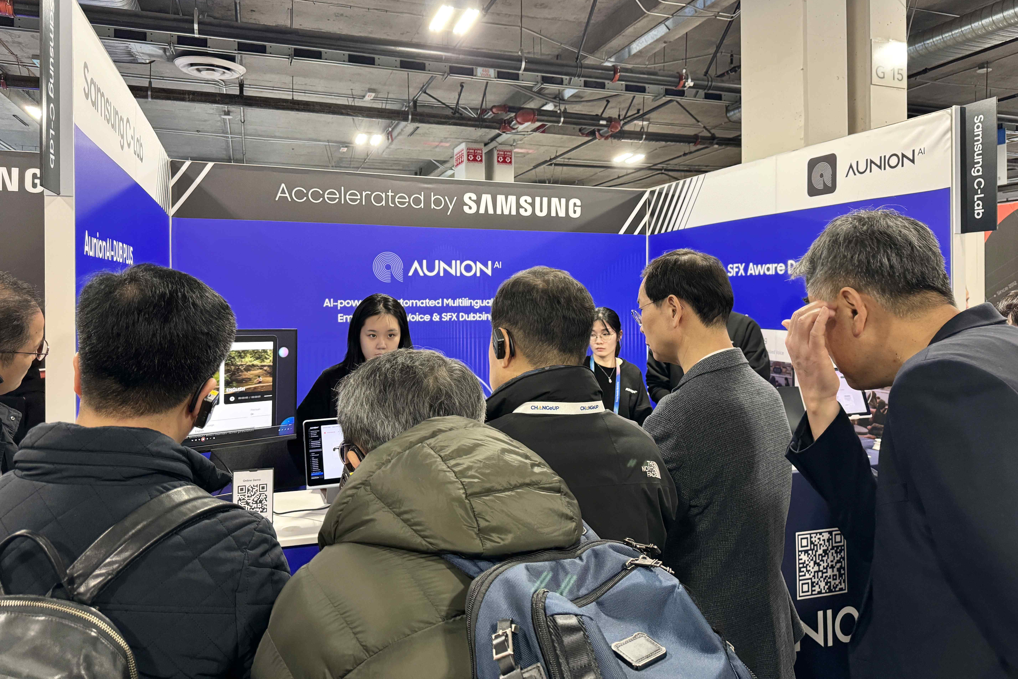

▲ The AunionAI team is operating a booth at CES 2026.

The Gwangju Institute of Science and Technology (GIST, President Kichul Lim) announced that AunionAI (CEO Hong Kook Kim, Department of Electrical Engineering and Computer Science), a professor-led startup, was featured as a notable example of promising AI technology in a report analyzing CES 2026, the world's largest information technology (IT) and home appliance exhibition.

The Samjong KPMG Economic Research Institute, in its report "Future Industry Trends from CES 2026," analyzed 10 technology trends at CES, held in Las Vegas in January this year, and selected "AunionAI-DUB," an AI-based automatic dubbing solution developed by AunionAI, as one of the key technologies demonstrating the expanding role of AI across industries.

The report selected AunionAI's AI-based automatic dubbing solution 'AunionAI-DUB' along with ▴ Nvidia's next-generation AI semiconductor (Vera Rubin NVL 72), ▴ Samsung Electronics' quantum-resistant cryptography (PQC)-equipped security chip (S3SSE2A), ▴ SK Hynix's 16-layer high-bandwidth memory (HBM4) product, etc. as one of the '10 most innovative products by trend' in the AI ​​field, and introduced them as examples of simultaneously eliminating language barriers and improving production efficiency in the next-generation global media, entertainment, and education content production environment.

"AunionAI-DUB" is a solution that uses AI to analyze the audio of videos produced in a specific language, automatically translates it into multiple languages, and then generates natural-sounding dubbing voices based on this analysis. Beyond simple dialogue translation, it considers various factors, including scene context, sound effects, and spatial awareness, significantly reducing the potential for incongruity in AI-driven dubbing content.

Samjung KPMG highlighted AunionAI's unique feature, which is its "AI agent" approach, which allows the AI ​​to independently evaluate and correct the quality of the resulting dubbing. By having the AI ​​agent verify and revise the translation and dubbing results, the company has achieved a technological structure that maintains a high level of automation while ensuring stable content quality.

At CES 2026, AunionAI demonstrated its AI-based automatic dubbing solution in a real-world content production environment, garnering attention from global media companies and platform stakeholders. In particular, the company demonstrated its technological prowess in naturally localizing entire scenes by incorporating not only voice synthesis but also sound effects and spatial awareness, leading to discussions about overseas partnerships, confirming the potential for global business expansion.

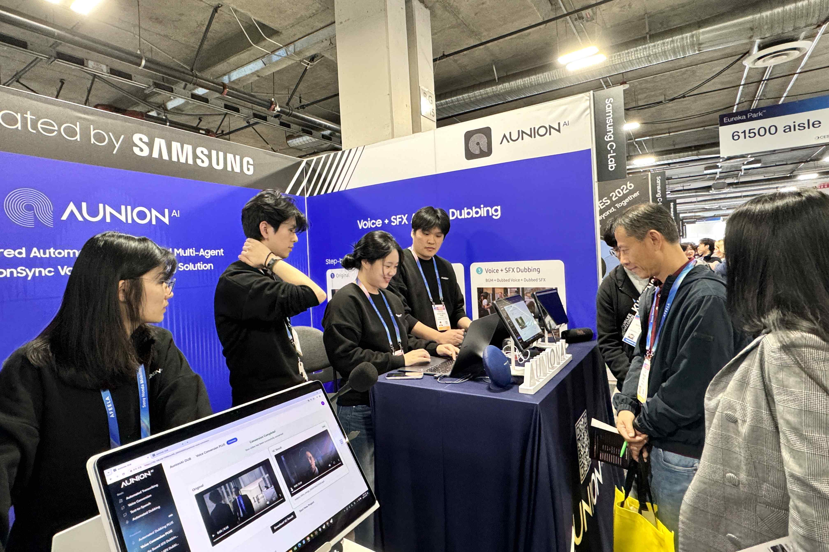

▲ The AunionAI team is demonstrating its next-generation AI dubbing solution, "AunionAI-DUB Plus," at CES 2026.

This solution, based on a fully automated dubbing process, delivers natural voice synthesis and precise lip sync. Its structure, which automatically evaluates and corrects AI-generated dubbing results, allows for high scalability across the global content market.

CEO Hong Kook Kim is a technology expert with over 30 years of research and industry experience in voice and audio AI. He has led the development of voice recognition and synthesis technologies at Samsung Advanced Institute of Technology and AT&T Research Laboratories in the United States.

Building on this research and industrial experience, GIST established AunionAI in 2023, leveraging the technologies accumulated at its lab. The company is focused on lowering the entry barriers to global content creation through AI technology.

CEO Kim stated, "It is significant that the Samjong KPMG report recognizes AunionAI's technology for both its industrial value and global competitiveness." He added, "Building on the research achievements accumulated at the GIST lab, we will develop this into an exemplary case of faculty entrepreneurship, where AI technology can be used to solve real-world industrial and societal problems."

GIST recognizes this achievement as a case that demonstrates the competitiveness of faculty entrepreneurship and technology commercialization models on the global stage. GIST plans to further strengthen its support for entrepreneurship and industry-academia collaboration to promote the industrial dissemination of research findings in AI, digital content, and language technology.



