[Greetings] Gwangju Institute of Science and Technology (GIST )

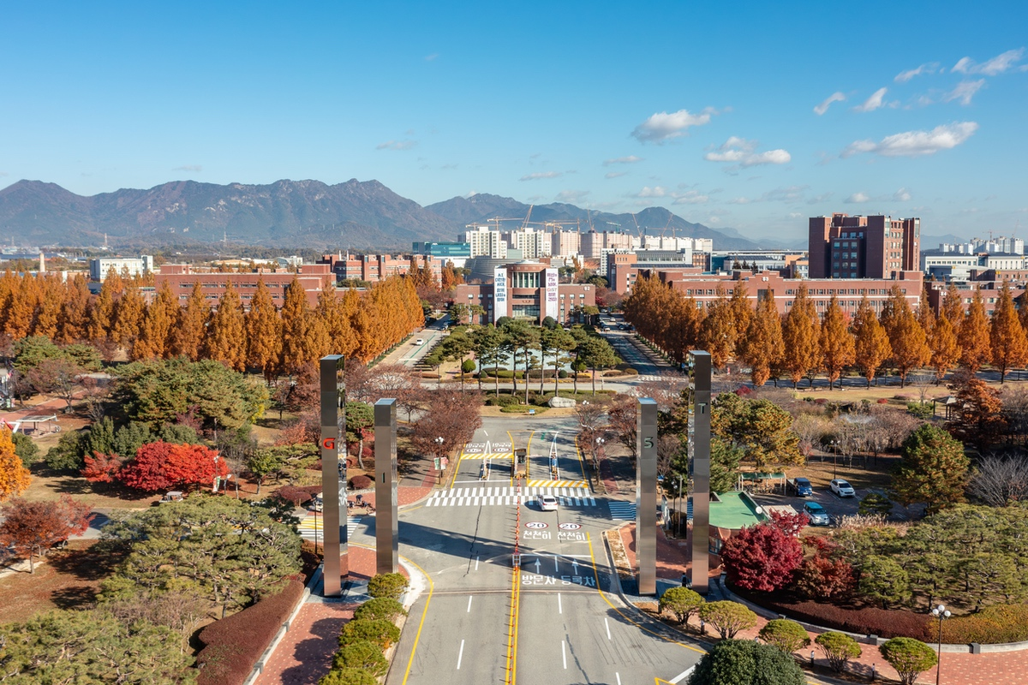

▲ Panoramic view of GIST campus

□ Appointments

▲ Director of the AI Gifted School Establishment Promotion Team: Tae-Young Kim

▲ Deputy Director of the AI Gifted School Establishment Promotion Team: Sang-hoon Jeon

▲ Office of General Affairs and Safety Dean: Young-wook Cho

▲ Director of the Office of Future Strategy: Seung-jae Lee

▲ Team Leader of the Office of Future Strategy: So-young Kim

Effective January 1, 2026



